**SHARE SUNDAY 2022**

**God’s kind of Hospitality**

**1. Introduction**

Share Sunday is an opportunity for the whole of the Uniting Church to celebrate the incredible community services being undertaken by our agencies, parish missions, presbyteries and congregations. It is also an invitation to continue to explore how we can partner together as we respond to Christ’s calling to serve humanity seeking to create an inclusive, connected and just world.

This year, the focus of our Share Sunday resources is **‘God’s kind of Hospitality.’**

These resources include a complete sample service, with all prayers and responses, sermon/reflection, intergenerational activity resources & suggested hymns. An additional PowerPoint with the complete service accompanies this resource for those congregations who use data projection in worship. These resources are available to download, but not in hard copy. However, if you are unable to download them, you may request a USB memory stick to be posted to you. Please adapt the material to suit your context and congregation(s).



This year’s occasion might be the time to invite some local Uniting staff, board members or volunteers along to be present in worship. We are happy to connect via ZOOM for congregations still meeting virtually. If you need a local contact to extend such an invitation, please let Megan Osborn know: E: Megan.Osborn@vt.uniting.org.

As we pray, reflect and worship together as part of our Share Sunday services, we can continue to build on the rich history of Share, and the incredible contributions we as a church community make as we engage with lives shattered in so many ways and find ourselves mutually transformed as we meet Christ in the stranger.

Thank you for participating.

** **

**2. Sample Worship Service for Share Sunday 2022**

Based upon the lectionary scripture readings for Sunday 28th August, Pentecost 12.

(These resources could be used on other Sundays or times of worship if departing from the lectionary is permissible in your context.)

**Acknowledgment of Country**

*According to your local custom.*

**Call to Worship**

*(We gather together as the people of God)*

God who embraces all

**We give ourselves to your loving embrace**

In your love we worship you

**Holding us, forming us, setting us free, to sing your praise and do your deeds**

**Opening Hymn**

**(Some suggestions)**

TIS 447 Lord your almighty word

TIS 220 This, this is the God we adore

TIS 107 Sing praise and thanksgiving

TIS 179 Praise with joy the world’s Creator

TIS 474 Here in this place new light is streaming

**Greeting**

The grace of the Lord Jesus Christ

and the love of God

and the companionship of the Holy Spirit

be with you all.

**And also with you.**

**Welcome & Introduction to the Share Sunday theme**

Share Sunday is an opportunity for the whole of the Uniting Church to celebrate the incredible community services being undertaken by our agencies, parish missions, presbyteries and congregations. It is also an invitation to continue to explore how we can partner together as we respond to Christ’s calling to serve humanity seeking to create an inclusive, connected and just world. This year our theme is ‘God’s kind of Hospitality’. What might that look like for you? How might you offer God’s kind of hospitality? How are all the relationships we build through our community services by congregation, Presbytery and agencies reflective of God’s kind of hospitality.

**Announcements/News**

(or your usual place in the service)

**Opening Prayer**

God, whose generosity overflows,

We are in awe of your creation teaming with life and potential.

You spread creation out before us and invite us to find our place in your ecology of love;

And as we explore, work and rest with you, you call us to be open and generous with others.

And as we go, we find you everywhere nudging, supporting, opening our ears, eyes and mind.

For your constant presence we are ever thankful.

**Prayer of Confession**

God of grace,

Your Word and Spirit are mirrors for us to see ourselves as we truly are.

We are thrilled when we are like you;

And we are appalled when we hoard your richness to ourselves -

Focused on taking rather than giving, holding rather than offering.

We tremble and falter at what we can and have become;

And so, we turn to you to be bathed in the water of your mercy

And radically changed by your love. Amen

**Declaration of Forgiveness**

Hear the Good News of our shared faith:

God’s arms are open wide, God’s heart is for you,

God’s eyes are upon you,

And in Christ God says

“Your sins are forgiven”

**Thanks be to God**

[If your congregation passes the peace and is mindful of the COVID guidelines, continue with]:

**The Peace**

*The peace of the Lord be always with you*

***And also with you.***

[and invite people to exchange a sign of peace with one another]

**Thanksgiving Song or Hymn**

(some suggestions)

TIS 685 The power of your love

TIS 693 Come as you are

TIS 717 Give thanks with a grateful heart

TIS 738 Shout to the Lord

**Scripture Readings**

(The Revised Common Lectionary for Sunday 28th August 2022, Pentecost 12)

Jeremiah 2:4-13

Psalm 81:1, 10-16

Hebrews 13:1-8, 15-16

Luke 14:1, 7-14

(NB: The reflection resources below are based on the readings from Luke and Hebrews)

Hebrews 13:1-3, 8, 15-16 NRSV

Let mutual love continue. Do not neglect to show hospitality to strangers, for by doing that some have entertained angels without knowing it. Remember those who are in prison, as though you were in prison with them; those who are being tortured, as though you yourselves were being tortured…

Jesus Christ is the same yesterday and today and for ever…

Through him, then, let us continually offer a sacrifice of praise to God, that is, the fruit of lips that confess his name. Do not neglect to do good and to share what you have, for such sacrifices are pleasing to God.

Luke 14:1, 7-14 NRSV

On one occasion when Jesus was going to the house of a leader of the Pharisees to eat a meal on the sabbath, they were watching him closely…

When he noticed how the guests chose the places of honour, he told them a parable. ‘When you are invited by someone to a wedding banquet, do not sit down at the place of honour, in case someone more distinguished than you has been invited by your host; and the host who invited both of you may come and say to you, “Give this person your place”, and then in disgrace you would start to take the lowest place. But when you are invited, go and sit down at the lowest place, so that when your host comes, he may say to you, “Friend, move up higher”; then you will be honoured in the presence of all who sit at the table with you. For all who exalt themselves will be humbled, and those who humble themselves will be exalted.’

He said also to the one who had invited him, ‘When you give a luncheon or a dinner, do not invite your friends or your brothers or your relatives or rich neighbours, in case they may invite you in return, and you would be repaid. But when you give a banquet, invite the poor, the crippled, the lame, and the blind. And you will be blessed, because they cannot repay you, for you will be repaid at the resurrection of the righteous.’

**Sharing Together** (Early Word & Activity)

This an opportunity for an intergenerational activity and conversation around the Question

**“What does God’s kind of hospitality look like to you?”**

**Set the context**- the call of Jesus from Luke 14: *when you give a banquet (or party), invite the poor, the crippled, the lame, and the blind.* And from Hebrews 13: *Do not neglect to show hospitality to strangers, for by doing that some have entertained angels without knowing it*

**Hand out the Activity Sheet provided in the resource pack** and encourage everyone to work together in pairs/small groups to complete the activity sheet. Encourage a mix of generations.

Invite contributions in words, drawings, sculpture, mime!

Share in small groups and report back to whole gathering if appropriate.

Another question for reflection:

**What might be some of the challenges if you find yourself excluded from the banquet or party?**

Close with prayers of thanks for the generous spirit of Christ within us, inviting us to share food and presence with those who have been left out or who are different from us.

**Hymn**

*A great song to finish of this shared time is:*

TIS 690 Beauty for brokenness

**Sermon/Reflection**

*There are some sermon/reflection materials in the resources pack (below) for the core reflection time, including some information on current statistics, information about some programs, and stories of how one time strangers were embraced by hospitality.*

**Hymn**

(some suggestions)

TIS 618 What does the Lord require?

TIS 607 Make me a channel of your peace

TIS 640 Kneels at the feet of his friends

**Offering**

We are caught up in God’s generosity and share our lives gladly with others day by day, so now we come with grateful hearts, to once again offer ourselves to God’s service and the building up of the church, for the sake of the world. We make our offering.

**Offering Prayer**

Generous and open-hearted God we are overcome with your gift of life, and life in all its fulness with Christ.

**Bless and multiply these gifts that the web of your care may be strengthened, and all will be embraced in hospitality.**

**To the glory of you name.**

**Amen.**

**Prayers of the People, concluding with the Lord’s Prayer**

In this prayer the words ‘Lord in your mercy’ are followed by the response ‘may the excluded be embraced’.

Lord we pray that the veil over our minds may be lifted, and we are able to see the world and all creatures with your all-inclusive and compassionate gaze.

We are aware that we offer hospitality from a land not our own, taken by dispossession from its original custodians the First Peoples of Australia. May we be bearers of love, hope and justice, to break the bonds of the suicide of their young, the incarceration of their young people and adults, that they will have secure housing to nurture vibrant families, communal employment for their self-determination, continued revitalisation of their culture, and may we be able to walk together the path of voice, treaty and truth.

Lord in your mercy: **may the excluded be embraced**

In this land where we have boundless plains to share, may we welcome and embrace people of every land that come seeking refuge. May Australia’s love of inclusion and acceptance of diversity be strengthened, and lead to the creation of a life-giving multicultural nation that is a light to the nations of the world.

Lord in your mercy: **may the excluded be embraced**

To you O Christ who was sometimes considered by your own family as not being in your right mind, we pray for all managing life challenged by mental ill-health. May they be embraced by supportive families and friends, excellent health care, and may they find peace of mind.

Lord in your mercy: **may the excluded be embraced**

Mother earth is limping, her lungs are congested, her waters poisoned and who knows what will evolve. Ever wise God, send a tsunami of insight and resolve, for the earth to be healed, threatened species brought back from the brink of extinction, for sustainability to reign in every part of our lives.

Lord in your mercy: **may the excluded be embraced**

Suffering servant and risen Lord, we pray for those excluded everywhere, for reasons that are sometimes plain and others we know not why, may your courage overcome our fear, your wisdom overcome our ignorance and your perseverance our apathy.

Lord in your mercy: **may the excluded be embraced**

God who gives sight to the blind, open our eyes to see your Spirit at work beyond the church; lead us into shared ventures that delight your heart and bring faith, hope and love, leading us one step closer to the reconciliation of all things. May the Uniting Church be reconciled within herself, that evangelical justice making, inspiring worship, and healing communion be our hallmark.

Lord in your mercy: **may the excluded be embraced**

We pray together our shared hope in the words of The Lord’s Prayer

**Our Father in heaven**

**hallowed be your name,**

**your kingdom come,**

**your will be done,**

**on earth as in heaven.**

**Give us today our daily bread.**

**Forgive us our sins**

**as we forgive those who sin against us.**

**Save us from the time of trial**

**and deliver us from evil.**

**For the kingdom, the power, and the glory are yours**

**now and forever.**

**Amen.**

**Closing Hymn**

*(Some suggestions)*

TIS 547 Be thou my vision

TIS 658 I the Lord of sea and sky

TIS 650 Brother, sister, let me serve you

TIS 674 Inspired by love and anger

**Word of Mission & Blessing**

All are loved by God, always have been, and always will be – so now go in the love of God, the courage of Christ, and the peace of the Spirit, offering God’s hospitality to whomever you meet.

**We go embraced by Christ**

**Amen!**

**Blessing Song**

*(Some suggestions)*

TIS 779 May the feet of God walk with you

TIS 780 May light come into your eyes

TIS 781 Father, bless us as we go

**3. Activity Sheet – What does God’s kind of hospitality look like to you?**

Share Sunday 2022-Activity

**What does God’s kind of hospitality look like to you?**

Draw, paint, write your responses here, then SHARE with others 😊

 

**4. Sample sermon/reflection Incorporating two video reflections:**

**THEME ‘God’s kind of Hospitality’**

**LECTIONARY READINGS Aug 28 2022 Pent 12**

Hebrews 13:1-3, 8, 15-16 NRSV

Let mutual love continue. Do not neglect to show hospitality to strangers, for by doing that some have entertained angels without knowing it. Remember those who are in prison, as though you were in prison with them; those who are being tortured, as though you yourselves were being tortured…

8 Jesus Christ is the same yesterday and today and for ever…

15 Through him, then, let us continually offer a sacrifice of praise to God, that is, the fruit of lips that confess his name. Do not neglect to do good and to share what you have, for such sacrifices are pleasing to God.

Luke 14:1, 7-14 NRSV

1 On one occasion when Jesus was going to the house of a leader of the Pharisees to eat a meal on the sabbath, they were watching him closely…

7 When he noticed how the guests chose the places of honour, he told them a parable. ‘When you are invited by someone to a wedding banquet, do not sit down at the place of honour, in case someone more distinguished than you has been invited by your host; and the host who invited both of you may come and say to you, “Give this person your place”, and then in disgrace you would start to take the lowest place. But when you are invited, go and sit down at the lowest place, so that when your host comes, he may say to you, “Friend, move up higher”; then you will be honoured in the presence of all who sit at the table with you. For all who exalt themselves will be humbled, and those who humble themselves will be exalted.’

He said also to the one who had invited him, ‘When you give a luncheon or a dinner, do not invite your friends or your brothers or your relatives or rich neighbours, in case they may invite you in return, and you would be repaid. But when you give a banquet, invite the poor, the crippled, the lame, and the blind. And you will be blessed, because they cannot repay you, for you will be repaid at the resurrection of the righteous.’

**Reflection**

The biblical narratives have many accounts of meals as being places of revelation and salvation. From Abraham entertaining the three strangers in Genesis 18, the feast for all peoples in Isaiah 25:6-9 and to the feast of wisdom in Proverbs 9:1-6; all the way through to the great banquet of Matthew 25. Meals were important social occasions where societal norms were preserved about honour, purity and the importance of kinship. They were also important to Jesus. Moore (2018)[1] lists 19 separate occasions in the gospels where Jesus was involved with meals. However, Jesus used meals to show how God broke through all systems of honour, purity and kinship to show that all are worthy and all are to be included, there is no ‘us and them’. Borg (2006)[2] draws attention to how controversial Jesus’ meal practice was. Some texts cited are:

Mark 2:16 Why does he eat with tax collectors and sinners?

Luke 19:7 He has gone in to be a guest of one who is a sinner.

Luke 15:2 This fellow welcomes sinners and eats with them.

Matt 11:19 and Luke 7:34 Look, a glutton and a drunkard, a friend of tac collectors and sinners.

So, through Jesus we can understand that where food is shared, respect is given, transformation can happen (Luke 19:1-10 and the story of Zacchaeus). Hospitality can be the place of revelation and salvation.

Meals and hospitality are signs of the reign of God – more than signs they are the practice of the reign of God – more than that they are God reigning – more than that they are God serving, God blessing, so that the child can grow into all that the child is able to become – loved, unique, dignified, accepted, gifted, to uniquely serve, as God has served them. And so, the seed planted grows to become the kind of tree, whose fruit does not fail and whose leaves do not wither (Psalm 1) – watered and fed so it can provide nourishment, protection, wisdom and adventure for those who sit in its shade, as part of the mutually supportive communal forest. Of course, hospitality involves more than meals.

Hospitality has once again become a theological theme as strangers fleeing persecution and violence have once again arrived in large numbers in countries. Not so much for post WWII refugees, nor for Vietnamese boat people. For them the purpose was to be assimilated into the dominant Anglo culture. But since Vietnam there has been a change to valuing difference, expressed in the sometime or often contested policy of multi-culturalism. Not assimilation but self-determination, becoming part of the multi-cultural dance to the tune of the contested values of inclusion, social justice and human rights.

So, hospitality is not to entertain the stranger, so they become like us, nor for us to trivialise their humanity by seeing their cultural features (especially food, clothing, song and dance) as entertainment. Nor is our hospitality to be transactional (shelter in exchange for subservience); rather it is to be relational – genuine engagements as much as possible heart to heart. God’s hospitality is the space to celebrate diversity, be mutually enriched, for earth to be as it is in heaven (Revelation 5:9).

But first the beggars and strangers must be fed and rested, so they can remember their own humanity, and have the spirit of life strong again within them.

How are they engaged and with what are they fed? Yes, risks need to be managed, but equally risks need to be undertaken – trust extended, gentleness rather than power demonstrated, competency in navigating the system the newcomers find so strange, space and time given. Space to be together and space to be apart, to integrate and understand what is happening. Time to think and feel the way ahead, and importantly to learn and communicate so that stories of life can be shared.

There is no room for romanticism, where everyone gets along and lives happily ever after. It is time for respect, listening, observing and learning – mutually as much as possible. In giving hospitality to the stranger, we run the grave danger that we might be changed, our understandings broadened, and our compassion deepened.

An older woman in Holy Week was excited because she came to be aware that her Easter overlapped with Ramadan, that Old and New Testament stories are referenced in the Koran, that Muslim women are delighted by the nativity of Christmas, as this woman was delighted by the familial and communal feasting at the end of each Ramadan day, then the great feast/festival of Eid. Common humanity, unique expressions – mutual transformations.

Miroslav Volf in ‘Exclusion and Embrace’[3] warns against the romantic picture of the first becoming last and the last becoming first, because in that scenario nothing really changes – privileged and disprivileged remain, exploiter and exploited remain, people don’t change they only change positions. At the heart of this is the envy of the oppressed, for the lifestyle of the oppressors. This envy turns to enmity, the same enmity that the oppressors have for the oppressed. This system of envy and enmity, of exploitation remains. The diabolical system must change. The invitation, the necessity, is to turn from envy and enmity towards the all-embracing and transformative love of God. The exploited need to see that their envy and enmity is sapping dry their humanity and corroding their relationships. The exploiters need to see that their behaviour means persistent conflict – as much as destructive for them as it is for those they exploit. All are called to see new ways of living in right relationships with each other, to be touched in their core by the pain of separation and therefore open to reconciliation with the ‘enemy’ - to repent for the new way of the reign of God to flower.

Our hearts have been broken open by Christ’s compassion and our minds by Christ’s wisdom. But our bodies don’t live beside the stranger, well not at least next to the poor stranger. It is the case that we can be strangers to our own neighbours, but that challenge is for another time. The poor, the bedraggled, the brutalised often live elsewhere. In urban and suburban nooks and crannies, sleeping rough, couch serving, fleeing, while we are kind of safe (politicians and communicators raise our level of anxiety so we will buy their wares) in our homes. Our safe homes are good things, the product often of Christian discipline and good stewardship. So how to be beside the stranger, how to share hospitality?

Local congregations do this as best they can, with pastoral care, friendship and support groups of all kinds. Yet when the needs are extreme and more numerous, a more coordinated approach is required. Parish and City Missions were formed.

Out of the strength of churches grew a response of compassionate service that led to congregational and denominational agencies offering all kinds of welfare – to ‘orphaned’ children, to care for the elderly. You know them … (names).

Decreasing capacity of churches and increasing regulation by governments have been responded to faithfully by churches to form well governed agencies that continue to provide this care far beyond what individual congregations and agencies could manage. And it is even more so now that governments informed by Christian and humanist principles extend ‘hospitality’ by tendering out programs of all kinds to those doing it tough – ‘the poor, the crippled, the lame, and the blind’.

The Uniting Church with all its congregations can be so thankful for the foresight in establishing these agencies in response to such changed circumstances and times. Don’t feel guilty, celebrate, be thankful, help where you can locally, partner with other congregations and organisations with similar values and purposes. In this way we reflect the inclusive and generous hospitality of God.

We end perhaps where we should have begun, with a definition of Christian hospitality displayed for us by Wouter Rijneveld (2018)[4] who quotes Arthur Sutherland (2006). *‘“In the light of Jesus’ life, death, resurrection and return, Christian hospitality is the intentional, responsible, and caring act of welcoming or visiting, in either public or private places, those who are strangers, enemies, or distressed, without regard for reciprocation.” This definition starts with a clear connection to Christology. All hospitality is rooted in Christ. He is the “poor, wayfaring stranger”, always guest and always homeless. He continues to be this stranger who comes in the guise of ‘the least of my brethren’ (Mt 25) and he may continue to be received by his followers in this way.’*

Every time we celebrate Holy Communion, Christ comes as guest and stranger, and for us becomes the host, such a host who is always ready to welcome the stranger. Thanks be to God. Every time we give hospitality to ‘strangers’ we are extending the communion table, embodying the mind and heart of Christ in strange places that become illuminated with God’s kind of hospitality. Thanks be to God.

With that extended introduction here are examples of how God’s kind of hospitality is being practiced by Uniting Vic Tas, always on behalf of, and sometimes in partnership with, congregations throughout the Synod. Uniting Vic Tas operates community meals programs in Ballarat, Hobart and Prahran. We provide hot meals for vulnerable people and an opportunity to reconnect with the community. These programs are only possible through the generosity of our compassionate donors. They make God’s kind of hospitality possible.”

2022 - 3 STORIES FROM UNITING SERVICES

*Regional Victoria (Ballarat)*

**Serving up support at BreezeWay**



**Compassion and respect – keys too transformative hospitality**

*Some people like to eat alone, some people have to eat alone, some people have nothing to eat. At BreezeWay, Ballarat, those experiencing homelessness and social isolation eat together. They find shelter and a safe place to be themselves. In this safe place they are respected and learn to respect themselves. Along with food they are made aware of wrap around services to assist their complex needs of homelessness, mental health and addiction.*

*This just doesn’t happen one day a year. For over two and half decades, for the 365 days of every year, BreezeWay has served over 400,000 hot meals to Ballarat’s most vulnerable people. This is an amazing organisation of resources and people. The dedicated team of staff and volunteers have been a welcoming and supportive part of many lives. It is this kind of hospitable support and welcome that provides the environment where positive and constructive change can happen.*

*With Covid the team was undaunted. While catering for the increasing demand for the service during Covid lockdowns, the team of loyal volunteers also served takeaway meals during uncertain times.*

*“Our volunteers have risen to every challenge, rapidly embracing the need to change service delivery and they have demonstrated resilience in continuing to support the most vulnerable in our community,” says BreezeWay co-ordinator, Jen Wright. “They continue to redouble their efforts and go above and beyond to meet the increasing need in the community, providing up to 125 meals each day.”*

*Uniting recently opened a larger BreezeWay service in Albert Street, which can now support over triple the amount of people. “For many people attending BreezeWay, it is their only daily connection with the greater community and the only way they can access a hot meal,” says Jen.*

*“BreezeWay’s impact on the local community would not be possible without the dedication, compassion and respect each and every member of our volunteer team brings through the door each day.”*

*This is transformational hospitality at work. Done in the name of Uniting and the Uniting Church. Something to celebrate.*

*Hobart (Tasmania)*

**Jodie shines through Covid-19**

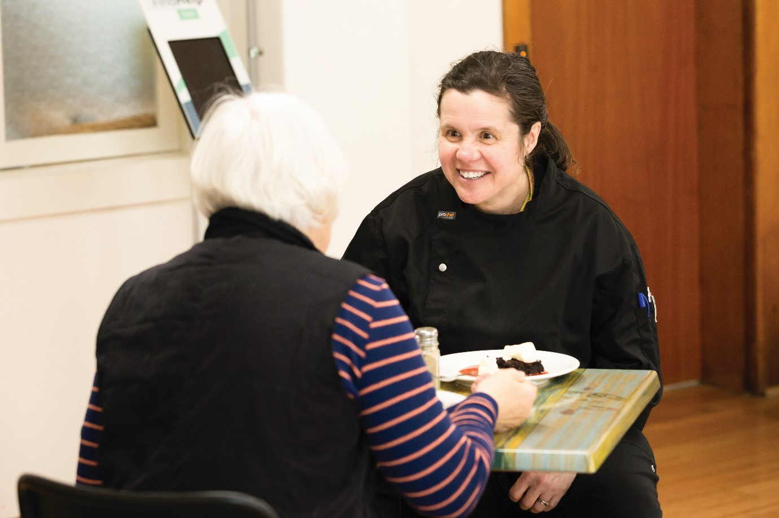

**The circle of hospitality**

*Jodie, with a husband and three children, still found herself alone at home in the middle of the day, and lonely. Jodie has an acquired brain injury that causes severe and ongoing short-term memory loss. Jodie is often unable to remember what she heard, saw or did only minutes earlier. A friend invited her along to NoBucks in Hobart and Jodie responded to that hospitality by becoming a volunteer then a supported staff member. Supported employees are people living with a disability who receive help to do their job, develop new skills and create long-term work goals.*

*One of the reasons Jodie is so valuable to, and appreciated by, Nobucks staff and customers alike is she can empathise with many of the people walking through the door. Like them, Jodie had a troubled upbringing and spent much of her teenage years in and out of psychiatric hospitals.*

*“It’s nice to feel valued,” Jodie says. “I’ve really enjoyed volunteering at Nobucks, so I’m proud to have the opportunity to become a staff member.*

*“I’ve volunteered for many organisations and this is my first paid role, so it’s very special.”*

*“Everyone loves Jodie,” says Chef Zaid. “She gets along well with the volunteers, her colleagues and the customers. She’s always up for a joke and has a smile of her face. When I ask Jodie to do something, she jumps straight in and does it.”*

*Since 2007, Nobucks, through Chef Zaid and his team of volunteers, serve about 300 meals a week. “We don’t receive government funding, we rely on the generosity of donors and our community. Without them, we wouldn’t be open…We have some great suppliers who provide discounted meat, fruit and vegetables, but it’s difficult to make it work,” Ziad says.*

*Uniting, in partnership with Hobart Central Uniting Church, volunteers and generous businesses and donors, expands the circle of hospitality with those who need it most. God is smiling.*

*Prahran (Metro Melbourne)*

**A Hearty Meal at Chapel Street’s Community Dinner**

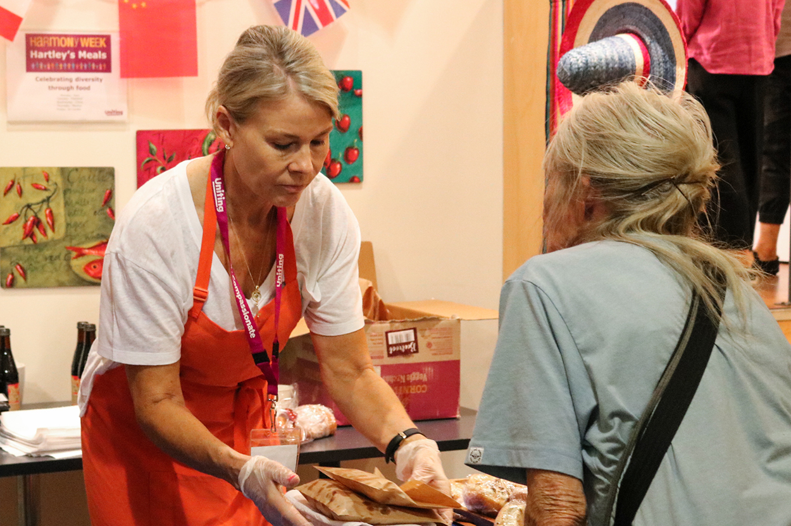

*Another shining example of God’s kind of hospitality is found nestled in the heart of Chapel Street, Prahan. Hartley’s Meals Community Dining Room is a homely, welcoming space where anybody can come and sit down, have breakfast or lunch, read a book or mingle.*

*Run by Uniting, Hartley’s Meals has been designed to help break down the stigma of food relief. From its beautiful courtyard to the warm hubbub and wonderful aromas that greet you as you enter, it looks and feels like a damn fine café.*

*Hartley’s Meals Team Leader Sara Loots says “Our dining room has communal tables and books as we want to make it a safe space for everyone – a place people can come to feel comfortable and connect,” she explains.*

*Anyone is welcome but most of the patrons are rough sleepers, rooming house residents, or those unable to cook for themselves or unable to afford food due to issues like loss of employment, low income, increasing cost of living, or struggles with mental health.*

*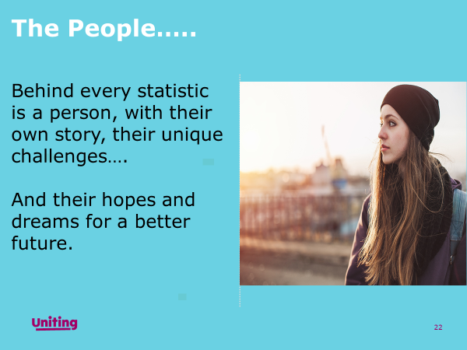The ingredients of God’s kind of hospitality: respect, warm welcome, safe space – lead to deep connections and transformation.*

**6. Acknowledgement**

These resources have been created and compiled by Uniting for use in congregational worship and may be modified and used according to local custom with acknowledgment.

1. (<https://markmoore.org/meals-of-jesus/?msclkid=0582860ecf9b11ecb7ebfe53e438ff0e> – accessed 9 May 2022
2. (Borg, M Jesus, New York, Harper Collins 2006 pp 157-160
3. Volf, M Exclusion and Embrace Nashville, Abingdon Press, 1996, pp112-119
4. Wouter Rijneveld 2018 accessed 7 April 2022

   <https://www.researchgate.net/publication/327932598_Theological_Account_of_Hospitality/link/5badff5992851ca9ed2bf3f0/download>