SHARE SUNDAY 2020

Sunday 30th August

A place to call home.
Focus on Youth Homelessness

1. Introduction

Share Sunday is an opportunity for the whole of the Uniting Church to celebrate the incredible community services being undertaken by our agencies, parish missions, presbyteries and congregations. It is also an invitation to continue to explore how we can partner together as we respond to Christ’s calling to serve humanity seeking to create an inclusive, connected and just world.

This year, the focus of our Share Sunday resources is youth homelessness, around the theme of ‘A place to call home.’
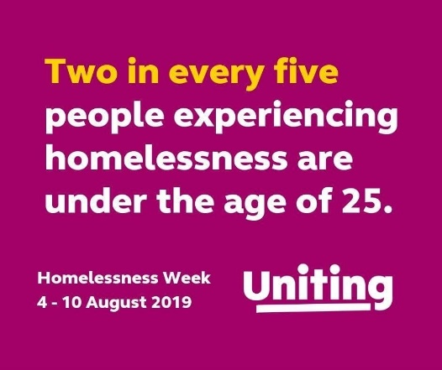
These resources include a complete sample service, with all prayers and responses, sermon/reflection, intergenerational activity resources & suggested hymns. An additional PowerPoint with the complete service and some powerful video reflections accompanies this resource for those congregations who use data projection in worship. These resources are available to download, but not in hard copy. However, if you are unable to download them, you may request a USB memory stick to be posted to you. Please adapt the material to suit your context and congregation(s).

This year’s occasion might be the time to invite some local Uniting staff, board members or volunteers along to be present in worship. We are happy to connect via ZOOM for congregations still meeting virtually. If you need a local contact to extend such an invitation, please let Deborah Grace Loh know: E: Deborah.Loh@vt.uniting.org.

As we pray, reflect and worship together as part of our Share Sunday services, we can continue to build on the rich history of Share, and the incredible contributions we as a church community make to improving the lives of many in our communities going through tough times. Thank you for participating.

2. Sample Worship Service for Share Sunday 2020

Based upon the lectionary scripture readings for Sunday 30th August, Pentecost 13.

Exodus 3:1-15
Psalm 105: 1-6, 23-26, 45b
Romans 12: 9-21
Matthew 16: 21-28

(These resources could be used on other Sundays or times of worship if departing from the lectionary is permissible in your context.)

Acknowledgment of Country
According to your local custom.

Call to Worship
(We gather together in the as the people of God)
God calls and gathers us as one people, uniting us together in a life of loving communion
We come to be renewed and refreshed in our life together
Let’s worship the God who calls us, claims us and forms us to embody and share God’s love in our world
Let’s worship the One who empowers, inspires and equips us for our life of loving service.

Opening Hymn
(Some suggestions)
TIS 162 Thank you for giving me the morning
TIS 181 Come, O God of all the earth
TIS 474 Here in this place new light is streaming
GA 557 Send down the fire of your justice.

Greeting

The grace of the Lord Jesus Christ
and the love of God
and the companionship of the Holy Spirit
be with you all.
And also with you.

Welcome & Introduction to the Share Sunday theme

Share Sunday is an opportunity for the whole of the Uniting Church to celebrate the incredible community services being undertaken by our agencies, parish missions, presbyteries and congregations. It is also an invitation to continue to explore how we can partner together as we respond to Christ’s calling to serve humanity seeking to create an inclusive, connected and just world.

Announcements/News
(or your usual place in the service)

Opening Prayer
Loving God,
We see your love revealed in your promises to your people: to be with them as they journey out of the wilderness toward the hope of a ‘promised land’, a land ‘flowing with milk and honey’, a place of welcome, respite and nourishment.
As we gather together, renew us in this ancient but ever new hope.
Let it strengthen our faith, let it shape our resolve to reach out to those so in need of that promise of a place to call home. Amen

Prayer of Confession
God of grace,
Out of the abundance of your love you created a world of incredible beauty as a place for all people to call home.
We confess to you that we are not always the faithful stewards of this great gift that you have called us to be.
Forgive us God….
When we take more than our share…
When we become so focused on protecting what we have that we forget what we can give…
When we fail to ensure all people find their promised place of refuge and rest…
Forgive us God. Heal us. Renew us. Inspire us in your generous love. Amen.

Declaration of Forgiveness
Hear the Good News of our shared faith:
God’s grace is sufficient for us,
The wide, open, welcome space that renews and recreates us.
Embrace the promise Christ offers to all:
“Your sins are forgiven”
Thanks be to God

(if your congregation passes the peace, continue with:
The Peace
The peace of the Lord be always with you
And also with you.

and invite people to exchange a sign of peace with one another)

Thanksgiving Song or Hymn
(some suggestions)
TIS 106 Now thanks we all our God
TIS 717 Give thanks with a grateful heart
TIS 743 Praise and thanksgiving let everyone bring
TIS 738 Shout to the Lord

Scripture Readings

Exodus 3:1-15
Psalm 105: 1-6, 23-26, 45b
Romans 12: 9-21
Matthew 16: 21-28

(NB: The reflection resources below are based on the Exodus reading)

Sharing Together (Early Word & Activity)

This an opportunity for an intergenerational activity and conversation around the Question
“What does home mean to you?”
Set the context- the promise of God to bring the people of Israel to a ‘good and broad land, flowing with milk and honey” ie a place to call home.
Hand out the Activity Sheet provided in resource pack and encourage everyone to work together in pairs/small groups to complete the activity sheet. Encourage a mix of generations.
Invite contributions in words, drawings, sculpture, mime!
Share in small groups and report back to whole gathering if appropriate.
Another question for reflection:
What might be some of the challenges if you do not have a home?
Close with prayers of thanks for the blessing of home, and a hope that all people will find a place to call home.

Hymn
A great song to finish of this shared time is:

TIS 697 All the sleepy should have a place to stay

Sermon/Reflection
There are some sermon/reflection if the resources pack (below) for the core reflection time, including some information on current statistics, two compelling video reflections from young people who have experienced homelessness and a short reflection on the promise and challenge in our reading from Exodus of ‘a place to call home’.

Hymn
(some suggestions)

TIS 674 Inspired by love and anger, disturbed by need and pain
TIS 658 I, the Lord of sea and sky, I have heard my people cry
TIS 618 AHB 568 What does the Lord require?
TIS 607 Make me a channel of your peace

Offering
We make our offering for the life and work of our church: sharing in God’s ministry of love in and for the world.

Offering Prayer
Loving God,
With thanks for the welcome place you open for us all, in your life, your world, your church,
We bring you our offering and pray that it may serve to bring your promise of place of belonging, nurture and hope to all people. And today, especially for our young people.
To the glory of you name.
Amen.

Prayers of the People, concluding with the Lord’s Prayer
Let us pray for the world, our community and for those in need.
Loving God
We know you through your promise to be always with your people,
leading us ever deeper into hope of new and abundant life.

We pray for the many people who are displaced in our world
for whom the promise of a place to call home seems an impossible dream.
Help us to have the courage to see the need in our world
To listen to the voices calling out for change
To act in solidarity for the transformation of our world

We pray for your church, a community called to be a place of welcome
to all who seek a place to belong
Help us to be faithful stewards of your promises,
A people who because they have received so much
Know that they have so much they can share.

We pray for our community, our families, our friends,
We bring before your those who are struggling,
Those in special need of your presence and your promise of hope.
May they be upheld by a renewed sense of your loving solidarity with them in all things.

On this Share Sunday, we particularly pray
for all who work tirelessly alongside those in our communities
so desperately seeking a place to call home.
We thank you for the gift of the new life they bring to so many.
Inspire us to do all we can to share with them as they bring hope to our young people.

We pray together our shared hope in the words of the The Lord’s Prayer

Our Father in heaven
hallowed be your name,
your kingdom come,
your will be done,
on earth as in heaven.
Give us today our daily bread.
Forgive us our sins
as we forgive those who sin against us.
Save us from the time of trial
and deliver us from evil.
For the kingdom, the power, and the glory are yours
now and forever.
Amen.

Closing Hymn

(Some suggestions)
TIS 547 Be thou my vision
TIS 658 I the Lord of sea and sky
TIS 650 Brother, sister, let me serve you
TIS 674 Inspired by love and anger

Word of Mission & Blessing
Gathered, renewed, nourished and inspired in the love of the God who is always with us,
We are now sent out to love and to serve.
Go, daring to share who you are, what you have, and what you dare to dream, for the healing and transformation of our world.
In the name of Christ.
Amen!

Blessing Song

(Some suggestions)
TIS 779 May the feet of God walk with you
TIS 780 May light come into your eyes
TIS 781 Father, bless us as we go

3. Activity Sheet – What does home mean to you?
Share Sunday 2020-Activity
What does home mean to you?

Draw, paint, write your responses here, then SHARE with others

4. Sample sermon/reflection Incorporating two video reflections:

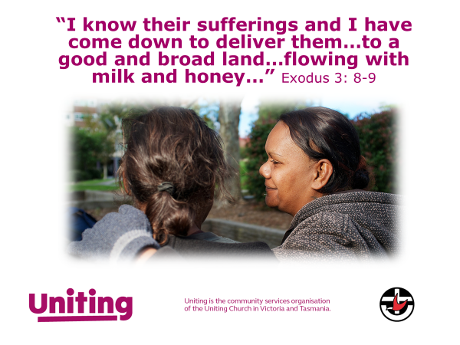
Our reading from Exodus today provides a compelling context for our Share Sunday focus on youth homelessness. It tells a story of a promise made to a people who had suffered a great deal as a minority people under an oppressive regime, a displaced people on an uncertain journey, with little in their past to encourage in them a sense of hope for what might come to them in their future. In the midst of their uncertainty, and their understandable sense of despair, we hear in our reading an extraordinary invitation to hope – this promise:

“I have observed the misery of my people…..I have heard their cry…. Indeed, I know their sufferings, and I have come down to deliver them… to bring them up out of that land to a good and broad land, a land flowing with milk and honey.” (Ex 3:7-8).

It is at once a promise that reveals not only what it is that we, as this people, can hope for, but also the identity of the one who makes the promise. This is the one who sees, who listens, who knows and understands, and then who acts, in profound solidarity, to bring healing and hope to a dispirited people. This is the one who ‘comes down’, to meet the people where they are, in their need, to walk alongside them. But more than that, to then lead them into that promised place, that ‘good and broad land’, where they will find sustenance, respite, rest, and relief from those past sufferings – a place they can call home.

As one of the foundational stories of our shared faith, this promise of a home or homeland shapes our hopes for ourselves and indeed for all people. It is a beautiful, persistent, insistent hope: A hope that holds a particular challenge to us as people of faith as we turn our focus to the wicked problem of homelessness in our Australian community this Share Sunday. And it is a wicked problem, in every sense of that word.

The numbers are startling and disturbing. Take a few minutes to read some statistics.

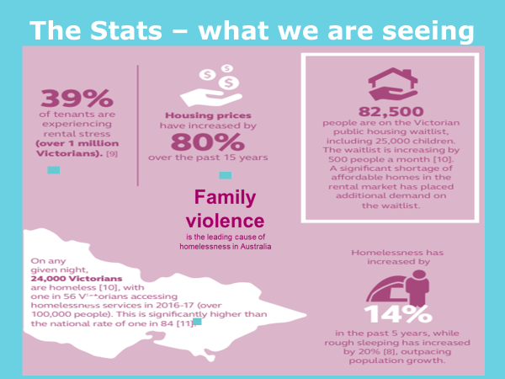
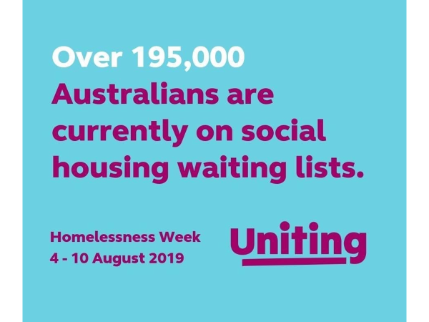

The most disturbing statistic is the easiest and most necessary one for us to remember. The
sad reality is that 2 out 5 people who experience homelessness are under the age of 25.

Over recent months, many of us have experienced – far more intensely than ever before – the centrality and significance of what it is to have a place to call home. While we may have grown a little weary of our far too familiar ‘four walls and roof’, we, nonetheless, have felt the comfort and security of that place of rest and respite from the viral menace threatening our communities. Our homes have become the places where we work, continue our education or educate our kids, attend our virtual doctor’s appointments, connect with our friends, our church. Alongside, of course those more prosaic comforts of a bed to sleep in, a fridge of food to raid (far too often) a bathroom to escape to for privacy as much as those more traditional functions. We have a new appreciation of all it means to have a home, and a sharper perception too of what it means if you do not. What does it mean for those 2 young people out of every five for whom homelessness is their reality?

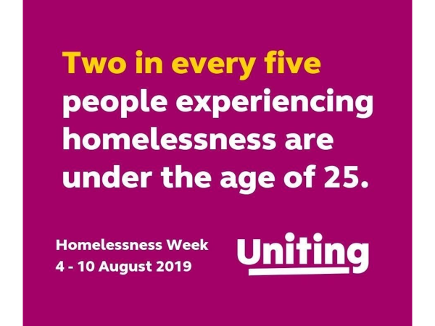
These are indeed troubling statistics. It can be tempting to be overwhelmed by the numbers, by the sheer scale of the problem. But as people of faith, the beneficiaries of a promise more compelling than any statistics, we must not allow ourselves to be overwhelmed. We have a promise to live out of and live into – no matter how wicked the problem seems. And promises of course are not in the end about statistics or problems. Promises are about people, they are made to people.
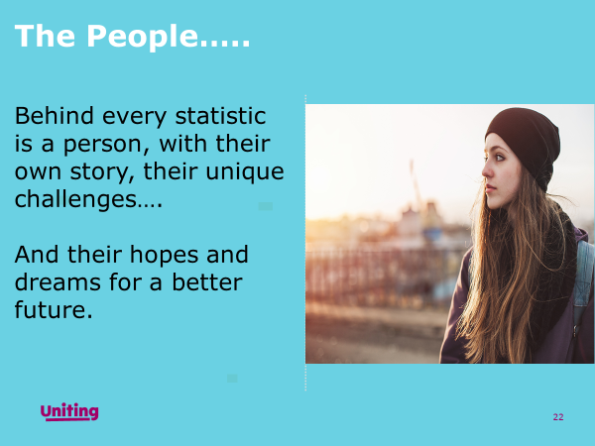

Our invitation this Share Sunday, extended through our shared faith, an in particular our reading form Exodus, is to grab hold of an ancient but ever new promise and ask how that might inform our response, not to the problem of homelessness, but to the young people at risk of or experiencing homelessness. Is there hope for them for that promise of a good and broad land? If not flowing with milk and honey, then at least a warm bed, a well stocked fridge, and a good internet connection to help them to stay connected to their opportunities for access to education, support, friendship, medical care, employment.

Will we grab hold of that promise and commit our time, talents, and yes, our money, to doing our little bit for that promise to come to fruition?

By way of an answer, please watch these two beautiful stories of what can happen when we see beyond overwhelming statistics; when we see, listen, understand and stand in solidarity with our young people.

Watch:
Janet’s story – https://vimeo.com/423497295
Jordan’s story - https://vimeo.com/423497980

5. Share Sunday 2020 – A place to Call Home.

Some Additional Background
- On any given night, 6,000 young Victorians are homeless. Common triggers are domestic and family violence, problematic drug and alcohol use (by the young person or their parents) or relationship/family breakdown.
- Particularly high rates of homelessness have been identified for young people exiting out-of-home care.
- The transition from youth to adult independence is a time of high vulnerability to homelessness. Experiencing homelessness at a young age can affect the persons trajectory for life, increasing their likelihood of alcohol and substance abuse, poor physical and mental health, social isolation and future homelessness as an adult. Intervening early is essential.
- Victoria’s Homelessness and Rough Sleeping Action Plan has no dedicated strategies to address youth homelessness.
- Young people experience homelessness and engage with homelessness services in ways that are different to people of other ages. For example, young people tend to have poor knowledge of Specialist Homelessness Services, so co-locating with mainstream services where young people are already engaged strengthens accessibility for this group. Adult services such as temporary accommodation options may also be unsafe for young people.
- The last Youth Homelessness Action Plan ran between 2006 - 2010, meaning that there has been no real action on youth homelessness for almost a decade. Between 2006-2016 homelessness amongst 19- 24 year old's has increased by 66%.
- Labor MP Paul Edbrooke said recently that while there had been significant investment into tackling homelessness ‘the thing we haven’t done well, up until now, is addressing youth homelessness. We’ve got a lot to do down here.’

Join with Uniting to advocate for:

- Support to access safe, stable and affordable accommodation
- Better transition planning for children leaving care
- Employment, education and training support for young people experiencing or at risk of homelessness
- Support to maintain connection to family
- Increased funding to specialist youth homelessness services/housing and support models.

The suggested means to deliver this will be a dedicated action plan from state government though we will work with consumers and other stakeholder groups (see below) to identify other areas of direct action that could contribute to the above outcomes.

Key messages:

Our ask is that the Victorian government ‘act on youth homelessness’.

- Young people are highly vulnerable when homeless
- Young people experience homelessness differently to adults and access services in different ways
- Young people don’t belong in adult services
- Preventing youth homelessness and intervening quickly when it does occur protects young people from poor life outcomes

6. Acknowledgement
These resources have been created and compiled by Uniting for use in congregational worship and may be modified and used according to local custom with acknowledgment.

