  - 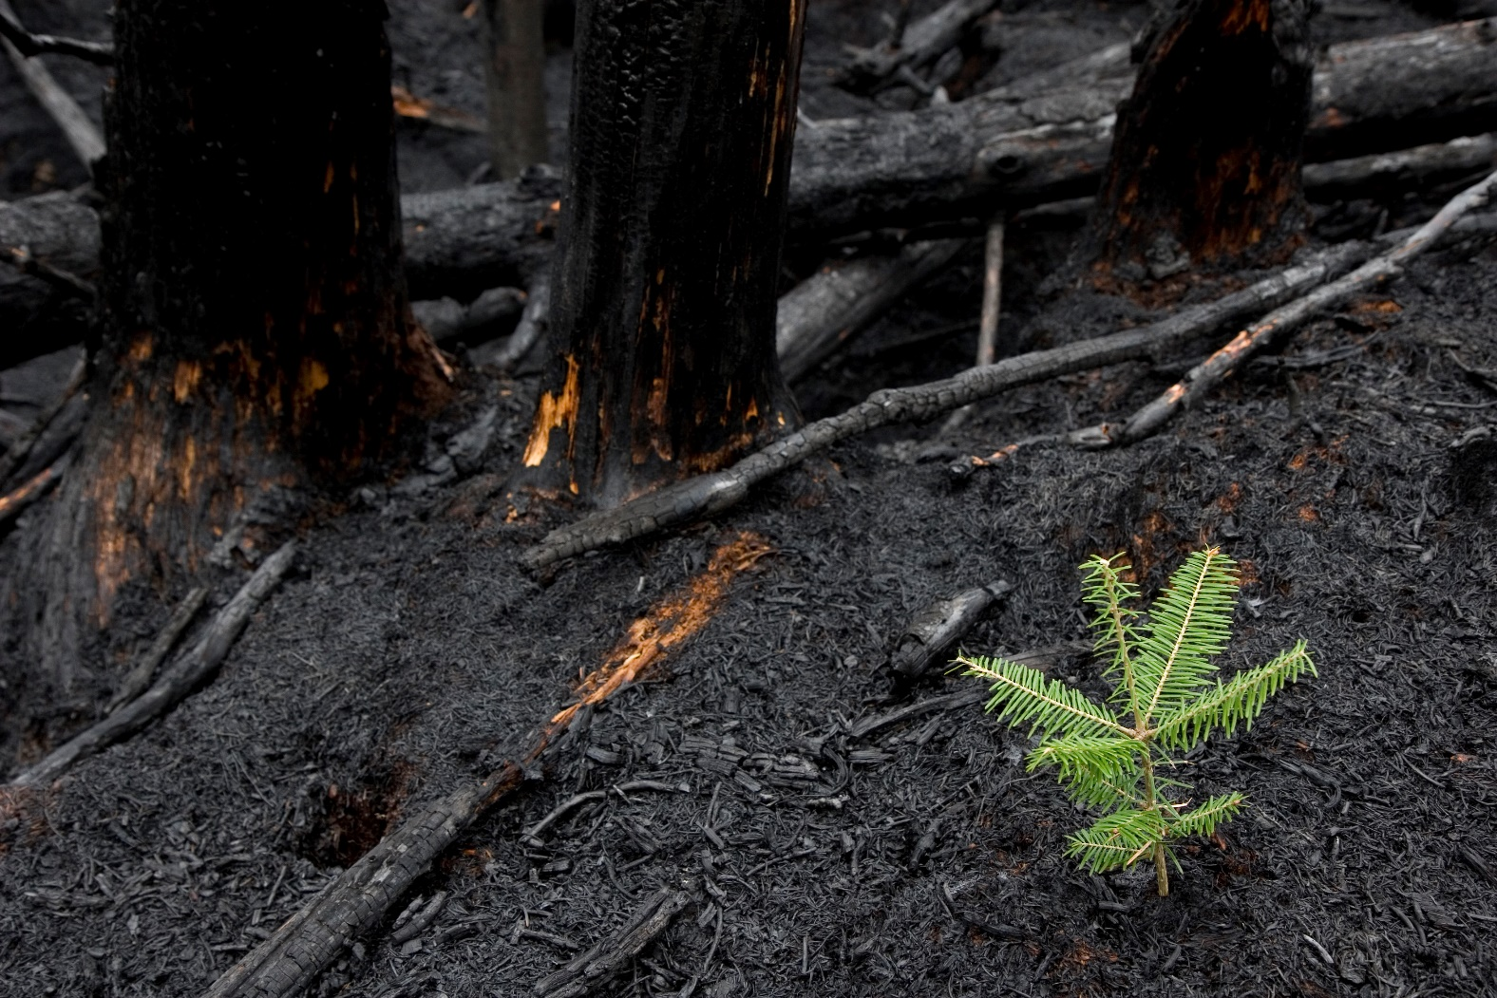

East Gippsland Uniting
Bushfire Recovery
RAPID ASSESSMENT and THEORY OF CHANGE

JUNE 2020

Acknowledgments
Principle Author:
Courtney Innes, Plan International Australia

Key Contributors:
Di Fisher, Linde Coggan and Ruth Churchill (Uniting Vic.Tas)

We also wish to thank the following people for their valuable contributions:
Wenda Donaldson, Crystal Russell (Uniting Vic.Tas)
Jan Parry, Dave Husy (Plan International Australia)

This material has been financed by the International Medical Corps (IMC). Responsibility for the content rests entirely with Uniting Vic.Tas and Plan International Australia (PIA). IMC does not necessarily share the expressed views and interpretations.

Contents
Definitions 5
1. Executive Summary 6
Project background and rationale 6
Aims of the project 6
Project methodology 6
Findings 7
Key challenges identified 7
Key opportunities identified 7
Conclusions 8
Next steps 8
2. Introduction 9
3. Why focus on children and young people? 10
Children in Emergencies (0-18 years old) 10
Young People in Emergencies (10-25 years old) 10
Prioritising Children and Young People 10
Uniting’s commitment to Children and Young People 11
4. Background 12
East Gippsland 12
Snapshot 12
Economic factors 12
Geographic factors 13
Social factors 13
Bushfire impact 2019-2020 14
Snapshot 15
Property clean-up 15
Recovery Branches 15
People and Wellbeing (Social and Community) snapshot 16
Funding – People and Wellbeing (Social Recovery) Financial Snapshot 18
Joint Commonwealth-State funding 18
Victorian Government 18
Social Recovery 18
Mental Health and Psychosocial Support Services 19
Victorian Government 19
Joint Commonwealth-State funding 19
Community Support 20
Individual and Household Assistance 22
5. Methodology and design 24
How was the report developed 25
Who was involved 26
6. Findings 28
Needs identified (since bushfires) 28
Children people aged 5-11 28
Overview 28
Qualitative 29
How are they coping? 30
Young people aged 12-18 30
Overview 30
Qualitative 31
How are they coping? 32
Inclusion and young people 33
Overview 33
Families 34
Overview 34
Qualitative 35
Coping Strategies 36
7. Governance and coordination 38
8. Key bushfire coordination bodies 40
Bushfire Recovery Victoria 40
Background 40
BRV Operations 41
BRV Strategy 42
Principle Policy Officer for Children, Youth and Families 42
Bushfire Recovery Centres 43
East Gippsland Shire Council 43
Districts and Place Managers 44
Community Recovery Committees 45
Social Recovery (People and Wellbeing) Committee East Gippsland 45
Psychosocial Sub-Committee for East Gippsland 46
9. Pre-Existing Coordination Networks for East Gippsland 47
Coordination Networks 47
10. Identified Themes 49
11. Bushfire recovery support services 51
12. Reports, research and communication 58
Current Gaps 58
Reports and Research 58
Communication Mechanisms for Bushfire Recovery 59
13. Discussion 60
Key challenges identified 62
Key opportunities identified 62
14. Conclusion 63
Opportunities 63
Communication 64
Inclusion 64
15. Uniting’s bushfire recovery theory of change 65
16. Bibliography 66

Definitions
Definition of ‘Child’ and ‘young person’
The UN Convention on the Rights of the Child (UNCRC) in Article 1 states that a ‘child’ is a person below the age of 18 years old.
There are four crucial stages of development that are pertinent when designing interventions to support children: early childhood (aged 0-4), primary (aged 5-9), lower secondary (aged 10-14), and upper secondary (aged 15-19).
Below is an overview of the different definitions of children and young people.
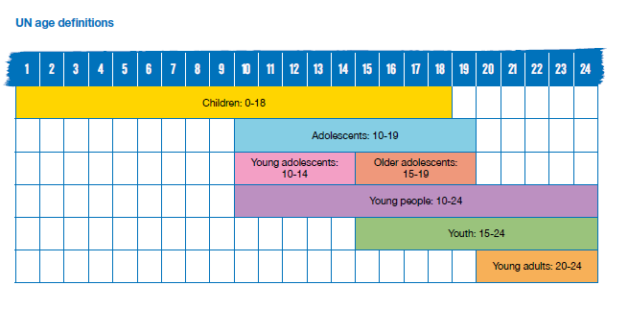
(Plan International, 2020)
This Rapid Assessment asked key informants about children and young people from age 5-18 years old. However, when it came to considering the activities to support the recommendations of the Rapid Assessment, Uniting Vic.Tas made a decision to extend their activities to include young people up to age 2, and their existing programming for the early development years 0-4, thereby supporting children and young people across all the developmental ages.
Psychosocial
The interrelation of social factors and individual thought and behavior.
Psychosocial resilience
Describes the capacity of individuals to navigate their way to the psychological, social, cultural and physical resources that sustain their wellbeing and their capacity individually and collectively to negotiate for these resources to be provided and experienced in culturally meaningful ways.

Executive Summary
Plan International Australia and Uniting Vic.Tas Bushfire Recovery Rapid Assessment and Theory of Change

Project background and rationale
In January 2020, Australia faced an unprecedented national crisis, as bushfires tore through bushland and rural communities across the country. In Victoria, the area of Gippsland in the east of the state was the most affected. The protracted nature of this crisis created circumstances that had never previously been experienced by communities or government response and relief agencies.
In Australia, and internationally, disasters disproportionately impact on children and youth. Children are unlikely to have cognitive capacities and emotional maturity to effectively manage challenges from disaster, and exposure to disasters increase their risk of serious and long-term consequences for social, psychological, emotional, cognitive and physical development. For young people, crisis situations can also accelerate or even skip the transition of adolescence into adulthood.
Uniting Vic.Tas (Uniting) has a long history of service provision within East Gippsland focused on children, young people and their families. A shared interest in the rights, participation and wellbeing of children and young people in bushfire recovery efforts brought Uniting and Plan International Australia together to partner on this project.
Plan International Australia strives to advance children’s rights and equality for girls all over the world. As an independent development and humanitarian organisation, PIA work alongside children, young people, supporters and partners to tackle the root causes of the challenges facing children, especially girls. PIA also support communities affected by natural disasters or emergencies.
By drawing on PIA’s capabilities, models and partners from international practice and combining this technical support with Uniting’s local knowledge and trusted relationships, we hope to contribute a unique perspective to support disaster recovery efforts in East Gippsland.

Aims of the project
This project aimed to:
- Undertake a Rapid Assessment and mapping of the current situation for children and young people across the developmental ages in bushfire-affected communities in East Gippsland.
- Develop a Theory of Change that provides the conceptual framework to plan and action our collective contribution to the immediate and longer-term recovery needs of children and young people in East Gippsland.
We hope that this project is beginning of ongoing conversation about the recovery needs of children and young people in East Gippsland.

Project methodology
The Rapid Assessment and Theory of Change were informed by Sphere Minimum Standards for Child Protection in Humanitarian Action and underpinned by Bronfenbrenner’s ecological systems theory.
Plan International and Uniting worked together to design 25 qualitative and quantitative interview questions. In total, interviews were conducted with 32 Key Informants across a range of Local Government, State Government and Community Service providers. Efforts were made to ensure interviewees had experience and knowledge on the different thematic areas and provided services across East Gippsland shire in locations such as Bairnsdale, Mallacoota, Cann River, Orbost and Buchan. Approximately 80 per cent of Key Informants identified as female and 20 per cent as male.
A major gap in this rapid assessment were the voices of children and young people. A decision was made not to interview children and young directly, as the short project timeframes may have compromised ethical data collection and representativeness. We recognise the critical need to hear directly from children and young people in the future to ensure a holistic approach.
The desktop review, data collection and Theory of Change workshops were conducted between 7 May 2020 and 24 June 2020.

Findings

Key challenges identified
The primary data collection highlighted the following key challenges:
- ‘Isolation from Peers’ and ‘Psychosocial Distress’ were the main sources of stress identified by Key Informants for children aged 5-11, and young people aged 12-18. The top two sources of stress identified for families of children and young people were ‘Psychological Distress’ and ‘Interactions with Formal Bodies’.
- Many Key Informants reported that direct opportunities for children and young people to be engaged in their recovery process were limited, but mostly non-existent.
- A lack of an inclusion lens was observed by many Key Informants at all governance levels of recovery.
- Key Informants reported unclear recovery coordination and governance mechanisms between:
  - State-based services and regional-based services
  - Government bodies and Non-Government Organisations/Community Service Organisations
  - Formalised recovery services and systems, and the community
  - Commonwealth funded programs and State funded programs.
- A disconnect between coordination of the services and systems that support child and youth rights centrally at a state level and at a regional level in bushfire affected areas was another key challenge perceived by many Key Informants.
- Clear communication to the community on coordination, governance, service access, community support and general trauma informed information was reported by Key Informants as limited and inconsistent.
- Key Informants stressed that the experience of the global COVID-19 pandemic was and will continue to interrupt communities from engaging in recovery processes that traditionally support their mental health and wellbeing.

Key opportunities identified
The primary data collection revealed the following opportunities to:
- Further strengthen connected coordination of the services and systems that support child and youth rights at a state-based and regional level.
- Leverage existing child and youth centred services and networks to embed a coordinated recovery approach.
- Better coordinate data gathering on the voices of children and young people in recovery.
- Provide more psychosocial support in community or group work, such as community recreational activities, to respond to isolation and psychosocial distress beyond one-on-one therapeutic interventions which are already well-resourced.
- Support the Community Recovery Committees (along with EGSC and BRV) to enhance the clear communication of the recovery mechanisms to the broader community, and to ensure a child and youth-centred approach.

Conclusions

Children and young people are actively involved in decision making at all stages of the emergency management cycle, from planning and preparedness to response and recovery, including activities in their own communities
Opportunity for child and youth-centred services and networks at a regional, state and Commonwealth level to work in coordination and collaboration to ensure that:
- The voice of all children and young people, are valued, and they are able to express themselves in culturally safe environment.
- All children and young people, especially those from diverse cultures and rural and remote areas, have the skills, connections and opportunities to participate and lead in decisions affecting their preparedness, response and recovery to emergencies.

Social connectedness increased (and psychosocial distress decreased) through community-based activities and group work
- Opportunity among services providers and networks in East Gippsland to scale up interventions that focus on community connectedness and that support families to develop a sense of safety and stability in the homes and community of children and young people.
- Opportunity, through the Psychosocial Sub-Committee, to expand their focus in this next stage of recovery, to include all the services that provide mental health and psychosocial support to children and young people across individual, group and community focussed interventions, and across all state, federal and privately funded backgrounds.

Communication
Opportunity for child and youth-centred services and networks to consider how they can support communication processes:
- Across the socio-ecological framework of the community
- Between the different tiers of governance
- To provide trauma informed key messaging on the recovery process to all relevant target groups, including children and young people, in a systematic and structured manner.

Inclusion
- Opportunity for child and youth centred services and networks to advocate an increased understanding and response to the diverse needs of these diverse groups.

Next steps
Our intention is to promote these findings widely and work collaboratively to help inform and contribute to the recovery efforts of children and young people in East Gippsland. We aim to distribute the final report and related resources widely through our networks, especially with the individuals who so generously contributed their insights as Key Informants.
We look forward to continuing to progress this work together to support collective recovery outcomes for East Gippsland communities and more widely across Victoria.

Introduction
In January 2020, Australia faced an unprecedented national crisis as bushfires tore through bushland and rural communities across the country. In Victoria, the area of Gippsland in the east of the state was the most affected with 11,311 km² or 54 per cent of East Gippsland burnt, including 902 km² of primary production land burnt (21 per cent of primary production land), and 9,979 km² of bushlands and forests burnt (63 per cent of bushlands and forests burnt). By 28 May 2020, 553 properties were registered for clean-up in East Gippsland (BRV, n.d.) The fires burnt for a protracted period, with extended closures of major roads including the Princes Highway, Great Alpine Road, Monaro Highway and Genoa-Mallacoota Road. Highways were closed for up to 37 days (Princess Highway East), with Bonang Road closed for 85 days (EGSC, 2020). Finally, on 20 February 2020, the East Gippsland bushfire that had burned for three months was declared "contained" (Final Significant Fire Contained in Victoria - CFA News and Media, n.d.).
The protracted nature of this crisis created circumstances that had never previously been experienced by communities or government response and relief agencies. This combined with the establishment of two new recovery agencies National Bushfire Recovery Australia (NBRA) and Bushfire Recovery Victoria (BRV) at the time of the fires, has created a new landscape for recovery in Victoria and Australia.
East Gippsland encompasses two local government areas and in recent times, before the bushfires, were already impacted by natural disasters such as bushfires or floods, economic downturns caused by drought or reduction of size of major industries including energy and mining. Currently, they are managing the compounding impacts of bushfire recovery in a time of global health pandemic due to COVID-19.
Uniting Vic.Tas (Uniting) have a long history of service provision within East Gippsland focused on children, young people and their families, and wish to ensure that they are best able to meet the needs of children and young people in the recovery process of East Gippsland. Through the engagement of a Plan International Australia Child Protection Consultant, Uniting collaborated with Plan International Australia (PIA) to undertake a rapid assessment of the current situation for children and young people, across the developmental ages, in bushfire-affected communities in Victoria. The purpose of this rapid assessment was to assist in determining the recovery needs of children and young people, who was supporting them on what issues, and where. This assessment enabled Uniting to identify opportunities for Uniting to respond directly to the needs of children and young people and collaborate with other stakeholders to respond to emerging gaps.
Utilising this rapid assessment, a Theory of Change has be developed for Uniting that considers children and young people across the developmental ages, at its centre, and aligns to a socio-ecological framework (children, family, community and systems), underpinned by trauma and recovery informed practise. The Theory of Change provides the conceptual framework by which Uniting will plan and action their contribution to the immediate and longer-term recovery needs of children and young people.

Why focus on children and young people?
In Australia, and internationally, disasters disproportionately and often severely impact on children and young people, influencing their health, education, living situations and work opportunities, often with lifelong implications. To mitigate or reduce their exposure to risks, and increase their personal resilience, as well as the resilience of their families and communities, we must include children and young people’s perspectives and involve them in emergency preparedness, planning, response and recovery. Children and young people are not only important stakeholders, but are also powerful agents of change (Mami Mizutori, 2020):
‘...showing respect to children and young people (is really important) because they bring a wealth of knowledge and a wealth of experience from their world.'

Children in Emergencies (0-18 years old)
Children are one of the most vulnerable groups during and after disaster events comprising approximately 30–50 per cent of all disaster-related mortalities (World Health Organisation, 2019). Children are dependent on adults for safety and protection, are in formative periods of physical and psychological development and may be unable to recognise hazards on their own (Masters, 2020).
Further, children experience and process traumatic events differently from adults (Save the Children Australia, 2020). They are less likely to have cognitive capacities and emotional maturity to effectively manage all of the challenges that arise after a disaster, and exposure to traumatic events, such as emergencies and disasters, increase the risk of serious and long-term consequences for the social, psychological, emotional, cognitive and physical development of children (Masters, 2020).

Young People in Emergencies (10-25 years old)
Adolescence marks the transition from childhood to adulthood when a young person experiences many drastic changes in their body, mind and the way they relate to the world. Adolescents start to form stronger connections with peers, while seeking more independence from their parents and families (Plan International, 2020, UNICEF, 2017).
Crisis situations can accelerate or even skip the transition of adolescence into adulthood. In situations of economic pressure, adolescents are more likely than younger children to be pulled out of school to take on caregiver or breadwinner roles in the family, or to migrate away from their families to seek work elsewhere. While carrying adult responsibilities, adolescents are not treated as such by society; their access to information and services is limited, as is their ability to participate in decisions affecting their lives. They are often chronically overlooked.

Prioritising Children and Young People
Collaborating with children, young people and communities will help build their resilience and ensure emergency plans are more robust, inclusive and fit for purpose in a localised context. The Take Care: A toolkit by Save the Children UK (2017) highlights that when children are given the opportunity to share their opinions and thoughts, it can significantly contribute to reducing their vulnerability before, during and after disasters. A growing body of evidence suggests that:
- There are mental health and wellbeing benefits arising from children and young people’s involvement (Peek 2008; Anderson 2005; Mitchell, Tanner & Haynes 2009).
- Children and young people introduce fresh and new ideas (Bolton & Neuwelt, 2014) and perceptions of the surrounding world. They can have a sophisticated understanding about disasters (Harwood et al. 2014).
- Children and young people can be key players in designing and creating resources for their peers, such as educational tools, a disaster management school curriculum (including a school emergency response plan), disseminating warnings, preparedness measures and reaction capacities, and planning for the protection of the environment to their parents and the wider community (Ronan et al. 2015; Bolton & Neuwelt, 2014; Finnis et al. 2010).
- Children and young people are good at analysing and communicating risk (Mitchell et al. 2008), sharing and contextualising knowledge, building credibility and trust and persuading others to act (using media, theatre, concerts). Children and young people are excellent social networkers and community-builders: they are good at mobilising people and resources (Geiselhart et al. 2008).
- Children and young people’s participation can be beneficial at recovery and rebuilding phases (Bartlett, 2008; Pine et al. 2015). Children and young people’s accounts have proved to be important to raise subtle and unconsidered questions and dimensions about the impact of disasters, such as who is actually affected by the disaster and how vulnerability is produced during the recovery process (Walker et al. 2012).
Children and young people require different approaches to their recovery process that is both reflective of their development age, and supported by family, adults and the broader community (Masters, 2020). Children and young people can encourage and teach others, have energy and creativity, and they understand their situation better than anyone else.
'Children and young people play an incredible part in recovery – a part that will be healing for them and will bring about this sense of belonging, a sense of agency and control.'
'We really need to see young people as experts on their own situations in recovery... [and] be willing to go through those challenges of asking questions and navigating the media space and information alongside them.'

Uniting’s commitment to Children and Young People

Uniting's role in child, youth and family services
Uniting works alongside children, young people and families in vulnerable situations, to provide case management, advice and counselling so that they can overcome these issues and live happy, healthy lives. In East Gippsland, we deliver a range of child and family services including family support services, family violence counselling, out-of-home care services, leaving care supports and placement, prevention and family reunification services, as well as brokerage and homelessness services for children and families in need of urgent support.

Uniting's role in early learning and school settings
Uniting runs 60 early learning services across Victoria and Tasmania including eight centres in East Gippsland. We provide early learning, family day care, occasional care, kindergarten, out-of-school hours care, and vacation care services help strengthen families, enabling parents to work while balancing their parenting responsibilities. We employ Kindergarten Inclusion Support workers and Preschool Field Officers to support children with additional needs, promoting and strengthening a best start to learning. In Gippsland, we provide early years intervention programs including Home Interaction Program for Parents and Youngsters (HIPPY), Best Start and supported playgroups.
We also deliver programs through outreach and innovative engagement strategies in schools and other service settings to improve health, wellbeing and development of children and young people.

Uniting's community development approach
Uniting has recognised leadership in East Gippsland in consultation, partnerships and a community development approach including facilitating and coordinating evidence-based therapeutic programs through Communities for Children such as Drumbeat, Secret Agent Society, Rhythm to Recovery and Play to Learn. We are established in local networks across East Gippsland and value opportunities to collaborate, bring services and community together around particular identified needs.

Background

East Gippsland
An overview of the East Gippsland region is detailed below.

Snapshot
- Total area: 20,940 km²
- Major towns: Bairnsdale (12,952 people), Lakes Entrance (6,071 people), Orbost (2,014 people), Mallacoota (1,005 people)
- Population: 44,960
- The median age in East Gippsland is 50 years old, compared to the Australian median age of 38 years old. The age of the earning population is 50 years old, which is higher than the Victoria median age of 42 years old.
- Children and young people under 25 years old made up 25 per cent of the total East Gippsland population.
- 2.9 per cent of the population of East Gippsland identify as Aboriginal and/or Torres Strait Islander. This can be compared with the Victoria wide average of nearly 1 per cent.
- The Socio-Economic Indexes for Areas (SEIFA), is a socio-economic index that summarises information about the economic and social conditions of people and households in an area. Lower scores reflect higher relative disadvantage, and higher scores correspond to lower relative disadvantage. East Gippsland is relatively disadvantaged with a SEIFA decile of 4, the national median is 5.

Economic factors
The median income is $37,743, lower than the Victorian median of $47,709.
East Gippsland has a higher proportion of government pensions and allowances recipients than Victoria:
- Aged pension: 20.9 per cent (Victoria 9.2 per cent)
- Carer allowance: 3.9 per cent (Victoria 2.5 per cent)
- Disability support pension: 5.4 per cent (Victoria 2.8 per cent)
- Commonwealth rent assistance: 7 per cent (Victoria 4.3 per cent).

Number of businesses
Employing | 1,601
Small business (<20 employees) | 1,530
Sole traders and other non-employing | 2,807
Total | 4,408
(National Bushfire Recovery Agency, 2020).
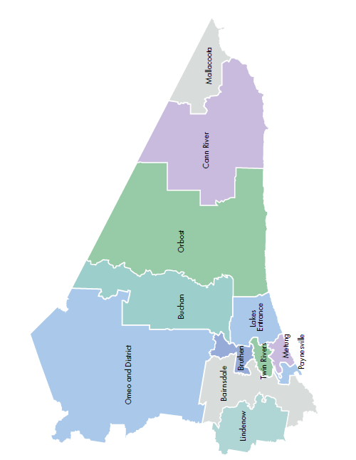

Geographic factors
East Gippsland is the second largest local government area in Victoria by area. The population of approximately 44,000 is spread across this region with upwards of 100 individual communities. There are vast differences between these communities, and it is essential to recognise that a one size fits all approach is not appropriate and consideration of the individual qualities of communities must be taken into account (East Gippsland Shire Council, Primary Care Partnership, 2017).
The unique geography and overall size of East Gippsland makes transport an on-going issue for families and children to travel easily around the region. This in turn creates challenges in accessibility to critical services such as health care, education and employment. Those living in remote areas have limited or no access to public transport (ARACY, 2018).

Social factors
In December 2019, Red Cross assessed the impact of the prolonged drought on farming communities in the region, with East Gippsland and parts of Wellington Shire experiencing below average to lowest recorded rainfall since 2016. They found that drought-related stress affected children and young people who were under significant pressure to contribute to the business and help reduce the workload of their parents during drought. The following quote illustrates this pressure: “Some children may miss school, give up sport and recreational activities and lose much needed sleep. Students as young as 13-years-old are working longer days than most adults.” (p 9, Brown, 2019). A UNICEF report on the impact of the drought in NSW on children and young people also found that drought places an emotional toll on children growing up prematurely and having responsibilities beyond their years (UNICEF, 2019).

In 2018 The Wellbeing of Children and Young People – East Gippsland Report 2018 highlighted that while there were some positive shifts in population data at a Local Government level of East Gippsland, there were additional challenges for the community to tackle.
Compared to Victorian averages these include:
- The percentage of children arriving at school who are developmentally vulnerable in physical health and wellbeing, language and cognitive skills, communication skills and general knowledge starting school are higher
- The percentage of four-year-olds attending kindergarten has been decreasing since 2011
- The number of family violence incidences are higher, along with a high number of children and young people who are present at family violence incidences
- The number of children and young people who are a victim of crime continues to be much higher
- The rates of children who report being bullied in Year Five to Year Nine are much higher
- The percentage of children at high risk of emotional and behavioural difficulties is greater
- There is a higher proportion of children who have additional needs
- The rising number of child protection substantiations needs attention.
Compared to Australian students these include:
- Year Eight East Gippsland students report a significantly higher level of depressive symptoms compared with the same group Australia-wide
- Students report a decline in coping with stress from Year Six to Year Ten
- Compared with students across Australia, Year Eight East Gippsland students report significantly lower levels of emotional control
- East Gippsland students report significantly higher rates of lifetime and recent alcohol use.

Bushfire impact 2019-2020
The 2019-2020 Bushfires was East Gippsland’s largest ever disaster. Below is an overview of the timeline of the fires:
- 21 November 2019 – fires first reported.
- Late November 2019 – active fires around Bruthen and Great Alpine Road.
- 27 December 2019 to 10 January 2020 – significant fire activity.
- Late January 2020 to early February 2020 – significant fire activity.
- 19 February 2020 – Tambo District fires contained after 91 days.
- 20 February 2020 – Snowy District fires remain going, including 73 ha peat fire near Cape Conran.
(EGSC, 2020)

Snapshot
In June 2020, the National Bushfire Recovery Agency has compiled profiles of local government areas (LGAs) affected by bushfires (108 in total). They found that in East Gippsland:
- 54 per cent of the shire was impacted by the 2019-20 bushfires
- 11,311 km² burnt
- 902 km² of primary production land burnt (21 per cent of primary production land)
- 9,979 km² of bushlands and forests burnt (63 per cent of bushlands and forests burnt)
- $8 million in primary producer grants were provided.
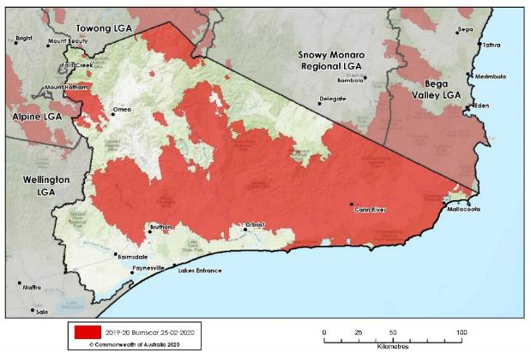

Property clean-up
As of June 2020, 254 debris clean-ups have been completed in Victoria (National Bushfire Recovery Agency, 2020). In East Gippsland, as of 28 May 2020, 553 properties are registered, works have commenced at 267 properties and 229 clean-ups are complete (BRV, n.d.).

Recovery Branches
The six recovery branches or Working Groups of Recovery in Victoria are:
- Buildings and Infrastructure (Built Infrastructure) – Chair: East Gippsland Shire Council (EGSC)
- Bio-diversity and Environment (Environment) – Chair: Department of Environment, Land, Water and Planning (DELWP)
- Business and Economic (Economic and Agriculture) – Chair: Regional Development Victoria (RDV)
- Built Infrastructure - Chair: East Gippsland Shire Council (EGSC)
- People and Wellbeing (Social and Community) (Social Recovery) – Chair: Department of Health and Human Services (DHHS)
- Aboriginal Cultural and Healing – Chair: Aboriginal Victoria supported by Gunaikurnai Land and Waters Aboriginal Corporation.
These branches or working groups are discussed in more details in the chapter Governance / Coordination. A snapshot related to Buildings and Infrastructure, Bio-diversity and Environment, Business and Economic, and Built Infrastructure can also be found at Appendix 1. No publicly available snapshot was found in relation to Aboriginal Cultural and Healing.
For the purposes of this rapid assessment, we will focus on the People and Wellbeing snapshot.

People and Wellbeing (Social and Community) snapshot
No publicly available snapshot found. Information below has been obtained from private meetings.
Case Management
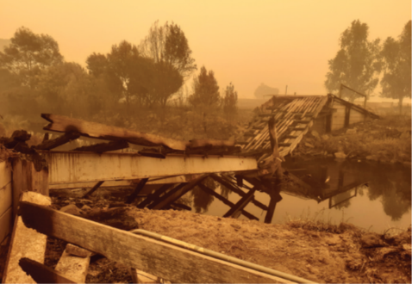
- Services providing case management are Gippsland Lakes Complete Health and Gippsland East Gippsland Aboriginal Co-operative, with Windemere providing triage and intake. Anecdotally, reports have indicated over 700 cases referred into case management across all services.
- Case support program will be a continued feature of the support that people need.
- Case management has been funded for 12 months ending January 2021, but will re-assessed after the internal Deloitte review.
Housing and accommodation
- It is understood that all people who lost their homes, are now in some sort of heated accommodation.
- East Gippsland were already struggling with low public housing and existing private rental stressors in areas like Mallacoota given tourist accommodation.
Individual and Household Financial Assistance:
Federal
Individuals and families
Payment type | No. of Payments | $ Paid
Disaster Recovery Allowance | 272 | $1.02 million
Disaster Recovery Payment | 3,054 | $3.492 million
Additional Payment for Children | 1,201 | $480,400
Small business and primary producers
Payment type | No. of Payments | $ Paid
Concessional loans | 1 | $100,000
Primary Producer grants | 122 | $8.086 million
Small business support grants ($50,000) | 38 | $986,582
Small business support grants ($10,000) | 617 | $6.17 million
(Funding, National Bushfire Recovery Agency, n.d.)

Victorian Government
- The Victorian Bushfire Appeal Fund allocated more than $16 million to help individuals and families recover. Housing Assistance Payments of up to $25,000 will be made to owner/occupiers and renters whose principal place of residence was either destroyed or severely damaged by bushfire. Payments will be made available through Windermere.
- Payments of between $1,000 and $4,500 are available through the Gippsland Emergency Relief Fund and The Salvation Army, Gippsland & East Gippsland Aboriginal Co-Operative, the Moogji Aboriginal Council East Gippsland and the Victorian Aboriginal Child Care Agency (VACCA)
(More Relief For Bushfire-Affected Victorians, Premier of Victoria, n.d.).
Psychosocial Support/mental health
No publicly available impact snapshot found.
Health and Medical Assistance
Did not seek this snapshot as it is beyond the remit of the project.
Community Development and information
No publicly available impact snapshot found.
Children and Young People
No publicly available impact snapshot found.
Save the Children Australia completed a submission to the Royal Commission into National Natural Disaster Arrangements in April 2020 (Save the Children, 2020). Save the Children Australia reported that disasters such as the recent bushfires can cause trauma and significantly affect children’s physical, mental, cognitive, emotional and social wellbeing and development, creating problems that reverberate into adulthood, impacting educational and employment outcomes. Children experience and process traumatic events differently from adults. Lisa Gibbs and colleagues (2014) summarised this evidence:
“The impact of disasters on the mental health, well-being and social inclusion including school engagement and social engagement of children and young people is well established. These effects, including anxiety, depression and post-traumatic stress, can extend into adulthood. For those who do demonstrate mental health problems or social difficulties, the presentation of any impacts will vary across age, time, setting and will interact with the effects of the disaster on the child’s parents, family and community. Children’s and young people’s sense of safety and security, their ongoing development and their social relationships can all be compromised”.

Save the Children Australia highlighted that during the bushfires in East Gippsland children’s needs were systematically misunderstood and overlooked in the response to the 2019-20 bushfires (p.9, Save the Children, 2020) because:
- Children’s services were not regarded as essential services
- There were systematic barriers to supporting children effectively
- Child Friendly Spaces were provided only where private funding was available.

Funding – People and Wellbeing (Social Recovery) Financial Snapshot
Delivering relief and recovery assistance to local communities has been a priority of all levels of government across Australia, and specifically to East Gippsland. Below is a brief snapshot of the funding announcements that have been made, but by no means is a representation of all funding committed to the recovery process. This snapshot only reflects State and Commonwealth Government funding announcements and does not include public fundraising that was directed to organisations such as Red Cross and the Salvation Army.

Joint Commonwealth-State funding
Responding to natural disasters is primarily the responsibility of individual State and Territory Governments. However, in recognition of the significant cost of the 2019-20 bushfire crisis, the Commonwealth Government committed to cost-share relief and recovery efforts with State and Territory Governments under the Disaster Recovery Funding Arrangements (DRFA). Through the DRFA, the Commonwealth Government provides financial assistance directly to the States and Territories to administer to local communities.
There are four categories of assistance under the DRFA:
- Category A: Assistance to individuals to alleviate personal hardship or distress arising as a direct result of a disaster. Category A assistance is provided automatically by the states without requiring approval from the Commonwealth Government.
- Category B: Assistance to the state, and/or local governments for the restoration of essential public assets and certain counter-disaster operations. Category B assistance also covers assistance to small businesses, primary producers, not-for-profit organisations and needy individuals through concessional loans, subsidies or grants. Category B assistance is provided automatically by the states without requiring approval from the Commonwealth Government.
- Category C: Assistance for severely affected communities, regions or sectors and includes clean-up and recovery grants for small businesses and primary producers and/or the establishment of a Community Recovery Fund. Category C assistance is only made available when the impact of a disaster is severe. It is intended to be in addition to assistance under Categories A and B and is usually considered once the impacts of the disaster on affected communities have been assessed. Category C assistance is requested from the states and requires agreement from the Prime Minister.
- Category D: Exceptional circumstances assistance beyond Categories A, B and C. Category D assistance is generally considered once the impact of the disaster has been assessed and specific recovery gaps identified. Category D assistance is requested from the states and requires agreement from the Prime Minister.
(Community Visits, National Bushfire Recovery Agency, n.d.)
A fact sheet on Commonwealth Government funding as of June 2020 can found at Appendix 1, with updated versions available through: https://www.bushfirerecovery.gov.au/progress-to-date/funding.

Victorian Government
In Victoria, the State Government has provided over $300 million towards bushfire response and recovery. Announcements on how this money was spent can be found at https://www.vic.gov.au/bushfire-recovery-programs-and-initiatives, and an overview of the Victorian Bushfire Appeal can be found at https://www.vic.gov.au/bushfireappeal.

Social Recovery
A snapshot of what was found through the desk and primary review pertaining to Social Recovery is outlined below. Given the rapid nature of the assessment, this snapshot highlights only key information made available, and would not represent all available funding that has been provided for bushfire recovery in Victoria.

Mental Health and Psychosocial Support Services

Victorian Government
11 March 2020: Victorian Government pledged $23.4 million to mental health. This included:
- $8.75 million to expand mental health services, provide specialist early intervention mental health advice to GPs and community health clinicians, and provide post-disaster treatment and advisory services through leading research centres.
- $6.6 million for practical mental health support programs such as:
    - Training local groups like football clubs to recognise when teammates are developing mental illness
    - Providing advice and training to parents to support their children through the long-term process of recovery
    - Peer outreach programs for farmers, foresters and small business owners
    - Health and wellbeing meet-ups such as local exercise groups, social events, and camps for young people.
- $3 million for Aboriginal Community Controlled Health Organisations to establish social and emotional wellbeing programs, aligned with the recommendation from the Royal Commission into Victoria’s Mental Health System.

2 March 2020: Victorian Government pledged $51.2 million initiative to every Victorian Government secondary school campus with funding for a mental health practitioner by 2022, so students can get mental health support (more than 150 schools this year), with ten schools targeted in East Gippsland by the start of Term 2. By 2022, the initiative will employ registered mental health professionals in more than 300 schools across the state, including psychologists, social workers, occupational therapists and mental health nurses. They will offer counselling and early intervention services, as well as coordinating support for students with complex needs, linking in with broader allied community and health services. Every government secondary school will receive between one and five days a week of support from a mental health practitioner depending on its size and requirements.

Joint Commonwealth-State funding
16 January 2020: $76 million for counselling and mental health support nationally including:
- $44.3 million for counselling and psychological services for people on the fire fronts for immediate counselling, ongoing psychological support, including telehealth and Primary Health Networks for additional mental health services.
- $5.7 million for trauma informed care and care coordination including for delivery of trauma informed care to people on the fire fronts; support for bushfire trauma response coordinators; and a National Cross-Service Framework.
- $2.7 million community grants helping communities recover.
- $16 million supporting emergency services workers and their families.
- $7.4 million supporting young people through headspace.
17 January 2020: The Commonwealth Government committed $8 million over 18 months to Beyond Blue towards supporting mental health in early learning services and schools affected by bushfire in NSW, Victoria, Queensland and South Australia.
This funding will enable Beyond Blue and its partners Early Childhood Australia and headspace to:
- Work with schools and early learning services in current bushfire affected areas and other stakeholders to determine immediate and longer-term local needs.
- Deploy Be You workers to support schools and early learning services in bushfire affected areas.
- Run evidence-based training for teachers and early learning services staff so they know what to look out for and how to support children and young people who may experience bushfire-related trauma and distress.
- Provide evidence-based, practical information for parents and carers.
- Help educators to navigate and connect students and families to available mental health services.
(beyondblue, n.d.)

June 2020: National overview of the Bushfire Recovery Access Program:
- $10.5 million: Front line emergency distress and trauma counselling will be available immediately, with up to 10 free mental health support sessions for individuals, families and emergency services personnel.
- $29.6 million: Bushfire affected individuals and families, and emergency response personnel will be eligible to receive Medicare rebates for up to 10 psychological therapy sessions, and will not need a mental health plan from a GP or a diagnosed mental illness to obtain these services.
- Psychological therapy sessions via telehealth will be available to people in fire affected rural areas that do not have easy access to mental health professionals. These sessions will also be Medicare funded.
- Funding of up to $300,000 each for headspace centre.
- $7.4 million: Serving areas significantly impacted by fire (Bairnsdale, Albury/Wodonga and Wangaratta, Bega, Queanbeyan, Nowra, Lithgow, Penrith, Gosford, Victor Harbour, with outreach to Kangaroo Island, Mount Barker).

National overview of trauma informed care on the frontlines:
- $2.0 million: Training in trauma informed care and psychological first aid will be provided to frontline emergency staff, including doctors, pharmacists and health professionals, as well as to organisations managing frontline emergency staff to identify personnel at risk.
- $16.0 million: Specialist organisations will provide trauma care services, including for Post Traumatic Stress Disorder (PTSD) to emergency service workers and their immediate families. There will be a pilot program to provide a support and mental health literacy network for emergency services workers and their families/kinship groups.

National funding for coordination:
- $3.2 million: Bushfire mental health response coordinators will be deployed to PHNs in fire affected areas. These coordinators will ensure that all state and federal services are working together effectively so that any individuals and families in crisis will receive rapid and high quality care.
- $500,000: The Commonwealth and State and Territory Governments will work together to develop a cross-jurisdictional mental health framework for responding to national disasters.

Community Support

Victorian Government
17 March 2020: 15 neighbourhood houses received an extra $10,000 each in recognition of the incredible efforts of staff and volunteers. The Neighbourhood Houses that will receive the one-off payment are:
- Buchan Neighbourhood House
- Bruthen and District Neighbourhood House
- Benambra Neighbourhood House
- Bemm River District Neighbourhood House
- Orbost Neighbourhood House
- Cann River Community Centre
- Community Centre Swifts Creek Inc
- Bairnsdale Neighbourhood House
- Briagolong Community House Inc
- Corryong Neighbourhood House
- Bendoc Resource Centre and Neighbourhood House
- Mallacoota District Health and Support Service Neighbourhood House
- Tallangatta Neighbourhood House
- Tubbut Neighbourhood House
- Lakes Entrance Neighbourhood House
February 2020: $8.5 million from a new Bushfire Tourism and Business Fund, to support a range of projects in fire-affected areas across East Gippsland and North East Victoria. Projects supported by the funding include:
- $2 million to rebuild Buchan Caves campground, develop a new masterplan and progress the first stage of works – including a new camp kitchen and other upgrades.
- $1.9 million in additional funding for the Ride High Country Private Sector Activation Initiative to expand bike tourism in north east Victoria.
- $500,000 for Rural Skills Connect co-ordinators to provide employment and training support for bushfire-affected farmers, their families and their workers.
- $300,000 towards a new sprinkler system at the abalone fisherman’s cooperative in Mallacoota.
- $250,000 towards a new masterplan for Paynesville Foreshore and Boardwalk.

Joint Commonwealth-State funding
As of June 2020:
National recovery: Supporting communities in recovery:
- $4.2 million: Expansion of mental health services in fire affected PHNs regions (as per drought response package). This delivers solutions to match any specific needs of local communities.
- $2.7 million: Small community grants round to fund activities at grass-roots level to help mental health and healing activities post bushfires. Community connectedness and recovery grants of up to $10,000 will be available to fund grass-roots level activities to help mental health and healing activities after the bushfires.
- These activities will promote peer support, with local residents helping each other and reaching out to others to identify those who are suffering from Post Traumatic Stress Disorder or depression, and prevent suicides.
Local communities:
- East Gippsland has received $1.417 million under LGA Grants Program. The program assists the most severely bushfire-impacted Local Government Areas to quickly rebuild vital infrastructure and strengthen community resilience (Victorian LGA Profiles, NBRA, June 2020).

11 May 2020: Nationally:
- $448.5 million to support the delivery of local recovery plans with priority given to the most severely impacted regions, drawing on local voices and local governments in close partnership and as part of cost-sharing arrangements with states. “This is about locals leading the recovery with the NBRA and our state and local partners ensuring our support gets to where it’s needed most…. I urge local communities to work with their state governments and to provide the National Bushfire Recovery Agency with their priority projects as soon as possible.”
- The support will back local projects and recovery plans, in specific areas, as well as initiatives that benefit all bushfire-affected communities. The projects could include those that build community capability and wellbeing, including through workshops and events, projects that focus on the landscape and water, replacing produce and stock, supporting local jobs and building future resilience.
- Funding includes:
  - $13.5 million for Community Wellbeing and Participation - backing Primary Health Networks with additional funding to provide critical, localised emotional and mental health support for bushfire affected individuals.
  - $27.1 million for Telecommunications Emergency Resilience (as well as $10 million from the mobile blackspots program) to strengthen telecommunications capabilities prior to future natural disasters, including the deployment of approximately 2,000 satellite dishes to provide a link if other connections are damaged, plus batteries and solar panels, to rural fire depots and evacuation centres.
(Boost for Bushfire Recovery | Prime Minister of Australia, n.d.)

16 January 2020: Joint-funded $86 million Victorian Bushfires Community Recovery Package, with funds being made available for immediate recovery works, as well as for programs that will be designed and implemented with bushfire affected communities over the coming months as local recovery committees are formed. These include:
- Community and Emergency Services Mental Health ($10 million) to boost mental health services and support for people impacted by fire including emergency service personnel.
- Community Recovery Hubs ($15 million) to provide one-stop shops for recovery services and programs, including mobile hubs to help dispersed communities and take services to remote areas.
- Community Recovery Committees ($6 million) to help local councils and communities develop locally-driven recovery plans that reflect their needs.
- Community Recovery and Resilience Grants ($35 million) to support locally-led programs that will assist community connection, engagement and resilience.
- Immediate Reconstruction and Rebuilding Program ($20 million) to support initial implementation of a reconstruction and rebuilding program for community infrastructure.

Individual and Household Assistance
Financial support provided directly to individuals and business was outlined above under the sub-heading ‘Individual and Household Financial Assistance’ from the ‘People and Wellbeing’ snapshot.

Victorian Government
1 April 2020: Housing Assistance Payments of up to $25,000 will be immediately made to owner/occupiers and renters whose principal place of residence was either destroyed or severely damaged by bushfire. Payments will be made available through Windermere.
16 January 2020: $14.4 million Victorian Bushfires Case Support Program to be immediately be available for people in Gippsland and North East Victoria and will be supported and coordinated by Bushfire Recovery Victoria:
- Services will be delivered by:
  - Windermere and Gippsland Lakes Community Health in Gippsland (Windermere is also providing a statewide contact, advice and information service).
  - Gateway Health in Northern Victoria.
  - cohealth in other parts of the state.
- Support coordinators will be a single point of casework contact, working to link people directly with vital support. The program includes support for people who may have been impacted by the bushfires in these areas but live in other parts of Victoria.
- Culturally appropriate services will also be offered by local Aboriginal Community Controlled Agencies to Aboriginal and Torres Strait Islander Victorians needing support.

Joint Commonwealth-State funding
16 January 2020: $40 million in additional national emergency relief funding:
- Used for food vouchers or used to pay for a broad range of basics including utility bills, clothing and petrol (as well as cash payments).
- Administered by the Salvation Army Property Trust and the St Vincent De Paul Society who will work with locally based organisations to ensure access for communities in need.
$10 million for financial counselling in affected areas nationally, including:
- Extra support for the National Debt Helpline.
- Increased funding for locally based financial counsellors in bush fire affected areas to deliver face-to-face services including through outreach (2 Victorian agencies have been provided with funding to employ 9.5 financial counsellors to work with those who have been bushfire impacted - Upper Murray Family Care in Wodonga and Anglicare in Gippsland).
- The No Interest Loans Scheme and StepUP, a low interest loan scheme, are available through Good Shepherd Microfinance.
- Compliance requirements for Centrelink are put on hold for 2 months.

16 January 2020:
- Recovery Grants of up to $75,000 have been extended to farmers in 15 local council areas in Victoria, to help the community recover after the recent bushfires.
- The grants are available in the Ararat, Alpine, Ballarat, East Gippsland, Glenelg, Golden Plains, Indigo, Mansfield, Northern Grampians, Pyrenees, Southern Grampians, Towong, Wangaratta, Wellington and Wodonga local council areas.

Methodology and design
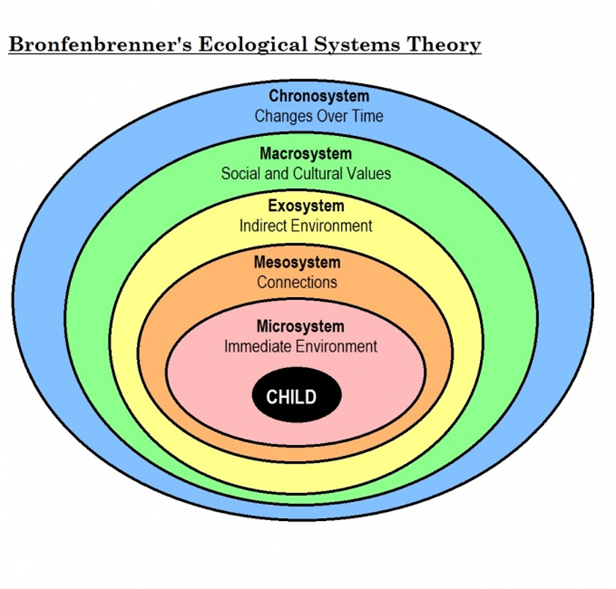
The rapid assessment design was informed by humanitarian response processes as outlined in the Sphere Minimum Standards for Child Protection in Humanitarian Action (The Alliance, 2019). It was also underpinned by Bronfenbrenner’s ecological systems theory (Batho et al., 1994) which acknowledges that children and young people cannot be separated from the broader context of their lives, and encourages a holistic perspective on the mental health, wellbeing and development of children and young people.
Diagram 1: Bronfenbrenner’s Ecological System’ (Batho et al., 1994)
The social-ecological model acknowledges that “children’s health and development occurs within multiples contexts, including the family, school, local neighbourhood and community environments, and that each of these environments is in turn influenced by broader social, economic, political and cultural factors.”
These contexts are inter-related and interdependent, meaning that changes in one can influence changes in others. (The Child and Their Local Ecology - Emerging Minds, n.d.)
Often the Mesosystem and Exosystem are combined into one system.
For the purposes of this rapid assessment the socio-ecological model was considered in the context of child, family, community and systems, as outlined in the next diagram.

Systems | - Broader economic, policy, social and wider environment  - State policies  - Federal policies  - Social norms and attitudes  - Climate
Community | - Local Government  - Schools  - Employment  - Transport  - Health  - Cultural groups
Family | - Immediate Family  - Household
Children and Young People | - 5-11 year olds  - 12-18 year olds  - Inclusive groups

How was the report developed
The rapid assessment was completed using a combination of secondary data sourced over the course of 7 days in May 2020, and primary data collection though Key Informant Interviews conducted over 10 days from 22 May to 5 June 2020. These were conducted with stakeholders across state, regional and community government, non- government and community members.
The Rapid Assessment report was developed using an assessment framework that considered:
- Population group - children and young people, across the developmental ages
- Geography
- Needs identified by children and young people
- Current services responding to the above needs
- The thematic areas of:
  - Education & Early Learning
  - Mental Health and Psychosocial Support: Children and Young People
  - Families
  - Communities
  - Children and Young People Participation.
The desktop analysis was conducted to understand what had been documented to date regarding the impact of the bushfires on children, and young people and who was working in the space, and who was funded to work in the space. The primary data collection of key informant interviews was conducted to provide a deeper insight into what stakeholders perceived to be the standout issues for children and young people in East Gippsland in regards to their bushfire recovery.
The interview asked the following questions:
- Key Informant name
- Position Title
- Male/Female
- Site Locations
- Thematic Area
- Are you collecting data and/or mapping documentation on bushfire recovery and happy to share?
  - If yes, what is its title and can you share? If not can you describe the content?
- Do you know of other data and/or mapping on bushfire recovery that is available or due to be released?
- What have children (aged 5-11) identified as their main sources of stress?
  - If other describe.
- What coping mechanisms are children aged 5-11 using to manage bushfire recovery?
- What have young people aged 12-18 identified as their main sources of stress?
  - If other describe.
- What coping mechanisms are young people aged 12-18 using to manage bushfire recovery?
- Has there been specific and/or different sources of stress, or coping mechanisms for children and young people from vulnerable groups –please specify the vulnerable group you are referring to
- Please describe the sources of stress or coping mechanisms you are seeing within these groups (if more than one group, please nominate the group referring to).
- What have Children and Young People’s families identified as their main source of stress.
  - If selected other please describe.
- What are Children and Young People’s families’ current coping mechanisms?
- Which organisation and/or role has taken on the coordination?
- What are they coordinating?

Who was involved
32 Key Informants were interviewed. 80% female, 20% male. They worked in government, non-government and community services with a mandate of state, regional and township. Some of the organisations represented included:
- BRV Gippsland office
- BRV State office
- Red Cross - Gippsland office
- Community Member - East Gippsland township
- Neighbourhood House - East Gippsland township
- Headspace- Bairnsdale
- Beyond Blue- State and Federal
- Schools P-12
- Bush Nursing Centre - East Gippsland
- Salvation Army - East Gippsland
- Save the Children - Gippsland
- Primary Care Partnerships - East Gippsland
- Uniting - Gippsland
- Gippsland East Gippsland Aboriginal Cooperative (GEGAC)
- Child and Community Wellbeing Program & Lead of Community Resilience in the Centre for Disaster Management and Public Safety - State
- East Gippsland Shire Council
- YacVic - State
- DHHS - Outer Gippsland
- Gippsland Women’s Health
- Lakes Entrance Aboriginal Health Association (LEAHA)
- Gippsland Lakes Community Health
- Community House - East Gippsland township
- Orbost Regional Health
- The Sanctuary Mallacoota.

Site locations:
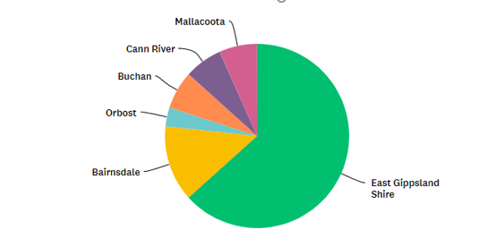

Thematic areas covered:
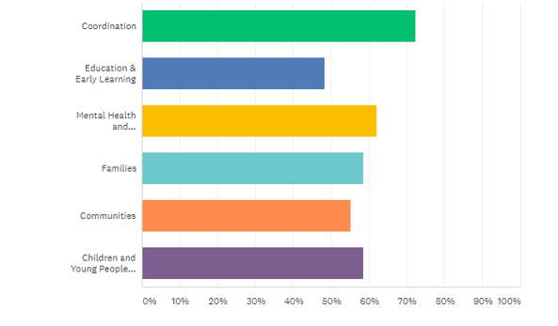

Children and Young People
A major gap in this rapid assessment were the voices of children and young people. The decision was made not to interview them directly as:
- The pre-existing representative groups of young people were not inclusive of young people from the fire damaged areas, and were also difficult to access in the short time available.
- Other data gathering from children and young people may have been in existence that we were not aware of and we did not wish to duplicate, or over burden the child and youth population of East Gippsland.
- The limited time available made an ethical data collection with children and young people difficult.
However, the lack of voice from children and young people is a significant gap, and one that will need addressing to ensure a holistic approach to supporting their bushfire recovery. It will be imperative to triangulate their responses against that which was found below.

Findings

Needs identified (since bushfires)
Key informants stated the top two sources of stress for children aged 5-11, and young people aged 12-18 were ‘Isolation from Peers’, and ‘Psychosocial Distress’. Key informants went on to state that the top two sources of stress for families of children and young people were ‘Psychological Distress’ and ‘Interactions with Formal Bodies’.
Below is an overview of the findings.

Children people aged 5-11

Overview
Key informants stated the top four sources of stress for children aged 5-11 as:
- Isolation from peers
- Psychosocial distress
- Housing and Accommodation
- Isolation from community

Table 1
# | Topic | Most significant stressor (mean/ average result) 1 = high and 5= low
 | Other (comments) | 1.67
1 | Isolation from peers | 1.78
2 | Psychosocial distress | 1.94
3 | Housing and accommodation | 2.12
4 | Isolation from community | 2.12
5 | Lack of recreational outlets and activities | 2.13
6 | Family tension- witnessing | 2.24
7 | Lack of voice/inclusion in recovery decision making | 2.47
8 | Parental tension- between parent and child | 2.53
9 | Education | 2.60
10 | Material Aid, financial Assistance and general addressing of subsistence needs | 3.71
11 | Youth Economic Pathways | 4.25
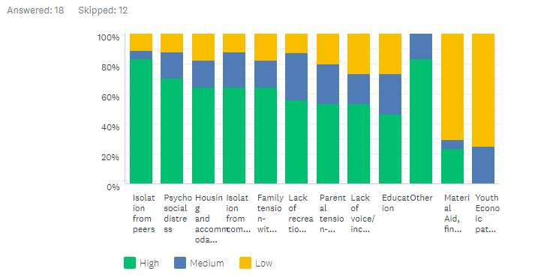

Qualitative
Some of the qualitative comments that Key Informants provided which complemented the above results are summarised below:

Psychosocial distress
“For Aboriginal young people cultural connection with their elders; country connection; traditional sites – young people stressed that they may have burnt.”
“A lot of reliance on parents and co-sleeping. Mothers the other day said 95% of their children were sleeping in their mother’s beds.”
“Seen a lot of regression in behaviour - bed wetting, thumb sucking (8-10 year olds), kids shutting down, separation anxiety, and self-harm as a coping mechanism. Children seeking parental support to manage and work through this.”

Housing and accommodation
“Most children still have a home; but it is a high stress for children who did lose their home.”
“Homelessness is always a stress for children. It isn't just a lack of roof over your head, it's leaving familiar surrounds, not living close to friends and family, can't go to same school. Kids just need to get back to school and connect with peers.”
“Children who have friends who have lost home, vicarious trauma and stress.”

Isolation from community
“Concerned about children and young people moving out of COVID-19, some were stuck to their homes, some in relief centres had a lot of interaction with others and then COVID-19 has isolated them completely, can play with everybody and then nobody.”
“COVID-19 is compounding isolation.”

Family tension- witnessing
“It is always a stress for young children where there is family tension. The idea they didn't see/hear they aren't impacted- this isn't correct as children are picking up the incredible anger in the community about who started the fires, reduction clearing, who should do more, concerned this would take a long time, environmental science, conservation, timber industry.”

Lack of voice/inclusion in recovery decision making
“From a service perspective there has not been the voice of children and young people”

How are they coping?
Below is a summary of the qualitative responses that Key Informants provided in answer to this question:
- Different across each community.
- Getting back to a routine.
  - Children want to get back to their familiar connections with people they know. Want to be in their own space/family/kids and just get on with it.
  - Best medicine was people and activity around them as usual.
- Recreational Activities:
  - Learning - people talk when something else is focused on.
  - Help needs to be almost disguised, any work will need to be very informal and 'disguised'.
  - Activity packs - The limited time available made an ethical data collection with children and young people well received, helped with boredom and gave some connection.
  - Having animals around was important for young children.
  - Needs to be creative - drumming and art to focus on something else.
  - Creative expression, sports and recreation and connection to nature (grief and loss with what was lost in natural environment).
- Not talking about it – e.g. DrumBeat class exited by young people when they were asked directly of their feelings about the bushfires.
- Getting back to school is important for routine and change of scenery.
- Connection with others:
  - Real urge for children and young people to reconnect and meet with others, peer-to-peer support being sought out.
  - Social connection - for all Save the Children’s pop up play spaces, lots of families attended as they got to sit around and talk and tell stories.
  - To be with their families is an important coping mechanism, some have been separated from families for a while. Reconnecting through recreational activities and engaging in counselling.
- Alcohol and other drugs - smoking marijuana, drinking and drug use.

Young people aged 12-18

Overview
Key informants stated the top four sources of stress for young people aged 12-18 as:
- Isolation from peers
- Psychosocial distress
- Isolation from community
- Lack of recreational outlets and activities

Table 2
# | Topic | Most significant stressor  (mean/average 1 = high and 5 = low)
 | Other (comments) | 1.2
1 | Isolation from peers | 1.28
2 | Psychosocial distress | 1.69
3 | Isolation from community | 1.71
4 | Lack of recreational outlets and activities | 1.72
5 | Youth Economic Pathways | 1.93
6 | Housing and accommodation | 2.0
7 | Family tension- witnessing | 2.0
8 | Lack of voice/inclusion in recovery decision making | 2.0
9 | Parental tension- between parent and child | 2.20
10 | Education | 2.41
11 | Material Aid, financial assistance and general addressing of subsistence needs | 2.69

Graph 2
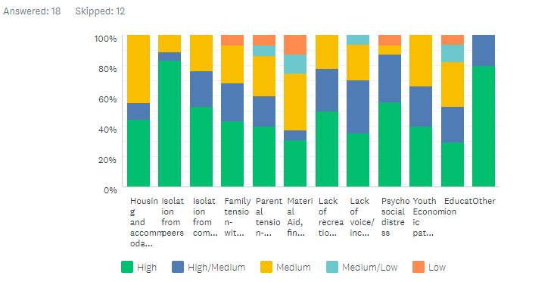

Qualitative
Some of the qualitative comments that Key Informants provided which complimented the above results have been highlighted below:

Psychosocial distress
“Kids who take on adult responsibilities, really important to get them back to their usual responsibilities.”
“Less coping mechanisms because more is expected of them, took on the burden of watching younger children.”
“Lack of capacity to debrief kids who took on adult responsibilities - they didn’t get school holidays - they worked all through the summer, took on responsibilities of adults and then went back to school, travelling every day 75km through burnt bush. Quite shocking for them to see the burnt bush – Nowa Nowa to Buchan is stark.”

Isolation from community
“Concerned about the mob staying isolated; they isolated very quickly.”

Youth Economic Pathways
“Employment - changed for young people; couldn't access their casual/part time work.”
“A lot of young people affected by closing of the timber industry, park is closed so taken out the casual employment, every little local employment opportunities -not huge amount of work done with young people in terms of bushfire.”

Housing and accommodation
“High stress for those who lost their homes.”
“Some young people are concerned about others who have lost their homes.”

Family tension- witnessing
“Young people were psychological first aid providers to parents as more equipped.”
“Adult stress impacting on young people.”

Lack of voice/inclusion in recovery decision making
“This has been hindered by COVID-19 lack of voice in recovery and decision making; not knowing what the recovery structures are.”
“Voices of young people not really being prioritised - have seen example many examples of this.”

Education
“Education a higher stress for year 10, 11, 12.”

Other
“Safety of animals a key concern.”

How are they coping?
Below is a summary of the qualitative responses that Key Informants provided in answer to this question:
- Activities:
  - For young people who already had issues in life and maybe some dislocation, music and other creative outlets were requested rather than items (e.g. trampoline or school uniforms). It was about finding something that they were interested in such as:
  - Woodwork and tools
  - Creative outlets
  - Bulk purchase of art supplies
  - Therapeutic recreation often supports and adds to resilience.
  - All getting together at the recreation ground to keep each other occupied – and being able to get back into activities post bushfire and COVID-19 (e.g. football and netball).
  - Return to education and being bought together. Recreation and activities to come together.
  - Looking for creative outlets (e.g. art, woodwork) - organisations such as headspace spreading out into these communities.
  - Some children came to dinners - possibly made to come as the dinners really revolved around adults.
  - Right after fire young men were jumping into tinnies on lake to get away from burnt bush and home - fishing and surfing.
  - Young women surfing.
- Youth specific space - instead of being included into other services having youth-specific health and counselling services.
- Social media:
  - Assume young people have connected with each other but through platforms.
  - Using access to social media to connect with peers.
  - Usual social media chat.
  - Seeking support of peers and use of social media to do this.
- Relationships with peers as coping mechanism:
  - Desire to come together and have peer-to-peer support, reconnected to place in community.
  - Young people (peers) are a good source of support for each other.
  - Utilising information from their school, peer-to-peer conversations and debriefing.
  - Encouraging each other to get out and exercise.
  - Spending time together.
- Self- care, not too much pressure academically and acknowledge that young people are going through difficult times.
- Smaller communities tend to be insular and look after their own problems.

Inclusion and young people

Overview
There has been very little research or data collected on the experiences of children and young people across all of their diversities. Further to this, the lens of inclusion does not appear to be mainstreamed, or integrated into the social recovery plans or governance structures, outside of the Culture and Healing pillar.

Has there been specific and/or different sources of stress, or coping mechanisms for children and young people from vulnerable groups?
Below is a summary of the qualitative responses that Key Informants provided in answer to this question:
- Aboriginal communities:
  - Relevant access to information, not knowing what is available. Fear of reaching out to non-Aboriginal services for economic services.
  - Racism and discrimination is directly impacting on Aboriginal people’s access to bushfire recovery.
  - There was huge extra stress for children as children were more stressed about fire – “if we lose this property/land (due to fire) we will never get it back”. For example, children on Aboriginal Trusts were more stressed than children in Buchan.
  - Aboriginal communities have additional source of stress through loss of land and sacred spaces through bushfire: “Impact on cultural understanding. Systemic racism from not understanding that they (young people) are part of the land. The land is hurting, they are hurting. Other community members not understanding why they are grieving so hard.”
- Loss of Primary Residence:
  - Children who lost residence experiencing high levels of stress.
  - Loss of primary residence is major stress for young people as they have not had their regular home and routines, and they may be living out of the home for some time and outside of the community.
  - Homelessness is a risk - if young people fall out with parents there are no extra places for them to go. Disconnect between what ‘bushfire affected’ means in terms of youth homelessness (not just house burnt down but homeless as a direct result of stress of bushfire). If family violence occurs, then there is no alternative options for accommodation.
- School leavers/disengaged young people - lot of recovery activities happen in schools but when young people leave school they lose support.
- Culturally and Linguistically Diverse (CALD) communities are already vulnerable and have been in the community for approximately 3.5 years. Not a lot of acceptance of CALD communities.
- Children and young people with disabilities:
  - Have heard about children and young people with disabilities – e.g. disruption to routine, change of environment and taking time to settle back down (i.e. all summer).
  - Disability - the Disability Network has already identified a need for supporting families of children with a disability. There is already an idea for a support position for East Gippsland families. This gap existed before the fires and has increased. There is a need to support families to navigate the system, including families who are not eligible for NDIS Respite availability.
  - Planning - parents of children with a disability were not thought about or well-supported during the time of evacuation. There were no strategies for people with disabilities and this was the number one stress for families with special needs. For example, having to move around was horrific; trying to explain the situation to people who need solid routines was difficult; carers having to juggle so many things (e.g. a situation where one child went missing); and accessing familiar clothing or food was challenging and presented difficulties for people with a disability and their carers.
  - Increase in behaviours of children diagnosed with Autism, such as loss of sleep and nightmares.
- LGBTIQA+ young people and communities experiencing fear of discrimination.

Families

Overview
Key informants stated the top four sources of stress for families of children and young people were:
- Psychological distress
- Interactions with formal bodies
- Employment Issues
- Housing and accommodation

Table 3
# | Topic | Most significant stressor (mean/average 1= high and 5 = low)
 | Other (Comments) | 1
1 | Psychological distress | 1.47
2 | Interactions with formal bodies | 1.53
3 | Employment Issues | 1.71
4 | Housing and accommodation | 1.82
5 | Parenting of children and young people affected by the fires | 1.83
6 | Isolation from community | 2.16
7 | Material Aid, financial assistance and general addressing of subsistence needs | 2.17
8 | Intimate partner (relationship) conflict | 2.36

Graph 3
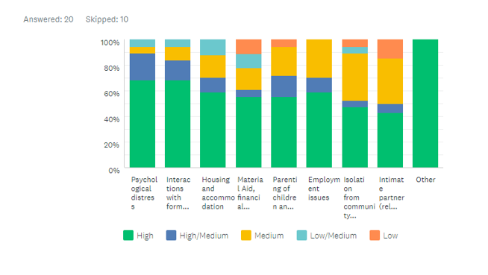

Qualitative
Some of the qualitative comments by Key Informants that complimented the above results have been summarise below:

Psychological distress
“Parents managing their own trauma, that of their children, and then parenting from home (due to COVID-19).”
“Trying to navigate the system - where do you go for certain things. Sometimes there is a lack of services.”
“Farmers - already at breaking point with drought.”
“Due to relocation away from home inability to stay connected with other support networks, grandparents etc.”
“A lot of overlap in roles which adds to stress (i.e. parent and teacher). In light of COVID-19, adds an extra layer of stress.”
“The changing scenes, people more affected than anticipated than expected than their house being cleaned up, tidied, the landscape changing.”
Lack of break/holidays. Grieving over loss of holidays - families desperate for a break and weren't able to take one:
- “Families usually went during holidays – but weren't able to go.”
- “It was a stress for the kids the loss of holidays has been an impact for the children.”
- “Inability to undertake family visits out of the area, for example, Christmas where they go out of country and spend time with family, the bushfires impacted the communities ability to connect with their family.”

Interactions with formal bodies
“People were confused about what they were entitled to and how to access it, a lot of stress working through this.”
“One of the difficulties was that there was never anything in writing as to what you'd applied for, people were often applying multiple times and not realising they'd already applied. It was a roller coaster, services trying to fill a gap, but not aware what the gap was. This was probably the highest stressor for people. Difficult for people to deal with this but even harder where there were children and other added issues. “
“People are exhausted by fights with insurance, applying for grants and being overwhelmed with information.”

Employment Issues
“Main industries in the area have been impacted - movement was restricted by the fires and then the COVID-19.”

Housing and accommodation
“Where homes are lost people are needing support.”
“Guilt from people who still have their houses.”
“People are concerned as they thought they had enough insurance but now because the ratings are changing for bushfire standards, it will cost more than what they're insured for. Apparently the same at Kinglake in Black Saturday (2009).”

Isolation from community
“Infrastructure for internet has not been fixed or re-established in some areas, this has been a challenge for families relating to social connection and school engagement.”
“Need to support families to engage again socially - not sure what that looks like. It is important for the social fabric of the community.”
“This has been really isolating. Enforced isolation through trees over roads etc, trees cleaned up and about a month or so before COVID-19 added to the situation.”

Material Aid, financial assistance and general addressing of subsistence needs
“Quite a lot fell through the gap for support, and lost money.”

Other
“The added layer for the Indigenous community was that their sacred sights might be destroyed, this raised anxiety for many Indigenous people.”
“Lack of communication about what is happening (for example, where there is smoke from burn offs) a huge factor. Powerlessness - lack of feeling of control over landscape, and easy to jump to a feeling of ‘people don’t care’, and suspicion.”

How are they coping?
Below is a summary of the qualitative responses that Key Informants provided in answer to this question:
- Communities - social activities:
  - Challenge is that there are few opportunities for socialising. Parents started engaging community-based recovery and then everything closed down (e.g. tennis club, pub, footy, netball season). These social activities are important and aren’t happening.
  - Before COVID-19, there were numerous, endless gatherings through various agencies (e.g. sports, BBQs etc). Lots of communal things were happening but COVID-19 shut these down.
  - Parents like to gather and chat - they are now all spread out in temporary accommodation and one or two key people have brought people together. This has continued online during COVID-19.
  - The community days that organisations were running such as meals at Sarsfield, talking with communities about their situation/needs, providing a meal and therapeutic activities for kids was well received. It was not intrusive, not professionals coming from Melbourne. This was important.
  - Trying to stay connected with each other, trying to keep children busy and in activities. Trying to get the children's lives back to as normal as possible and implementing routines that have been lost during bushfire.
  - Looking for practical support and reconnection to community.
- The Case Manager program has been well taken up and they appear to be providing support.
- Reconnecting with family:
  - Seeking support by phone or virtual tools, wanting to gather socially but unable because of COVID-19.
  - Spending time together - after fire came through there was no power for a couple of weeks, no TV, and families were shut off from rest of world. A lot of chat about being forced to spend time together has had positive effects (similar for COVID-19).
  - Families really wanted to de-stress, to be more present with their children, and a desire and need to reconnect within family.
  - Opportunities for families to recreate with each other; family unit spending time together.
- Psychosocial support:
  - A lot of families are accessing psychosocial care or psychological care.
  - People have started to talk a bit more about what is going on for them, compared with earlier on.
  - Rob Gordon has done some webinars which were well-received.
  - Songs and story books for the children are being requested, as well as support to re-establish routines that have been lost.

Governance and coordination
This chapter provides an overview of the Governance and Coordination mechanisms that are supporting Bushfire Recovery in Victoria. There are multiple tiers to consider when mapping Bushfire Recovery and Coordination. These include: Commonwealth Government and nationally mandated organisations; State Government and state mandated organisations; Regional or shire mandated government bodies and regionally based organisations; Community mandated organisations and members.
This rapid assessment was not able to capture the detail of all tiers in the time available. Notably missing is that of the National Bushfire Recovery Agency (NBRA), Emergency Management Victoria (EMV) and their work on recovery prior to the establishment of Bushfire Recovery Victoria (BRV) including the mechanisms that inform current recovery processes, and the state focus of Department of Health and Human Services (DHHS). While the rapid assessment was able to capture the work conducted by DHHS at a regional level, the state-based mechanisms – and the connection of the regional based mechanisms to the state-based mechanisms – require further exploration.
It is important to recognise that the protracted nature of the bushfires meant that the newly established agencies NBRA and BRV, were supporting both immediate relief and recovery needs at the time of establishment. NBRA states on 12 June 2020 that:
“Since we first hit the ground running in January, the work of the National Bushfire Recovery Agency has been twofold – helping with immediate relief, whilst looking ahead for emerging and longer-term recovery needs.
Looking forward, we are now transitioning from immediate relief to longer term recovery support that will be delivered in partnership with State and Local governments through our investment in Local Economic Recovery and Complementary Projects as well as our ongoing projects in the social, environmental, and economic and infrastructure sectors.
Supporting this work will be an ongoing gap analysis that will review the economic, social, infrastructure and environmental impacts of the 2019-20 bushfires. This will take into account existing and complementary support measures and identify gaps in recovery effort, including a methodology for updating this work into the future.”
(Statement from National Bushfire Recovery Coordinator, Andrew Colvin APM OAM, National Bushfire Recovery Agency, n.d.)

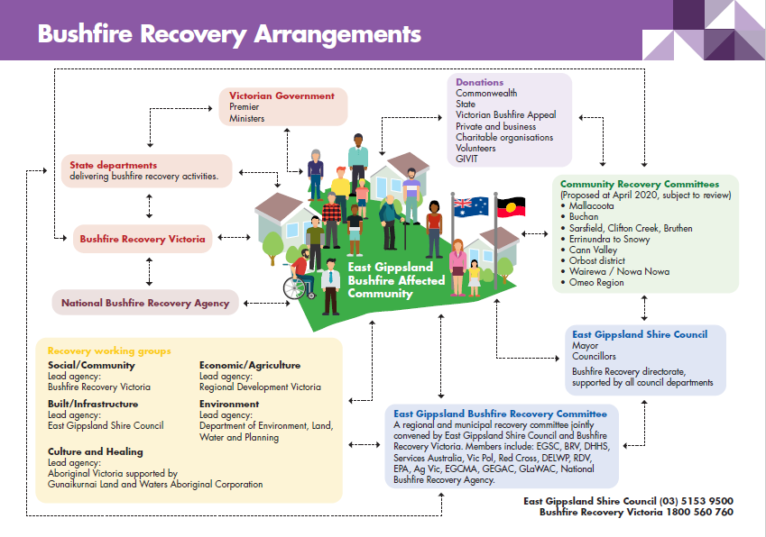

This chapter will focus mostly on how the regional mechanisms coordinate with each other and, where possible, their state counterparts.
The diagram to the right provides an overview of how East Gippsland Shire Council (EGSC) and Bushfire Recovery Victoria are working together to support Recovery in East Gippsland.
Please note as of 10 June, the lead Agency under Social/Community is DHHS.
(BRV and EGSC, 2020)

Key bushfire coordination bodies

Bushfire Recovery Victoria

Background
On 6 January 2020, the Victorian Premier announced a permanent dedicated agency called Bushfire Recovery Victoria (BRV) to work directly with local communities impacted by Victoria’s devastating bushfires, to begin the process of rebuilding and recovery. The media release stated:
“The new Bushfire Recovery Victoria (BRV) will be wholly focused on the needs of Victorian communities, working closely with locals to ensure that rehabilitation projects are both locally-driven and locally-delivered. Recognising the lengthy process of recovery – in addition to the increased risk our state faces due to longer and hotter bushfire seasons – the work of BRV will be permanent and ongoing.
That includes a commitment to supporting any Victorian communities impacted by future bushfires. The critical work of BRV will begin straight away, even as our emergency services continue to battle bushfires in our state’s north and east. This effort will extend across a range of priorities from the immediate clean-up and ensuring the health and wellbeing of residents and farmers, to longer-term work to help local communities and local economies, like the agricultural and tourism sectors, get back on their feet. In line with this commitment, Community Recovery Committees will be established to ensure locals have a voice throughout this process, while local jobs and expertise will be prioritised wherever possible.
The agency will also be responsible for advising the Victorian Government on the coordination of efforts and the development of an overarching plan for the restoration and recovery of communities across our state.”
(New Dedicated Agency To Guide Bushfire Recovery, Premier of Victoria, n.d.)
BRV’s chair is former Chief Commissioner of Victoria Police Ken Lay, and the CEO is Lee Miezis, Deputy Secretary at the Department of Environment, Land, Water and Planning. The new agency will sit within the Department of Premier and Cabinet with to ensure whole-of-government coordination, and report directly to the Premier.
Previously, EMV had a position titled State lead of Relief and Recovery, it is understood this role now has the focus of State lead for Relief.
- The Emergency Management Act 2013 (the Act) established Emergency Management Victoria in July 2014 and plays a key role in implementing the Victorian Government’s emergency management reform agenda. Their website states: “Leading emergency management in Victoria by working with communities, government, agencies and business to strengthen their capacity to withstand, plan for, respond to and recover from emergencies”. The Act provides for the development of: the State Emergency Response Plan the State Emergency Recovery Plan 2020 (EMV, 2017). The operation protocols of this plan can be found in the Emergency Management Manual Victoria (Emergency Management Manual Victoria, 2018).

BRV Operations
The below infographic describes the Governance Structure of Bushfire Recovery Victoria (BRV, 2020b).
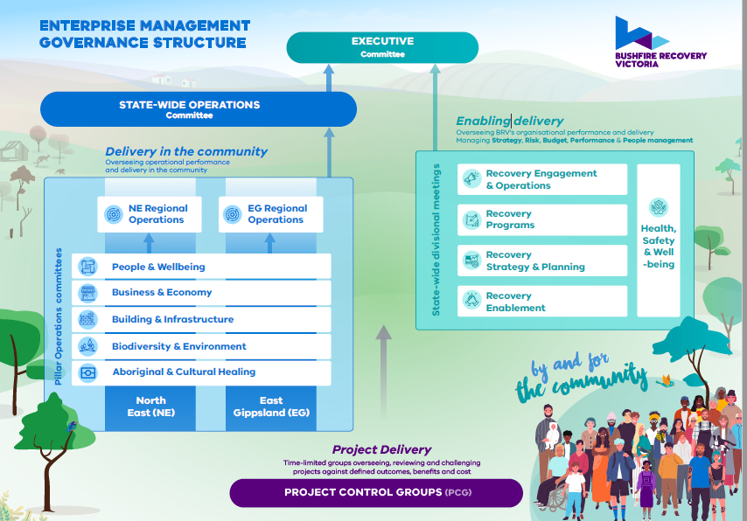
The BRV branches align with the recovery environments and functional areas outlined in Chapter Four of the current EMV Manual (EMV, 2017) (see figure 5 below).

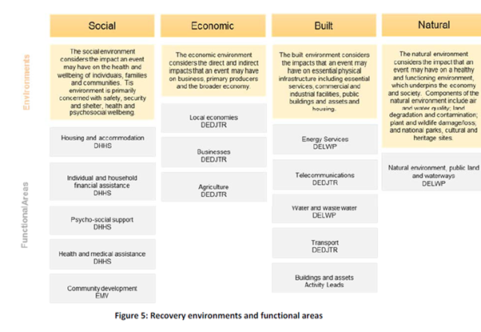

BRV Strategy
The complete infographic on BRV’s Strategy, May 2020 (BRV, 2020a) can be found in Appendix 2. It states the following:
- Vision: Individuals, families, communities, businesses and regions are stronger and more resilient through
community-led recovery.
- Role: To work directly with Victorian communities to support their recovery. To coordinate recovery activities by partnering with communities,
governments, businesses and not-for-profit organisations.
Recovery Outcomes for People and Wellbeing:
- People are safe and secure.
- People are healthy and well.
- Communities are cohesive and people connected.

Principle Policy Officer for Children, Youth and Families
The Principal Policy Officer for Children, Youth and Families in BRV is a newly established role is to ensure government departments or associated entities coalesce around ways to support children, youth and families.

Bushfire Recovery Centres
BRV established six physical Community Recovery Hubs in EGSC strategically placed in larger centres which are frequented by surrounding communities to access services. Recognising the remoteness and diversity of recovery needs across the vast Gippsland area, each impacted town will be serviced by a mobile Hub which will use physical Hubs as a base. BRV are responsible for their establishment and have employed Community Recovery Hub coordinators for each site. BRV lead on the centres as direct service delivery to the community – with EGSC supporting.
Community Recovery Hubs delivered and operated by Bushfire Recovery Victoria are opening across affected communities. The hubs will serve as important community meeting places that link locals to the practical support they need. Services at individual hubs are being specially tailored to the individual needs of each community and include planning and rebuilding advice, individual case support, access to government and non-profit service providers, and small business advice. Hubs will be staffed by locally-based coordinators to provide face-to-face support and help reduce the complexity for community members (EGSC, 2019). In line with coronavirus restrictions, Hubs will be operating with physical barriers, space restrictions and forward bookings where required for the safety of staff and residents. Community members are encouraged to visit their local Hub in person but are asked to call in advance to book a visiting time. Hubs will be located at:
- Sarsfield
- Bairnsdale
- Orbost
- Buchan
- Cann River
- Mallacoota

East Gippsland Shire Council
The EGSC work closely and manage implementation of the recovery process at a local level. They lead the Regional Recovery Committee established in January 2020 “to look at the high-level coordination of all agencies that are involved in recovery to ensure that we’re working together, all working towards supporting all our communities to recover” (Community Recovery a Priority for Council, East Gippsland Shire Council, n.d.).
The Regional Recovery Committee constitutes the five Recovery Branches or Working Groups pillars of:
- Bio-diversity and Environment (Environment) - DELWP
- Business and Economic (Economic and Agriculture) - RDV
- Building and Infrastructure - EGSC
- People and Wellbeing (Social and Community) (Social Recovery) - DHHS
- Aboriginal Cultural and Healing – Aboriginal Victoria supported by Gunaikurnai Land and Waters Aboriginal Corporation.
It is jointly convened by EGSC, and chaired by CEO of EGSC, Anthony Basford. Members of this committee include representatives from:
- East Gippsland Shire Council – Stuart McConnel, Director and responsible for Buildings and Infrastructure and Emily White Manager Community Recovery (as of June 2020)
- BRV - Laurice (Loo) Richardson, Regional Recovery Director- Gippsland BRV
- DHHS – Sharyn Fischer Area Director Outer Gippsland
- Services Australia
- Victoria Police
- Red Cross – Andrew Brick, Acting State Fire Recovery Lead and Drought Recovery Programs Coordinator - Gippsland (Victoria)
- DELWP
- Regional Development Victoria (RDV)
- Environment Protection Authority Victoria (EPA)
- AgVic
- EGCMA (East Gippsland Catchment Management Authority)
- Gippsland and East Gippsland Aboriginal Co-Operative (GEGAC)
- Gunaikurnai Land and Waters Aboriginal Corporation (GLaWAC)
- NBRA.
The Recovery plan for East Gippsland has yet to be finalised. This is currently in draft. Emily White is the newly appointed Manager Community Recovery for EGSC and shares an office at EGSC with Laurice (Loo) Richardson, Regional Recovery Director- Gippsland (BRV).
It appears the EGSC role is primarily that of coordination with state players, developing the Regional Recovery Plan (still in draft), facilitating some grants, liaising and supporting with the Community Recovery Committees, and leading on the Building and Infrastructure pillar.

Districts and Place Managers
Prior to the bushfires the council developed a framework for community planning. The Shire was divided into 12 districts, and the EGSC have been working with these districts for the last two to three years to develop a community plan/strategy. At the time of the fires some districts already had an established plan. The EGSC wish to co-present these plans, along with the work that BRV have conducted, jointly to the Community Recovery Committees for consideration as part of their recovery planning going forward. The EGSC will employ up to six “Place Managers” who will be responsible for the 12 districts. They are not called “Recovery Managers” to acknowledge the work that was already conducted prior to the fires.
The 12 Districts are:
- Lindenow
- Bairnsdale
- Omeo & District
- Bruthen
- Twin Rivers
- Paynesville
- Metung
- Lakes Entrance
- Buchan
- Orbost
- Cann River
- Mallacoota

Community Recovery Committees
Community Recovery Committee’s (CRC) will keep local voices, know-how and expertise front and centre during recovery planning and delivery. Taking this place based, community-led approach will ensure projects, grants and support programs developed with community, and funded government, over the coming months and years will be the right fit for that community.

CRCs are:
- Funded through BRV to make decisions at a community level on recovery.
- Led by EGSC and supported by BRV. This is the core community development component of the recovery and is where key communication between community council and shire is expected to occur.
- Currently being established – with six are being formed now (e.g. Mallacoota just had official elections) to support bushfire recovery efforts based on the needs and priorities identified by fire affected communities.
- Being established with support of council such as through linking into existing representative community groups.

Committees located in:
- Bruthen
- Cann Valley
- Clifton Creek
- Mallacoota and District
- Omeo, Cobungra, Swifts Creek and Ensay
- Orbost and District
- Sarsfield
- Wairewa

Social Recovery (People and Wellbeing) Committee East Gippsland
The Social Recovery Working Group for East Gippsland is chaired by DHHS, as per the Bushfire Recovery Arrangements described above. Meetings are weekly on Thursdays.

The Social Recovery Outcomes Plan found in Appendix 3 includes the following objectives:
- Regional community recovery objectives that “support and coordinate a community led recovery based on community need and aspirations.”
- Communications and Information objectives that “provide timely, clear and accessible information to enable community to make informed decisions.”
  - Provide the community with timely, accessible, tailored and relevant information about recovery assistance - no lead agency, support agencies include Blaze Aid, GERF, Red Cross, Rotary, Salvation Army, Volunteering Vic.
  - Increase telecommunication and IT infrastructure in community to improve communications and reduce isolation - led by BRV/EGSC, Support by NBN, Telstra.
  - Coordinate information to the broader community to maximise donations and volunteerism – led by BRV.
- Housing and accommodation objectives that: “Assist emergency displaced people to access temporary accommodation and support when returning to permanent housing”.
- Individual and household financial assistance objectives that: “Support and assist people to access practical assistance to manage their own financial recovery.”
- Psychosocial recovery objectives that: “Provide and support the community to access tailored psychosocial services”.
- Health and medical assistance objectives that: “Ensure health and wellbeing services are delivered to support individuals”.
- Aboriginal Culture and Healing objectives that: “Aboriginal cultural safety and healing is valued, respected and supported”.
Within social recovery there are two sub-groups: Psychosocial Sub-Committee and Housing.

Psychosocial Sub-Committee for East Gippsland
The Social recovery group has two sub- committees of Psychosocial Support and Housing. These meet on alternate fortnights. These sub-committees meet on alternative fortnights.
The Psychosocial Sub-Committee for East Gippsland is chaired by the Manager of Social Recovery at DHHS. The Psychosocial Sub-Committee has a draft work plan which has the following goals:
- To assist those affected by the disaster with opportunities to reconnect with their communities.
- To provide access to timely information about post-disaster circumstances and recovery activities.
After recent conversations, the Psychosocial Sub-Committee have recognised that their action plan pertains to one-on-one psychosocial support, and not that of group or community work. This key action area will be included from here on in.

Pre-Existing Coordination Networks for
East Gippsland

Coordination Networks
Name | Information | Contact
Mental Health and Psychosocial Support Networks
Gippsland Primary Health Partnership (GPHN) | Mapping of services and supports around for entire population- shared with PSS support group. | - GPHN Coordinator Regional Services (Wellington/East Gippsland)
East Gippsland Primary Care Partnership (EGPCP) | EGPCP is a voluntary partnership of health and community support agencies working together towards achieving better health outcomes for the community across the East Gippsland local government area. EGPCP play an important role in facilitating and sustaining effective partnerships, supporting collaborative change and shared goals in East Gippsland.  The EGPCP has facilitated a systems thinking for collective impact approach to mental wellbeing in East Gippsland. This work is done as the Mental Wellbeing Network.  The EGPCP facilitates a number of groups including:  - Mental Health and Wellbeing Network  - Drug and Alcohol Prevention Alliance | - Partnerships Facilitator  - Alcohol and Drug Network Facilitator
Mental Wellbeing in East Gippsland | Have produced measuring change 2020, with two objectives:  - Children and young people have opportunities to have their voice heard  - There is a collaborative approach to primary prevention (i.e. mental wellbeing) across East Gippsland organisations. | - East Gippsland Primary Care Partnership, Partnerships Facilitator  - Alcohol and Drug Network facilitator
Drug and Alcohol Prevention Alliance | Acts as governance board for the Communities that Care program. Prevention, community engagement and community health and wellbeing focus. | - Partnerships Facilitator  - Alcohol and Drug Network facilitator
Youth Participation
Youth Focus Network | Meets monthly – representation from most people who work directly with young people:  - 45 active members (140 email list)  - Sharing resources for young people affected by bushfires and in the current COVID-19 situation. | - Youth Engagement Officer East Gippsland Shire Council
Children and Early Learning
Children's Wellbeing Collective | Provides structure for future coordination/collaboration. Positioned as a potential player in coordination, have promoted that children and young people should have a voice, scope to focus on children and young people and see that play out in the hub areas. | - Project Facilitator, Children’s Wellbeing Collective, Save The Children  - Children’s Wellbeing Collective Project Officer, Save The Children
Early Years Network Bairnsdale | A number of Early Years Networks exist across East Gippsland (e.g. Bairnsdale and Surrounds Early Years Network, High Country Early Years Network). | - Various facilitators
Special Needs Network | Advocacy for families and children with additional needs.
Families
Prevention of Family Violence Network
Communities
Buchan, Gelantipy and District Renewal Association Inc. | An incorporated association for the Buchan, Gelantipy and surrounding areas with a purpose of renewing the area to better than prior to recent disasters. This group will focus on planning, consultation and advocacy. Less of a role around coordination. The group expects to consult with children and young people for projects related directly to them. Subcommittees where relevant will involve children and young people. | - Buchan, Gelantipy and District Renewal Association Inc. President and Secretary
Inclusion
Local Area Services Network | Network for all the homelessness services. Talking about bushfire response, with DHHS involved in network.

Youth Networks
There are five youth representative committees locally based. They are:
Name | Information | Contact
Mallacoota Youth Sanctuary |  | Youth Facilitator
Headspace Youth Advisory Group (YAG) |  | Community Engagement Officer
Gippsland Community Health Youth Ambassadors |  | Chair of Koori Youth Council
Koori Youth Council
East Gippsland Shire Council Youth Ambassadors |  | Youth Engagement Officer

Identified Themes
There were two strong themes that emerged in regard to our research on governance and coordination. These were an identified lack of clarity regarding coordination, and a lack of clear communication.
Below is a summary of the qualitative responses by Key Informants that were gathered during the primary data collection.

Coordination
Key Informant quotes on coordination:
“There is an opportunity, currently not met, to coordinate and harness the whole of sector approach for young people in the region.”
“Stakeholder analysis is needed as it is unclear who is doing what. Discussions on different platforms – e.g. arts and culture - is lacking coordination. Local representation, those who live here following up, locally based coordination, authority to hold others accountable.”
“One thing that we identified was that we were very much flying by the seat of our pants – there needed to be a region-wide response and protocols for bushfire and coordination. All stuck in our own bubbles with lack of clarification of roles. EGSC required to share information.”
“Challenge with coordination is that everyone has wanted to coordinate but in their own domain. Need to take stock and look at what existing structures are in place and how could they be utilised. No point setting up independent or new structure -if it doesn't leverage off existing structures. Examples where people think they have coordinated but have taken a siloed lens and haven't thought about how it links back to other areas. Experience with BRV is that they have had no lens around children and young people.”
“Feedback from BRV has seemed to focus around infrastructure and less around anything else.”
“Cycling in of people from Melbourne. Communities invest and then a new person comes and it has to be done again; extracting from communities but not receiving back what they've identified...”
“Too many agencies are contacting the schools. For example, one school received calls from 27 agencies to end of March.”
“Mental Health group - open up for everyone to be involved in group - maybe it could coordinate more than 'do' something? Are children getting outcomes? If not, what needs to be done?”
“Not gaps but perhaps double up. For example, multiple mappings being completed."
“Coordination is just not happening, we may have individual linkages but not a coordinated approach.”
“Coordination at time of response was lacking. Relief centre training had been held in the same building 6 weeks before and none of those at training used Memorandum of Understanding. The procedures didn't seem to be followed; other councils support which is why the MOU is set up.”
“No one co-ordinating formally for children and young people.”
“This is where we are falling down, I do not know where the coordination is occurring or coming from.”
“Plenty of agencies offering resources. Not aware of coordination.”
“Lots of mapping, lots of coordination, lots of talk – no service delivery. Lots of drought recovery positions - funding for bushfires only trickling through now.”

Communication
Key Informant quotes on communication:
“There is no clear communication strategy for all groups for the Bushfire Response.”
“When working at the community level, you often don't have a good understanding of what's happening.”
“Getting better with communication through the recovery sub committees. Different organisations are working offline and reporting back so it is more efficient. Work still needs to be done to improve efficiency and communication of these committees.”
“Be great to get some answers. Clearer communication.”
“Communications is lacking, need a community-based communication strategy.”
“Openness and clarity. Community is floundering. Community doesn't know who's coming to do what.”
“Communication was the biggest issue at the time of response. All the top people were at the ICC and the communication to the relief centre was a problem. Lack of preparedness coordination of relief centre.”
“Trauma informed communication response for communities and agencies not literate in health/trauma. For example, there was a flare up (fire) 2.5 months after the fires and the impact was noticeable. 2 weeks ago, back burning retriggered anxiety. Agencies not thinking through risk management from a trauma-informed approach and not understanding the importance of communication from a trauma-informed place.”

Direct knowledge of systems and services to inform response and recovery
Key Informant quotes on knowledge of systems and services to inform response and recovery:
“It would be good to have services mapped out efficiently. How do they interconnect, made clearer? What single source of truth for what’s out there? How is everyone linked up and where can access the information.”
“Basic mapping of where the [BRV] Hubs and key services sit, who they feed up into, how the [BRV[ pillars work, how BRV have responsibility – this is still a bit lacking but would be useful. While there are overview documents that are all in bits and pieces - these are not all put together.”

Bushfire recovery support services
Participants interviewed through the primary data collection, and through the collection of the desk review materials, were asked which organisations and roles were operational for the bushfire recovery effort. The results from this have been mapped below. It is by no means an exhaustive list, given the nature of the rapid assessment. Apologies to any key roles or organisations that have been missed. In addition to this work, there have been other mappings completed on Support Services that can be found in the Appendices as outlined below:
- Mapping of services by the Red Cross 2019 Drought Needs Analysis - Appendix 4.
- CTC Community Programs Profile: Evidence and non-evidence-based programs East Gippsland, GB Aug 2019 - Appendix 5.
Organisations and roles supporting the bushfire recovery effort have been grouped into the following tables:
- Mental Health and Psychosocial Support Services
- Education and Early Learning
- Community Support
- Inclusion Support
- Individual and Household Assistance
- Health.

Mental Health and Psychosocial Support Services
Name | Information |  | Contact
Organisations
Beyond Blue | Received funding from Commonwealth Department of Health to provide bushfire support across Australia - in Victoria, New South Wales, South Australia and Queensland. In Victoria this includes in East Gippsland and Ovens Murray. |  | Project Lead, Be You Bushfire Response Project, Beyond Blue
With staff located in each of their 13 priority regions:
- 25 staff dedicated to providing this support.
- 13 priority regions across the 4 states.
Focus is on mental health support to schools and early learning centres. This is a whole of school preventative approach to mental health called the Be You initiative (which is the next iteration of Minds Matter).
 | headspace is partner in delivering this to schools (so staff based at headspace centres).  Early Childhood Australia is partner in delivering to Early Childhood Learning Centres. |  | headspace Be You Coordinator - Victorian state manager. Based at headspace Head Office (Melbourne).  Early Childhood Australia.
Key elements outlined below. See https://beyou.edu.au/bushfire-response-program:
- Contact Liaison Officers (CLO’s)- work closely with individual learning communities to identify their needs and provide guidance on wellbeing support and services that suit those needs. CLOs provide support that is tailored to the local context and needs of each individual learning community, with a focus on recovery planning and resilience-building activities
- Trauma training- schools and early learning services have access to trauma training events in a regular scheduled format, both online and face-to-face.
- Recovery Planning - CLOs work with schools and early learning services to support the development of a recovery plan. Individually tailored, a recovery plan maps out and identifies short, medium and long-term activities to support recovery and promote resilience in each learning community. This Program allows for up to 18 months of support, but many plans will extend well beyond this period to allow for long-term recovery in communities.
- A Contact liaison officers- work with school or early learning centre to map out medium to long term community recovery process. Help community to lead recovery.
- Service mapping- Due to the largely state-based response to the bushfire crisis, supports and services available to each region and community varies. Navigating the service sector has been a key challenge for many schools and early learning services. The service maps will act as a quick reference guide outlining wellbeing and other recovery services for children and young people in the local area.
 | Two headspace staff for Victoria recruited. Staff are located within headspace national (not located in Bairnsdale but will have links to them).
headspace Bairnsdale | - Work closely with RAV (Relationships Australia Victoria - the lead agency of headspace) I-connect team therapeutic interventions from 0-18 years old.  - headspace Bairnsdale established programs called “out road trips” went into school for day. Offer intake appointments and at lunch health promotion activities. Positively received. In Swifts Creek, Orbost and Mallacoota. |  | Community Engagement Officer
 | In COVID-19 – headspace Bairnsdale moved everything online.
Allocation additional bushfire federal funding - 2 youth access workers for clinicians.
Engagement officer role expanded from 0.6EFT to full time for 12 months.
 | Headspace has good relationships with principals and school nurses.
 | After initial youth consultation (statements such as “I just want a fishing rod so I can go with my family”) headspace Bairnsdale decided to have one day per week worker located in school or community spot.
Primary Health Network | Mapping of services and supports around for entire population - shared with PSS support group.  Private consultant (psychologist) working with PHN to support this. To assist in identifying gaps regarding mental health. |  | GPHN Coordinator Regional Services (Wellington/East Gippsland)
Bush Nursing Centres | - Bush nursing centres and royal flying doctors provided counselling.  - Bush nurses work closely with RAV (Relationships Australia Victoria - the lead agency of headspace) I-connect team therapeutic interventions from 0-18 years old. |  | Nurse Manager Buchan Bush Nursing Centre
RAV and Royal Flying Doctors | RAV partnered with Royal Flying Doctors to provide outreach and counselling support to Buchan, Cann River and Mallacoota.
Gippsland Lakes Complete Health (GLCH) | GLCH is doing a lot of work with young people through their youth team. |  | - Executive Manager, Family, Youth and Children's Services  - Team Manager, Bushfire Case Support
Emerging Minds | - National to local strategy  - Joined up solutions to local issues  - Workforce support for mental health  - Work after 2009 bushfires: https://emergingminds.com.au/resources/podcast/re-release-disaster-preparedness-myths-and-programs-that-hold-promise/  More details available at: https://emergingminds.com.au/resources/library/?s=bushfires
Save the Children | Journey of Hope was developed in the USA and used in disaster recovery around the world by Save the Children, including in New Zealand after the Christchurch earthquake. Save the Children plan to roll Journey of Hope out in schools across East Gippsland.  A carer module of Journey of Hope is planned for funding through East Gippsland Communities for Children (Uniting).  Save The Children have located a ‘youth van’ in East Gippsland for 2020. |  | Regional Manager, Southern Victoria
Bushfire Recovery Centres | Recruiting mental health practitioners - they will sit within Community Recovery Hubs.
Attendees of Psycho-Social sub committee | - EGSC  - BRV  - DHHS via Red Cross  - VCCEM  - Anglicare  - DHHS | - GEGAC  - GPHN  - DET  - DELWP  - GLCH  - Windermere | Manager, Social Recovery, BRV
NOTE: Professional workforce recruitment is difficult - but a steep demand across as a range of services who are recruiting mental health practitioners.
Individuals
Bushfire Recovery Centres | BRV to recruit Mental Health practitioners. |  | Manager, Social Recovery, BRV
DHHS | Psycho-social Sub-Committee Coordinator |  | Manager, Social Recovery, BRV
University of Melbourne | Research - Child and Community Wellbeing Program and Lead of Community Resilience in the Centre for Disaster Management and Public Safety. |  | Director

Education and Early Learning
Name | Information | Contact
Organisations
Department of Education (DET) | Have provided additional mental health support for the 2019-2020 bushfires. DET is providing additional support for bushfire affected areas, including:  - Trauma recovery support initiative for schools and early childhood centres ($3.8 million).  - Increased mental health support for impacted schools and early childhood centres ($4 million).  - Provision of additional allied health services staff, including psychologists and social workers, to impact areas to directly assist schools and early childhood services to respond and recovery from the effects of bushfires.  - $500,000 will be provided to the non-government sector so they can engage allied health staff to support impacted Catholic and independent schools. | - Branch Manager, Outer Gippsland Area, South Eastern Victoria Region, DET  - Area Executive Director, Outer Gippsland Area, South Eastern Victoria Region, DET  - Principal Liaison, Outer Gippsland Area, DET
 | - Trauma Response Centre provide expert advice and support in trauma response and recovery for schools and early childhood services to support children and young people to recover from the impacts of the bushfires.  - Designated central team to look at disaster recovery – funded for 4 years.  - Support includes training and coaching for staff, evidence-based resources and an intervention program for students affected by bushfire. | Manager of the Bushfire Trauma Recovery Team
 | Partnering with trauma recovery expert Dr Rob Gordon, who along with his colleagues is visiting impacted schools and early childhood communities. | Dr Rob Gordon
 | DET mapped services available to support the school community, as a base for schools to be able to identify the services that best meet their needs. Schools were apparently overwhelmed with offers of support, and as a result the DET requested services not to contact schools. DET have attempted to address this by managing the interface between community services and schools.
- DET are planning a recovery planning meeting with school principals - and are keen to move on a joined-up government approach.
- DET has Clinical psychologists currently doing sessions within schools.
- DET are employing 4 trauma practitioners -to link in with hubs (from allied health background).
- DET also employing MH practitioners- clinical psychologists to be based within schools.
Orbost Regional Health | Early years – funding through drought relief to coordinate a social worker attached to playgroups. | Director, Primary & Community Services, Orbost Regional Health
Save the Children | Pop-up playgroups in communities (currently on hold due to COVID-19 restrictions) including at community events. | - Project Facilitator, Children’s Wellbeing Collective, Save The Children  - Children’s Wellbeing Collective Project Officer, Save The Children
Uniting | Early Learning Centres are operated by Uniting across East Gippsland with Coordinators based in Bairnsdale. | Early Years Coordinator, Uniting
Individual roles
Uniting | The Statewide Children’s Resource Worker has a role in supporting children and children’s services across Gippsland. The role includes brokerage funding to support children. | Statewide Children’s Resource Worker, Uniting
DET | Key staff responsible for co-ordinating the psychosocial support and mental health to schools are: | Branch Manager, Outer Gippsland Area, South Eastern Victoria Region, DET
 |  | Principal Liaison, Outer Gippsland Area, DET
 | They are supported by/report to. | Area Education Director (South East Victoria)
 | Manager of the Bushfire Trauma Recovery Team. Sits within the Inclusive Education Professional Practice Branch.

Inclusion Support Services
Name | Information | Contact
Organisations
Gippsland and East Gippsland Aboriginal Cooperative (GEGAC) | GEGAC offers a full range of holistic services for Aboriginal people that includes but is not limited to medical, housing, community wellbeing, family support, education, employment and most importantly a place of cultural connection and representation for all Aboriginal people. | Operations Manager, Chris Beal
Lakes Entrance Aboriginal Health Association (LEAHA) | LEAHA is the Aboriginal Community Controlled Health Organisation based in Lakes Entrance. LEAHA aims to improve the health and wellbeing of the Aboriginal peoples within the community and around Lakes Entrance, Lake Tyers beach, Lake Bunga, Swan Reach, Tambo Upper, Metung and surrounding areas. A range of health services are provided. | Executive Officer
Individual roles
Disability advocacy | Gippsland Disability Advocacy has employed an advocate specifically to support people with disabilities who were impacted by the summer bushfires.

Community Support Services
Name | Information | Contact
Organisations
Bushfire Recovery Hubs | Bushfire Recovery Hubs Coordinators at Sarsfield, Bairnsdale, Orbost, Buchan, Cann River, Mallacoota. | Regional Recovery Director – Gippsland Coordinator, Mallacoota Bushfire Recovery Hub. Other Recovery Hub Coordinators can be reached through the centres.
Neighbourhood Houses | Buchan | Coordinator, Buchan Neighbourhood House
 | Cann River Community House | Debbie Austen, Support assistant
 | Bairnsdale
 | Swifts Creek Community Centre
 | Lakes Entrance
 | Orbost
 | Benoc
 | Tubbut
 | Benm River
 | Mallacoota
 | Bruthen
 | Benambra
Uniting | In East Gippsland, Uniting operates Communities for Children as the Facilitating Partner and the HIPPY program. | Executive Officer, Uniting Gippsland
Engage and Grow | Private business supporting mental health and wellbeing of children, including children with additional needs. Uniting fund Engage and Grow to deliver wellbeing programs (Drumbeat and Secret Agent Society in schools through Communities for Children. | Wellbeing programs facilitator/s
Save the Children | Children’s Wellbeing Initiative, including facilitation of the Children’s Wellbeing Collective. | - Project Facilitator, Children’s Wellbeing Collective, Save The Children  - Children’s Wellbeing Collective Project Officer, Save The Children
Individual roles
East Gippsland Shire Council (EGSC) | Director/Built Infrastructure Working Group Chair | Stuart McConnel
EGSC | Community Recovery Manager | Emily White
EGSC | Place Manager Mallacoota | Eva Grunden
DHHS | Social Recovery Working Group Chair/ Area Director Outer Gippsland | Sharyn Fisher
DHHS | Senior Emergency Coordinator | Laura Edwards
Mentor | Bushfire Recovery Mentor for Mallacoota - lived experience of recovery after Black Saturday | Steve Pascoe

Youth Participation
Name | Information | Contact
Organisations
The Sanctuary - Mallacoota Youth Centre | The Sanctuary emerged because young people needed a place to gather, support each other and organise whilst being cut off from electricity, internet, daylight and the rest of the world during the summer of 2020. In the short time since, it has become a respected, inspiring and effective mechanism of grassroots youth leadership, mutual aid, peer support and representation as we overcome the bushfires and look towards an uncertain post-COVID-19 future.  Sustainability of funding for future of the Sanctuary is not confirmed. The Sanctuary is now in need of resources for role sustainability and building costs. | Coordinator, The Sanctuary, Mallacoota  Member, Mallacoota Recovery Committee
YacVic | No presence in North East of Victoria at the time of the bushfires. Reached out after bushfires and received the strongest response from Mallacoota. | YacVic Rural Manager
 | YacVic, in collaboration with The Sanctuary, EGSC and Save the Children set-up a consultation with young people in Mallacoota. They had a one-day workshop on the voices of children and young people. This process was to be expanded to schools, in collaboration with DET, before COVID-19. It is expected that this will continue once restrictions are lifted. The focus will be on what young people need for support.
 | YacVic have submitted a proposal with BRV. This proposal is to provide opportunity for broad consultation and training with young people across the region. It will support the youth voices and leadership capacity development of young people in bushfire affected regions. This will include training community-based committees on how to work with young people, and advocacy and leadership skills – informed by research. They would support any young person who sits in any committee roles and connect with other young people across Victoria.
 | YacVic developed a protocol for use by Commonwealth, State and Local Government emergency and recovery services and institutions, and local youth services, youth workers and others who engage with young people in disaster affected areas. Titled: “Youth-focused Disaster recovery Protocol Feb 2020” and found in Appendix Six It aims to provide guidance on key matters for consideration / inclusion in post-disaster recovery and rebuilding, to ensure positive outcomes for young people aged 12-25 who have been affected directly and/or indirectly by a disaster. (YacVic, 2020)
 | YacVic run Rural State huddles and the Youth Positive Participation Network (YPPN).
 | Vic SRC (YacVic) – in EGSC focussed on how to broaden leadership skills, and better engagement with children and young people, as lead by young people. This was a collaboration with the Youth Ambassadors and DET respectful relationship program.
Save the Children | Conducted pop-up social activities in affected regions, before COVID-19. March 2020 report stated that they had connected with 417 children and young people and around 67 parent’s parents/carers and 101 other adults across a number of East Gippsland communities. | Regional Manager, Southern Victoria
Individual roles
Gippsland Lake Complete Health | Art exhibition for children in Sarsfield and Bruthen. | Andrea Farley

Individual and Household Assistance
Name | Information | Contact
Organisations
Gippsland Lakes Complete Health | Providing case management services to individual families, as funded by DHHS. | Bushfire Case Management Team Manager
Windemere | Providing case management services to individual families, as funded by DHHS.
GEGAC | Providing case management services to individual families, as funded by DHHS.
Salvation Army | Heavily involved at time of Response, particularly in the relief centre at Bairnsdale. Have created a Bushfire Outreach Worker role. | Salvation Army Captains  Bushfire Outreach Worker
Red Cross | Red Cross invited to EGCS Recovery Committee, Social Recovery sub-committee and the Psychosocial Sub-Committee Working Group. | Acting State Fire Recovery Lead and Drought Recovery Programs Coordinator - Gippsland (Victoria)
Red Cross have employed three Recovery Officers in:
- Alpine/Towong shire - Corryong and Bright fires
- Bairnsdale- up to Orbost – Sophie
- Mallacoota – Louise.
 | Red Cross focus is on their front line service role, forward facing workers particularly BRV, rotating through Bushfire Recovery Hubs. Advice on grants, advice on other services. Red Cross can provide training sessions on communicating and recovery. Details on funds receiving are nationally-based, not state or LGA.
 | As Red Cross moves from recovery into preparedness - Red Cross will offer training in preparedness – through project called pillowcase (grab bag): How to prepare for different emergencies.
Individual roles
GEGAC | Bushfire Case Managers
Cohealth | Bushfire Case Managers
Windemere | Bushfire Case Managers
Salvation Army | Bush Outreach workers

Health
Name | Information | Contact
Organisations
Gippsland Lakes Complete Health | Working through prioritising the needs of the people. | Executive Manager, Family, Youth & Children's Services
 |  | Team Manager, Bushfire Case Support
Bush Nursing Centres | They have put on health professionals - 2 in Bairnsdale and 2 in Orbost. | Nurse Manager, Buchan Bush Nursing Centre
Individual roles
Gippsland Women’s Health | Family Violence Regional Coordinator, Acting Executive Officer | Acting Executive Officer, Gippsland Women’s Health
Orbost Regional Health | Director, Primary & Community Services | Director, Primary & Community Services, Orbost Regional Health

Reports, research and communication
There has been both formal and informal research and mappings conducted to assist with identification of needs for children, young people, their families and community in East Gippsland. Below is an overview of what were able to gather during our secondary and primary information collection. It is by no means an exhaustive list, so apologies in advance if there is information missing.

Current Gaps
There have been recognised gaps in reports, research and communication pertaining to children and young people’s bushfire recovery. These include:
- Limited available current data gathered on the voices of children and young people in East Gippsland.
- Limited coordination between those services who do intend to collect information on the voices of children and young people in East Gippsland.
- A communication strategy for the East Gippsland community (inclusive of children and young people, families, services and community members) on bushfire recovery processes.

Reports and Research
Who | What
Reports
Dr Lisa Gibbs, University of Melbourne | Youth focused Disaster Recovery Protocol
 | Black Saturday - Understanding disaster recovery and resilience
 | Bushfire trauma puts schooling at risk
 | Post Disaster Support for school communities
 | Where do we start? A proposed post-disaster intervention framework for children and young people
Red Cross | Gippsland Drought Needs Analysis December 2019
Communities for Children | Wellbeing of Children and Young People in East Gippsland, 2018
Health and Wellbeing report for EGSC | Well Placed for Wellbeing: Partnering for Healthier and More Connected Communities in East Gippsland (2017-2021)
NBRA | Profiles of local government areas (LGAs) affected by bushfires, including East Gippsland, have been compiled by the National Bushfire Recovery Agency
 | NBRA worked with consultancy group Ernst and Young to identify initial indicators of the impact of the fires on local economies and local industry drivers. While the consistency of data available from so many jurisdictions was a challenge, Ernst and Young was able to provide estimates on economic exposure that combined with more qualitative inputs provides a good sense of the magnitude and relative severity of economic and industry impacts by local area.
YacVic | Submission to the Royal Commission on bushfire responses, titled Youth-Focused Disaster Recovery Protocol February 2020
Save the Children | Submission to the Royal Commission, titled Children’s Experience and needs in the 2019-2020 bushfires
Mapping and Surveys
Red Cross South Australia | Submitting proof of concept to collect voices of bushfire affected children aged 5-11 years old. Intention is that children’s voices are getting heard through all that is going on.
Save the Children | March 2020 report on findings from pop-up play activities. Save the Children connected with 417 children and young people and around 67 parents parents/carers and 101 other adults across a number of communities. Top 3 issues identified:  - Lack of space  - Activities and services for children and young people in communities (before, during and after bushfires)  - Recovery needs to be community led at the pace they determine and long-term support for communities is required (issues in communities have been exacerbated by the bushfires).
Centre for Multicultural Youth | Mapping of services for CALD people with Latrobe University (pre-bushfire).
SRC | Survey of youth services - top 5 concerns for self personally and in community (pre-bushfire).
East Gippsland Shire Youth Survey 2019 | Youth Ambassadors conduct annually. Survey results highlight their key areas of their concern locally, and mirror’s questions against the Mission Australia National survey. This was presented to EGSC last September and endorsed by EGSC.
Primary Health Network | Mapping of services and supports around for entire population - shared with PSS support group.
DET | Child and youth services agency mapping – to support schools with a triage of services and contact details of services. Not for general distribution. Not yet provided to schools.
YacVic and EGSC | Whole day youth consultation in Mallacoota with EGSC, YacVic, Save the Children, headspace and The Sanctuary. Topic of social and emotional well-being.
YacVic | Proposal submitted to bushfire recovery to provide opportunity for broad consultation and training with young people across the region.
headspace Bairnsdale | - Immediately after bushfires Key Informant Interview with Bush nursing centres, local organisations, community recovery manager’s, schools - to connect and ask their initial needs. There was a lot of feedback stating that ‘we’re fine’.  - Conducted initial youth consultation to inform programming going forward.  - Conducting community consultations through focus groups with young people in Swifts Creek and Mallacoota, and Orbost secondary college.
NBRA | Commissioned social research company The Social Deck to give them greater insight into local communities information and engagement needs ensuring NBRA could be as timely and effective as possible as they assist in recovery of local communities.
Organisation data collection
DHHS | Deloitte is continuing state assessment of the (people and wellbeing) Case Support Program and providing guidance about what else may be required. This program was originally funded for 12 months ending January 2021 and will then be revised based on this review. This will be an internal document only.
Psychosocial Sub-Committee | Collecting aggregate data from organisational representatives in committee.
DHHS | At the first stage of recovery, DHHS requested case management services (GLCH, Windemere, GEGAC) to call everyone who had lost their house; quickly captured as much information as possible (265 lost houses and about 100 wanted some help or were desperate for help; immediate response and medium to long term).
Beyond Blue | Establishing internal monitoring and review process of program efficacy.
Gippsland Women’s Health (GWH) | - GWH have some anecdotal information - perhaps to be used for some type of voices project.  - GWH knows that family violence crime statistics for Victoria show that Wellington and East Gippsland have increased during bushfires and COVID-19.  - Keeping data on GWH brokerage spending.  - Collating referral data for early years (SPPI), Parents Under Pressure (funded by CfC) and counselling programs.

Communication Mechanisms for Bushfire Recovery
Who | What
EGSC | EGSC have been providing Bushfire Community Newsletters every 3 days from 6 January - 29 May 2020. Newsletters now appear to have moved to fortnightly.  The 51 editions as of 12th June can be found here: https://www.eastgippsland.vic.gov.au/Bushfire_information/Bushfire_Community_Newsletter_and_Videos
NBRA and Services Australia | Launched a website Recovery Connect which links the public to bushfire recovery services in their area. People can search for different types of assistance they may need – be it financial, emotional, accommodation, environmental, physical health, food and household supplies or support for their animals. They are then directed to a range of support services available in their area. Recovery Connect currently focuses on bushfire support and will be developed in future to include other disaster recovery services, such as for COVID-19 and drought.

Discussion
The primary data collection highlighted that the top two considered sources of stress for children aged 5-11, and young people aged 12-18 was ‘Isolation from Peers’ and ‘Psychosocial Distress’. Key informants went on to state that the top two sources of stress for families of children and young people were ‘Psychological Distress’ and ‘Interactions with Formal Bodies’. The experience of the emergency was compounded by the protracted nature of the bushfire, with communities, or the services that supported them not prepared for a response over such an extended period. Further, the experience of the global COVID-19 pandemic interrupted communities from engaging in recovery processes that traditionally support their mental health and wellbeing, as illustrated in the quote below.
“The informal gatherings, conversations, social activities and opportunities for community members to engage in have been interrupted. Parents started doing community-based recovery and then everything closed down - tennis club, pub, footy, netball season - these are important and aren’t happening.” (anonymous Key Informant interviewee)
The rapid assessment found that there was limited information currently available or scheduled to be gathered on particular groups of children and young people such as Aboriginal children and young people, children and young people with a disability, children and young people from culturally and linguistically diverse (CALD) backgrounds or part of the LGBTIQA+ community. While there was a recognition that children and young people’s needs were multiple, varied and intensely compounded by the bushfires, (followed by the global pandemic COVID-19) the documentation of these needs, and the clear processes/practices for supporting equity, diversity and inclusion were not visible.
It was established that for members of the East Gippsland community, governance and co-ordination was unclear, confusing and complicated. With many key informants highlighting their frustration at their inability to understand who was responsible for what, and limited documented information readily available to describe bushfire recovery governance arrangements. The difficulty of successfully understanding governance roles and responsibilities was recognised in part, to not be a fault, so much as an understandable by-product of the establishment of two bushfire recovery agencies during the time of the immediate response and relief efforts, as one Key Informant stated: “It must be acknowledged that it is difficult to fly, when you have yet to build your wings”. Community members expressed feeling confused, with little to no access to information regarding governance and coordination easily available.
The rapid assessment also identified that mechanisms which connected the regional-based services to the state-based services were unclear, with key informants mostly unable to articulate how the regional mechanisms were connected to their state counterparts and vice versa. Further, that governance and coordination bodies reflected mostly State departments, with little to no representation from non-government organisations and community service providers. Those few non-government and community service organisations that were connected to the coordination mechanisms were traditionally those that received new state funding for bushfire recovery work. The organisations that received Commonwealth funding, or state-based funding from a department that was not specific to recovery, did not appear to be considered when mapping services for children, young people and their families, and were not invited to the relevant coordination mechanism. Given that many of these providers worked in community development, much of the critical work of directly supporting communities was not recognised at the formal governance and coordination mechanisms.
However, as the chapters on Service Delivery and Governance and Coordination demonstrates, there are a number of services delivering support to children, young people, their families and communities as part of their pre-existing programming or in collaboration through a local network. Networks or consortiums such as those supported by the Primary Care Partnership and Communities for Children are well-positioned to leverage and pivot their support child and youth recovery in the region. Further, the establishment of Community Recovery Committee’s and Bushfire Recovery Centres offers a real opportunity for collaboration, coordination and connection between the community, the community/social services sector and other mechanisms.
The assessment revealed examples of grass roots community-lead child and youth recovery, such as The Sanctuary in Mallacoota which emerged because young people needed a place to gather, support each other and plan. The Sanctuary has responded directly to the needs of children and young people at the time of the emergency, and in their ongoing recovery. It was supported financially by the local school, EGSC and community in its initial set up, and continues to receive community support. However, the inability of The Sanctuary to attract sustainable funding has proven frustrating for the centre. The Mallacoota Community Recovery Committee was one of the first Community Recovery Committees to be established and has two youth representatives on it. The community and youth-lead work in Mallacoota provides an opportunity for other services to support, witness and learn from their recovery processes.
Another key message that was reiterated repeatedly throughout the rapid assessment was that communication was limited, unclear and confusing. It was identified by the assessment that clear communication to the community on coordination, governance, service access, community support and general trauma informed information was limited and inconsistent. Targeted communication messages to particular communities such as children and young people, people with disabilities and the Aboriginal community were not readily available.
The funding of mental health and psychosocial support services is well documented, however, the rapid assessment found that much of this funding is place based, such as in schools or health services, and delivered through a one-on-one therapeutic model. Concern was expressed that children and young people who were not in schools would not be able to access mental health and psychosocial support (especially given COVID-19 restrictions). While there have been pro-active services engaging with communities to address the issue of social isolation and psychosocial distress, they have had to take a pause due to the COVID-19 pandemic. Further, there was limited visibility of all psychosocial support activities to groups and communities through formal mechanisms (e.g. group work for families) and through informal mechanisms (e.g. community recreational opportunities).
Finally, and most relevant to this report was the absence of children and young people’s voices in their recovery process. No systematic mechanism was identified to incorporate the voice of children and young people across all stages of the emergency management process: from planning and preparedness through to response and recovery. The Sanctuary in Mallacoota offered an exception. Finally, while child and youth-centred agencies are working towards gathering the voices of children and young people in their bushfire recovery needs, formal coordination around this critical work has yet to be established.
It is important to note that the unprecedented protracted nature of this bushfire created a relief, response and recovery landscape like none ever experienced before in Victoria, creating pressure points on mechanisms that had mostly been established as a result of the 2009 bushfires.

Key challenges identified
The primary data collection highlighted the following key challenges:
- ‘Isolation from Peers’ and ‘Psychosocial Distress’ were the main sources of stress identified by Key Informants for children aged 5-11, and young people aged 12-18. The top two sources of stress identified for families of children and young people were ‘Psychological Distress’ and ‘Interactions with Formal Bodies’.
- Many Key Informants reported that direct opportunities for children and young people to be engaged in their recovery process were limited, but mostly non-existent.
- A lack of an inclusion lens was observed by many Key Informants at all governance levels of recovery.
- Key Informants reported unclear recovery coordination and governance mechanisms between:
  - State-based services and regional-based services
  - Government bodies and Non-Government Organisations/Community Service Organisations
  - Formalised recovery services and systems, and the community
  - Commonwealth funded programs and State funded programs.
- A disconnect between coordination of the services and systems that support child and youth rights centrally at a state level and at a regional level in bushfire affected areas was another key challenge perceived by many Key Informants.
- Clear communication to the community on coordination, governance, service access, community support and general trauma informed information was reported by Key Informants as limited and inconsistent.
- Key Informants stressed that the experience of the global COVID-19 pandemic was and will continue to interrupt communities from engaging in recovery processes that traditionally support their mental health and wellbeing.

Key opportunities identified
The primary data collection revealed the following opportunities to:
- Further strengthen connected coordination of the services and systems that support child and youth rights at a state-based and regional level.
- Leverage existing child and youth centred services and networks to embed a coordinated recovery approach.
- Better coordinate data gathering on the voices of children and young people in recovery.
- Provide more psychosocial support in community or group work, such as community recreational activities, to respond to isolation and psychosocial distress beyond one-on-one therapeutic interventions which are already well-resourced.
- Support the Community Recovery Committees (along with EGSC and BRV) to enhance the clear communication of the recovery mechanisms to the broader community, and to ensure a child and youth-centred approach.

Conclusion
The rapid assessment was completed using a combination of secondary data sourced over course of seven days, and primary data collection from Key Informant Interviews conducted over 10 days, with stakeholders across state, regional and community government, non- government and community members. This assessment does not claim to offer a thorough and robust account of the experiences of children and young people regarding bushfire recovery in East Gippsland, or of the services and mechanisms supporting them. We acknowledge that one of the biggest pieces missing from this rapid assessment was the direct voices of children and young people.
What the rapid assessment does offer is a report that provides an overview of what was immediately apparent to the community regarding children and young people’s current recovery needs in East Gippsland. And an overview of as many support mechanisms, agencies and roles identified by the East Gippsland community, and their supporting partners regarding this recovery.
This rapid assessment is hoped to be the beginning of ongoing conversation regarding the recovery needs of children and young people in East Gippsland, providing a mechanism to progress opportunities that best support children and young people. A number of the opportunities identified though this rapid assessment, have been picked up by Uniting in their design of a ‘Uniting Bushfire Recovery Theory of Change’. This can be viewed in the final chapter of this report.

Opportunities
Children and young people are actively involved in decision making at all stages of the emergency management cycle, from planning and preparedness to response and recovery, including activities in their own communities
Children and young people have a vital role to play in disaster risk reduction, research activities, policy creation and decision-making (Peek et al., 2016).
It is, therefore, critical to ensure that any intervention framework includes consideration of the needs of all age groups of children and young people, and that this framework does not just focus on children and young people’s vulnerabilities and their need for protection, but instead recognises the capacity of children and young people to have an active role in disaster recovery (Gibbs et al., 2014). This is supported by the international instrument of law Article 12 of the United Nations Convention on the Rights of the Child (UNCRC), which states that children have the right to participate in all matters which affect them (UNITED NATIONS CRC Convention on the Rights of the Child, 2009).
There is an opportunity for child and youth-centred services and networks at a regional, state and federal level to work in coordination and collaboration to ensure that:
- The voice of all children and young people, are valued, and they are empowered to express themselves in culturally safe environment
- All children and young people, especially those from diverse cultures and rural and remote areas, have the skills, connections and opportunities to participate and lead in decisions affecting their preparedness, response and recovery to emergencies.

Social connectedness increased (and PSS Distress decreased) through community-based activities and group work
The rapid assessment highlighted the level of psychosocial distress and social isolation that community members were experiencing. In 2016, the Beyond Bushfire Study Results found that one of the strongest predictors of recovery outcomes was social ties. It also found that being connected with many people is generally a protective factor, and that involvement in local community groups and organisations was associated with more positive outcomes in terms of mental health and wellbeing (University of Melbourne, 2016). For children and young people, extended networks beyond the family are associated with positive adjustment and resilience. It assists their access to resources, and to information about community developments and recovery progress (Gibbs et al., 2014).
Further to this, one of the key tenants in supporting children and young people’s mental health and well-being is to attend to their sense of safety and stability. Intervention frameworks during recovery must therefore address the safety, security and stable of the family environment, and of peer to peer connection. This is especially pertinent for adolescents who are beginning to form stronger connections with their peers (Gibbs et al., 2014).
This [safety and stability] becomes especially important after a natural disaster for the simple reason that the vast majority of important people in the child’s life (parents, siblings, teachers and friends) will have experienced the same potentially traumatic event as the child. It, therefore, becomes even more important than usual when working with children to understand how the significant people and significant relationships in a child’s life are going in a post-disaster environment (McDermott et al., 2012).
While one-on-one psychosocial interventions have been well-resourced from both State and Commonwealth Government funding, and a number of mental health professionals have and will be employed in the area, there is an opportunity among services providers and networks in East Gippsland to scale up interventions that focus on community connectedness, both formal and informal, and that support families to develop a sense of safety and stability in the homes and community of children and young people.
There is an opportunity, through the Psychosocial Sub-Committee, to expand their focus in this next stage of recovery, to include all the services that provide mental health and psychosocial support to children and young people across individual, group and community focussed interventions, and across all State, Commonwealth and privately funded services.

Communication
Given the clear feedback on communication from the assessment, there is a role for child and youth-centred services and networks to consider how they can support communication processes:
- Across the socio-ecological framework of the community
- Between the different tiers of governance
- With the Community Recovery Committees
- By providing trauma informed key messaging on the recovery process to all relevant target groups, including children and young people, in a more systematic and structured manner.

Inclusion
Following the 2009 Black Saturday bushfires, the Commission recognised that young people, older adults, and people with impaired health were inequitably affected by the fires. These findings replicated earlier studies which demonstrated that individuals with social vulnerability characteristics suffered disproportionally negative outcomes (Garlick, 2015). There has been little documented evidence found through this rapid assessment of the needs of children and young people from diverse groups, including children and young people with disabilities, Aboriginal children and young people, LGBTIQA+ communities, CALD communities, children and young people from low socio-economic backgrounds, and those residing in more remote and rural locations.
There is an opportunity for child and youth-centred services and networks to advocate for enhanced understanding and responsiveness to social equity, accessibility, diversity and inclusion to ensure recovery efforts respond holistically to needs of East Gippsland’s communities.

Uniting’s bushfire recovery theory of change
IMPACT: CHILDREN AND YOUNG PEOPLE’S RECOVERY NEEDS ARE PRIORITISED IN EAST GIPPSLAND
Objectives

1.3, 2.5, 3.6
Child and youth centred services and networks are consistently coordinated, in their support of child and youth rights, social capital and social inclusion

3. Social Inclusion: All children and young people are connected to their community through shared identity with close family and friends, and associations/relationships with a range of people and institutions.
2. Social Capital: All children and young people feel safe and secure as their mental health and well-being needs are met within their homes and communities.
- Rights: All children and young people have a voice at all stages of the emergency management cycle from planning and preparedness to response and recovery, including activities in their own communities.

2.1 Psychosocial tools and resources: Children and young people have access, through a range of mediums, to psychosocial tools and resources to support their resilience and coping mechanisms
1.1 Participation and leadership: All children and young people, especially those from diverse cultures and rural and remote areas, have the skills, connections and opportunities to participate and lead in decisions affecting their preparedness, response and recovery to emergencies
Outcomes
3.1. Children and young people have an increased circle of people, institutions and networks
3. 2. Social opportunities provide a sense of connectivity to community for children and young people
3.4. Families and peers: Children and young people have increased connection to their family and peers

2.2 Families and peers provide mental health and wellbeing support to children and young people
2.3 Service Access: Children, young people and families can access clear pathways to professional services in town centres, and rural and remote locations for support their mental health and well-being.
3.5. Culturally diverse children and young people are connected within their community
3.3. Community actors, services and networks provide creative approaches to connecting children and young people to community
1.2 Voice: The voice of all children and young people are valued, and they are able to express themselves in a culturally safe environment
2.4 Inclusive: Communities are inclusive and provide a safe and secure space for all Children and Young People

Strategies

Collaborate and partner with child and youth centred services and networks

Invest in and mobilise community support and connection activities
Invest in the direct psychosocial resilience (provide definition) support of children and young people, and their families

Influence policy makers to include the voice of children and young people in recovery
Promote the leadership of children and young people in recovery

Bibliography

ARACY. (2018). The Wellbeing of Children and Young People.
Batho, G. R., Husen, T., & Postlethwaite, T. N. (1994). The International Encyclopedia of Education. In British Journal of Educational Studies (Vol. 42, Issue 4, p. 406). https://doi.org/10.2307/3121682
beyondblue. (n.d.). Beyond Blue welcomes Commonwealth funding for bushfire-affected early learning services and schools.
Boost for Bushfire Recovery | Prime Minister of Australia. (n.d.). Retrieved June 25, 2020, from: https://www.pm.gov.au/media/boost-bushfire-recovery
BRV. (n.d.). Factsheets, updates and publications - bushfire recovery. Retrieved June 28, 2020, from: https://www.vic.gov.au/bushfire-recovery-programs-and-initiatives
BRV. (2020a). An Overview of our Strategy (Issue May).
BRV. (2020b). Governance Structure.
BRV and EGSC. (2020). Bushfire Recovery Arrangements (Issue 03).
Community recovery a priority for Council - East Gippsland Shire Council. (n.d.). Retrieved June 25, 2020, from: https://www.eastgippsland.vic.gov.au/Council/News_and_Media_Releases/Community_recovery_a_priority_for_Council?BestBetMatch=Bushfire Community Recovery Committee%7Ca9105241-b67d-487f-9936-cd88d197b1a6%7C2cfb6766-0e51-4243-aa63-9f5e01126afe%7Cen-AU
Community Visits, Bushfire Recovery Agency. (n.d.). Retrieved June 25, 2020, from: https://www.bushfirerecovery.gov.au/progress-to-date/local-communities
East Gipppsland PCP and East Gippsland Shire Council. (2017). Well Placed for Wellbeing (Issue November 2017).
EGSC. (2019). Bushfires 2019-20 Community Newsletter Bushfires 2019-20 Community Newsletter.
EGSC. (2020). East Gippsland Bushfires 2019-2020 asset impact snapshot.
Emergency Management Victoria. (n.d.). Victorian emergency management strategic action plan: update #2 2017-2020.
Emergency Management Victoria. (2017). Emergency Management Manual Victoria. Victorian Government - Department of Justice.
Final significant fire contained in Victoria - CFA News and Media. (n.d.). Retrieved June 25, 2020, from: https://news.cfa.vic.gov.au/-/final-significant-fire-contained-in-victoria
Funding | National Bushfire Recovery Agency. (n.d.). Retrieved June 28, 2020, from: https://www.bushfirerecovery.gov.au/progress-to-date/funding
Garlick, D. (2015). The Vulnerable People in Emergencies Policy: Hiding vulnerable people in plain sight. Australian Journal of Emergency Management, 30(1), 31–34.
Gibbs, L., Snowdon, E., Block, K., Gallagher, H. C., MacDougall, C., Ireton, G., Pirrone-Savona, A., Forbes, D., Richardson, J., Harms, L., & Waters, E. (2014). Where do we start? A proposed post-disaster intervention framework for children and young people. In Pastoral Care in Education (Vol. 32, Issue 1, pp. 68–87). https://doi.org/10.1080/02643944.2014.881908
McDermott, B., Berry, H., & Cobham, V. (2012). Social connectedness: A potential aetiological factor in the development of child post-traumatic stress disorder. Australian and New Zealand Journal of Psychiatry, 46(2), 109–117. https://doi.org/10.1177/0004867411433950
More Relief For Bushfire-Affected Victorians | Premier of Victoria. (n.d.). Retrieved June 28, 2020, from: https://www.premier.vic.gov.au/more-relief-for-bushfire-affected-victorians/
National Bushfire Recovery Agency. (2020). VIC LGA profiles at June 2020 (p. 60).
New Dedicated Agency To Guide Bushfire Recovery, Premier of Victoria. (n.d.). Retrieved June 25, 2020, from: https://www.premier.vic.gov.au/new-dedicated-agency-to-guide-bushfire-recovery/
Peek, L., Tobin-Gurley, J., Cox, R. S., Scannell, L., Fletcher, S., & Heykoop, C. (2016). Engaging youth in post-disaster research: Lessons learned from a creative methods approach. Gateways: International Journal of Community Research and Engagement, 9(1). https://doi.org/10.5130/ijcre.v9i1.4875
Plan International. (2020). Adolescent Programming Toolkit Guidance and tools for adolescent programming and girls ’ empowerment in crisis settings.
Save the Children Australia. (2020). Save the Children submission - Children’s experiences and needs in the 2019-20 bushfires (1).
Statement from National Bushfire Recovery Coordinator, Andrew Colvin APM OAM, National Bushfire Recovery Agency. (n.d.). Retrieved June 25, 2020, from: https://www.bushfirerecovery.gov.au/news/statement-national-bushfire-recovery-coordinator-andrew-colvin-apm-oam-1
The child and their local ecology - Emerging Minds. (n.d.). Retrieved June 25, 2020, from: https://emergingminds.com.au/our-work/guiding-principles/children-local-ecology/
The University of Melbourne. (2016). Beyond Bushfires Final Report 2010-2016.
UNICEF. (2019). In their own words: the hidden impact of prolonged drought on children and young people.
UNITED NATIONS CRC Convention on the Rights of the Child. (2009).
Victorian Red Cross. (2019). The Needs of Drought Affected Gippsland Farming Communities Analysis of the needs of drought-affected farmers, their families and communities in East Gippsland and Wellington Shires.
YacVic. (2020). Youth-Focused Disaster Recovery Protocol Why is it important to have a special protocol for young people?

The rapid assessment offers an overview of recovery needs and available support mechanisms in June 2020 but does not claim to offer a robust account of the bushfire recovery experiences of children and young people in East Gippsland.
Nixon, M. (2020) Australian Child and Adolescent Trauma Loss and Grief Network Youth voice and agency in recovery, Recovery Matters webinar series. (10 June 2020)
Axford, A. (2020) Emerging Minds. Youth voice and agency in recovery, Recovery Matters webinar series. (10th June 2020)
Gaudion, B. (2020) 'The Sanctuary' Mallacoota Youth Group. Youth voice and agency in recovery, Recovery Matters webinar series. (10 June 2020)
Gibbs, L et al, 2014, ‘Where do we start? A proposed post-disaster intervention for children and young people’, Pastoral Care in Education, 32 (1): 68-87, pp 68-9, references omitted.

