  - 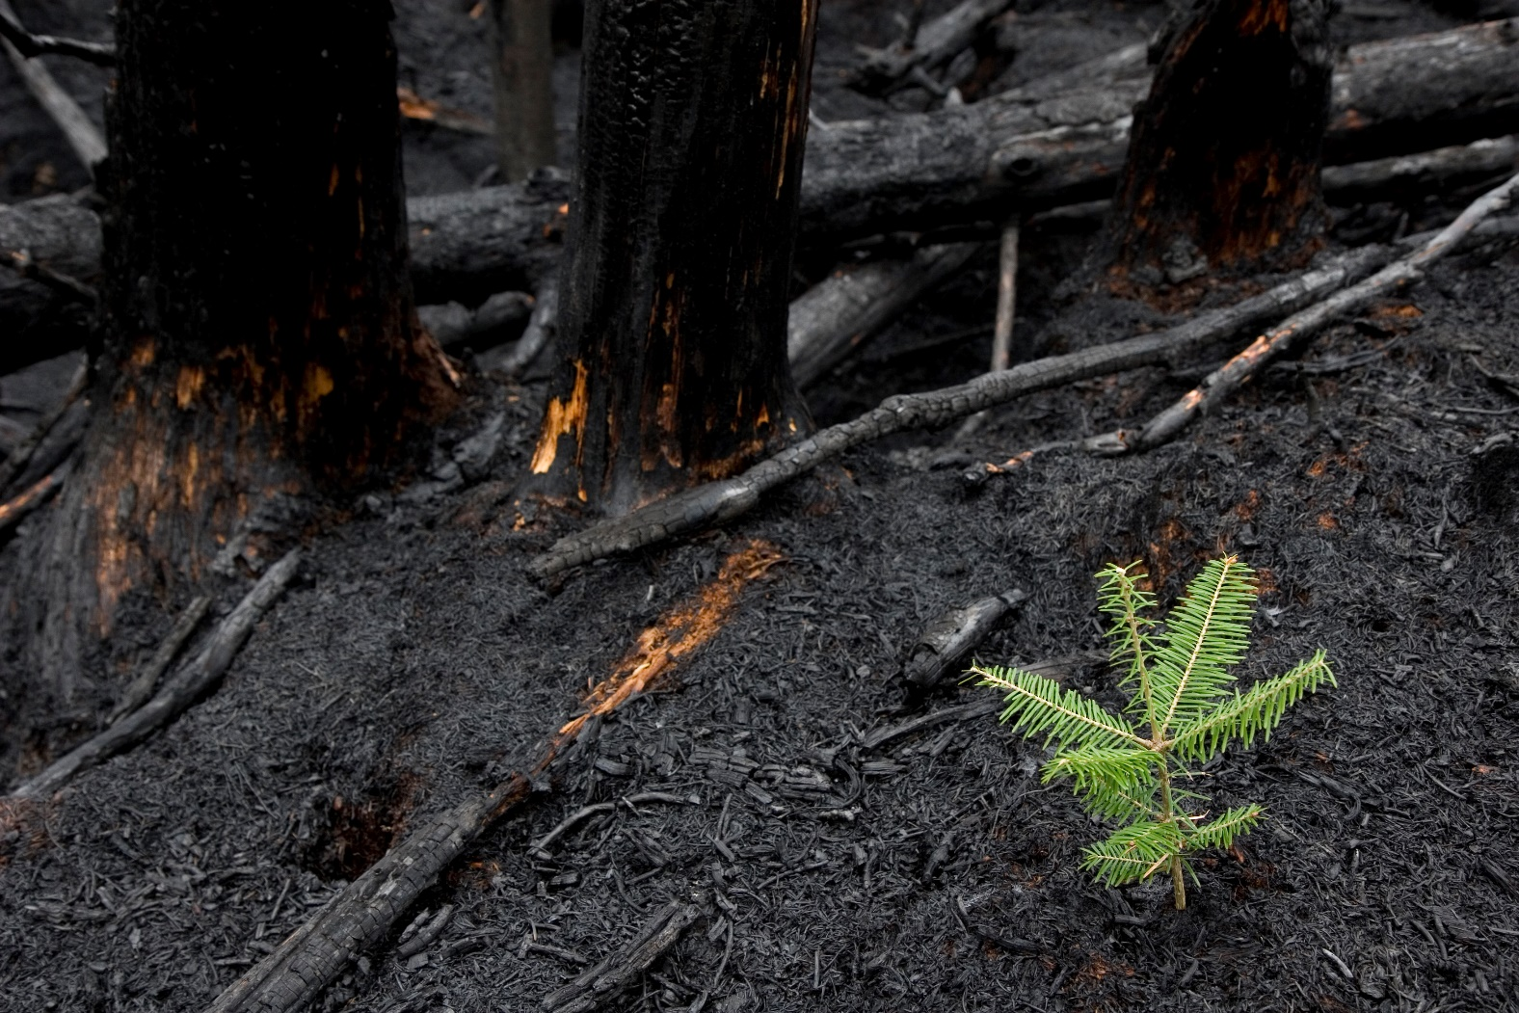

East Gippsland Uniting
Bushfire Recovery
THEORY OF CHANGE

JUNE 2020

Contents
Acknowledgments 3
Introduction 4
Definitions 5
Why a Theory of Change? 6
Our Strategies 6
Our Objectives 6
Our Impact 6
Our Principles 7
Theory of Change 8
Results Framework 9

Acknowledgments
Principle Author:
Courtney Innes, Plan International Australia

Key Contributors:
Di Fisher, Linde Coggan and Ruth Churchill (Uniting Vic.Tas)

We also wish to thank the following people for their valuable contributions:
Wenda Donaldson, Crystal Russell, Tracey Sheilds, Rae Ellis, Rebecca Ford, Jane Neate, Carrie Jagusch, Tracey Donaldson, Megan Stanbridge, Heidi Hunter, Toni Mackay, Sue Grogan-Williams, Robyn Zee (Uniting Vic.Tas)
Jan Parry, Dave Husy (Plan International Australia)

This material has been financed by the International Medical Corps (IMC). Responsibility for the content rests entirely with Uniting Vic.Tas and Plan International Australia. IMC does not necessarily share the expressed views and interpretations.

Introduction
In January 2020, Australia faced an unprecedented national crisis as bushfires tore through bushland and rural communities across the country. In Victoria, the area of Gippsland in the east of the state was the most affected with 11,311 km² or 54 per cent of East Gippsland burnt. The bushfires burned for three months and were finally declared contained on 20 February 2020.
The protracted nature of this crisis created circumstances that had never previously been experienced by communities or government response and relief agencies. This combined with the establishment of two new recovery agencies National Bushfire Recovery Australia (NBRA) and Bushfire Recovery Victoria (BRV) at the time of the fires, has created a new landscape for recovery in Victoria and Australia.
Uniting Vic.Tas (Uniting) have a long history of service provision within East Gippsland focused on children, young people and their families. Uniting aims to ensure that they were best able to meet the needs of children and young people in the recovery process of East Gippsland. A shared interest in the rights, participation and wellbeing of children and young people in bushfire recovery efforts brought Uniting and Plan International Australia (PIA) together to partner on this project.
Through the engagement of a PIA Child Protection Consultant, Uniting collaborated to undertake a rapid assessment of the current situation for children and young people, across the developmental ages, in bushfire-affected communities in Victoria. This rapid assessment then informed the Theory of Change.
This Theory of Change provides the road map through which Uniting will plan and action their contribution to the immediate and longer-term recovery needs of children and young people in East Gippsland. It provides a clear articulation of how they will dedicate their existing resources, and evidence-based rationale for future resource opportunities.

Definitions
‘Child’ and ‘Young Person’
The UN Convention on the Rights of the Child (UNCRC) in Article 1 states that a ‘child’ is a person below the age of 18 years old.
There are four crucial stages of development that are pertinent when designing interventions to support children: early childhood (aged 0-4), primary (aged 5-9), lower secondary (aged 10-14), and upper secondary (aged 15-19).
Below is an overview of the different definitions of children and young people.
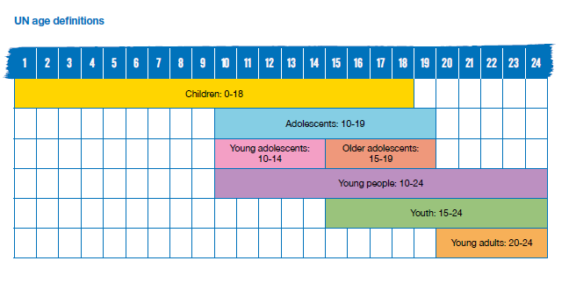
(Source: Plan International Adolescent Programming Toolkit, June 2020).
Psychosocial
The interrelation of social factors and individual thought and behavior.
Psychosocial resilience
Describes the capacity of individuals to navigate their way to the psychological, social, cultural and physical resources that sustain their wellbeing and their capacity individually and collectively to negotiate for these resources to be provided and experienced in culturally meaningful ways.

Why a Theory of Change?
The Theory of Change visualises how we expect to reach our intended impact, which is that children and young people‘s recovery needs are prioritised in East Gippsland. This section describes our efforts (strategies or grouped activities) to address the needs, risks and barriers of children and young people, as well as the broader changes or results (objectives) which are necessary for children and young people, their families, communities, systems and public policy to achieve our desired impact.
Note that the Theory of Change may need to be changed over time as feedback from monitoring and evaluation systems inform the effectiveness of the strategies, or as the external context changes. A Theory of Change does not outline implementation milestones or specific timeframes. An Implementation Plan or Work Plan is developed separately to achieve this.
Change occurs over time, and as such some changes will occur before others. Therefore, the strategies and activities will be implemented over short, medium and long-term periods.

Our Strategies
- Promote the leadership of children and young people in recovery
- Influence policy makers to include the voice of children and young people in recovery
- Invest in the direct psychosocial resilience support of children, young people and their families
- Invest in and mobilise community support and connection activities
- Collaborate and partner with child and youth centred services and networks.

Our Objectives
Objectives 1: Rights - All children and young people have a voice at all stages of the emergency management cycle, from planning and preparedness to response and recovery, including activities in their own communities.
Objective 2: Social Capital - All children and young people feel safe and secure as their mental health and wellbeing needs are met within their homes and communities.
Objective 3: Social Inclusion - All children and young people are connected to their community through shared identity with close family and friends, and associations / relationships with a broader range of people and institutions.

Our Impact
Children and Young People’s Recovery Needs are Prioritised in East Gippsland.
Impact is reached when:
- The need for safety and security is provided to children and young people by their family, friends and community
- Children and young people have a dedicated circle of people, institutions and networks that support their connectedness to community
- Children and young people have the opportunities to meaningfully participate and lead in decisions affecting their recovery.

Our Principles
- All activities and strategies are conducted in collaboration and cooperation with other stakeholders and members of the community
- Children and young people, across the developmental ages, are placed at the centre of action, recognised as drivers of their own actions, and promoted in their leadership
- Children and young people’s recovery cannot be separated from the broader context of their family, community, service systems and public policy
- All activities are underpinned by trauma and recovery informed practice
- The recovery needs of all children and young people, especially those from diverse cultures and rural and remote areas are included across the Theory of Change
- Approaches are community-centred, responsive and adaptive to diverse and changing need
- Uniting provides long-term support that authentically builds trust and local relationships.

Theory of Change
IMPACT: CHILDREN AND YOUNG PEOPLE’S RECOVERY NEEDS ARE PRIORITISED IN EAST GIPPSLAND

Objectives
1.3, 2.5, 3.6
Child and youth centred services and networks are consistently coordinated, in their support of child and youth rights, social capital and social inclusion

3. Social Inclusion: All children and young people are connected to their community through shared identity with close family and friends, and associations/relationships with a range of people and institutions.
2. Social Capital: All children and young people feel safe and secure as their mental health and well-being needs are met within their homes and communities.
- Rights: All children and young people have a voice at all stages of the emergency management cycle from planning and preparedness to response and recovery, including activities in their own communities.

Outcomes
2.1 Psychosocial tools and resources: Children and young people have access, through a range of mediums, to psychosocial tools and resources to support their resilience and coping mechanisms
1.1 Participation and leadership: All children and young people, especially those from diverse cultures and rural and remote areas, have the skills, connections and opportunities to participate and lead in decisions affecting their preparedness, response and recovery to emergencies
3.1. Children and young people have an increased circle of people, institutions and networks
3. 2. Social opportunities provide a sense of connectivity to community for children and young people
3.4. Families and peers: Children and young people have increased connection to their family and peers

2.2 Families and peers provide mental health and wellbeing support to children and young people
2.3 Service Access: Children, young people and families can access clear pathways to professional services in town centres, and rural and remote locations for support their mental health and well-being.
3.5. Culturally diverse children and young people are connected within their community
3.3. Community actors, services and networks provide creative approaches to connecting children and young people to community
1.2 Voice: The voice of all children and young people are valued, and they are able to express themselves in a culturally safe environment
2.4 Inclusive: Communities are inclusive and provide a safe and secure space for all Children and Young People

Strategies

Collaborate and partner with child and youth centred services and networks

Invest in and mobilise community support and connection activities
Invest in the direct psychosocial resilience support of children and young people, and their families

Influence policy makers to include the voice of children and young people in recovery
Promote the leadership of children and young people in recovery

Results Framework
GOAL or IMPACT: CHILDREN AND YOUNG PEOPLE’S RECOVERY NEEDS ARE PRIORITISED IN EAST GIPPSLAND
Objectives 1: Rights - All children and young people have a voice at all stages of the emergency management cycle, from planning and preparedness to response and recovery, including activities in their own communities
Outcomes | Outputs | Activities | Strategies  (Activities grouped)
1.1 Participation and leadership: All children and young people, especially those from diverse cultures and rural and remote areas, have the skills, connections and opportunities to participate and lead in decisions affecting their preparedness, response and recovery to emergencies | Emergency preparedness, response and recovery mechanisms are informed by the voices of children and young people | 1.1.1 Interested children and young people, especially those from diverse cultures and rural and remote areas, will be connected to existing leadership programs and representative committees, provided leadership training, and supported to represent the voices of children and young people to key decision makers on preparedness, response and recovery | Promote the leadership of children and young people in recovery
1.2 Voice: The voice of all children and young people, are valued, and they are able to express themselves in culturally safe environment | The voices of children and young people on preparedness, response and recovery are documented and shared across community, service provider and government (local, state, federal) | 1.2.1. Develop a joined-up community, service provider and government (local, state, federal) strategy for gathering, documenting, and sharing the voices of children and young people on preparedness, response and recovery | Influence policy makers to include the voice of children and young people in recovery
 |  | 1.2.2. Child and youth recovery needs assessment completed in collaboration with key stakeholders such as EGSC, YacVic, headspace Bairnsdale, Mallacoota Youth Sanctuary, Mental Wellbeing Network
 | The voices of children and young people on preparedness, response and recovery are collected from the community | 1.2.3. A suite of pop up activities to collect children and young people’s voices in an agile manner from community
 | Increased number of community members in East Gippsland trained to implement voices projects | 1.2.4. Training sessions to community members on tools and techniques to hear the voices of children and young people

Objective 2: Social Capital - All children and young people feel safe and secure, as their mental health and wellbeing needs are met within their homes and communities
Outcomes | Outputs | Activities | Strategies  (Activities grouped)
2.1 Psychosocial tools and resources: Children and young people have access, through a range of mediums, to psychosocial tools and resources to support their resilience and coping mechanisms | Children of Early Learning age will have increased resilience and coping mechanisms | 2.1.1. Pet psychosocial support group therapies delivered to early learning cohort | Invest in the direct psychosocial resilience support of children, young people and their families
 | Children and young people across the developmental ages have increased resilience and coping mechanisms. | 2.1.2.Deliver art therapies to children and young people across the developmental ages, through a flexible approach that best reflects the demographics of the community
2.2 Families and peers provide mental health and wellbeing support to children and young people | Children and Young People aged 12-25 are supported by their families in their wellbeing through performances) | 2.2.1. Deliver ‘Drumbeat’ program (as an evidence-based program) to children and young people aged 12-25 in the community
 | Children aged 0-5 years, and their families, have an increased sense of mental health and wellbeing | 2.2.2. Deliver group work interventions through kinder gym, art therapy and music program for children aged 0-5 years old
 | Tutors and parents are engaged in training and employment, families are empowered and engaged in their children’s learning and their local community, and children aged 4-5 years develop a love of learning early, that is maintained throughout their lives | 2.2.3. HIPPY program expanded to effectively reach families in more remote areas of East Gippsland for 4 years from 2021
2.3 Service Access: Children and families can access clear pathways to professional services, in town centres and rural and remote locations, for support their mental health and wellbeing | Families of children under 5 years old have clear access pathways to recovery activities | 2.3.1 Early Learning Centres will be prioritised as delivery sites of recovery activities for families of children under 5 years old
 | The Sanctuary has a sustainable model for 3 years (or 1 year initially) providing a space for young people to access youth-specific services | 2.3.2 (also 3.3.1) Resource ‘The Sanctuary’, Mallacoota and it’s coordinator position
2.4 Inclusive: Communities are inclusive and provide a safe and secure space for all children and young people | Community members have increased awareness of the meaning and impact of the bushfires on the mental health and wellbeing of children and young people in all of their diversities | 2.4.1. Collaboratively develop a suite of psycho-education information and communication material that celebrates diversity and recognises children and young people’s needs for bushfire recovery

Objective 3: Social Inclusion - All children and young people are connected to their community through shared identity with close family and friends, and associations / relationships with a broader range of people and institutions
Outcomes | Outputs | Activities | Strategies  (Activities grouped)
3.1 Children and young people have an increased circle of people, institutions and networks | Young people aged 16-18 years access employment and traineeships in their local communities | 3.1.1. Develop youth traineeships for young people in Mallacoota, Cann River, Orbost, Buchan, Bruthen, Swifts Creek, Omeo | Invest in and mobilise community support and connection activities
3.2 Social opportunities provide a sense of connectivity to community for children and young people | Young people aged 12-25 years have an increased connection to their peers | 3.2.1. Provide small resource grants for young people aged 12-25 years to develop social opportunities that increase peer to peer connectivity
3.3 Community actors, services and networks provide creative approaches to connecting children and young people to community | The Sanctuary has a sustainable model for 3 years (or 1 year initially) providing a space for children and young people to connect with friends, associations, and a broader range of people | 3.3.1. Resource ‘The Sanctuary’, Mallacoota and it’s coordinator position
3.4 Families and peers: Children and young people have increased connection to their family and peers | Families will experience relaxation and rest and increase their connection to each other | 3.4.1. Weekend camps for families to be held in Lake Tyers caravan park
3.5 Culturally and linguistically diverse children and young people are connected within their community | Culturally and linguistically diverse young people aged 10-25 years will access increased healing opportunities | 3.5.1. Present collaborative healing opportunities for children and young people aged 10-25 years from culturally and linguistically diverse backgrounds, within their communities

Enablers to achieve Outcome 1.2, 2.5, 3.6: Child and youth-centred services and networks are consistently coordinated
Outcomes | Outputs | Activities | Strategies  (Activities grouped)
1.3, 2.5, 3.6. Child and youth centred services and networks are consistently coordinated, in their support of child and youth rights, social capital and social inclusion | Increased collaboration and partnership between child and youth centred services and networks | 4.1.1. Dedicate staff resources to actively participate in child and youth centred networks (this includes coordination, influence, facilitation, participation, mapping, providing focus on children and young people’s rights, inclusion and connectedness) | Collaborate and partner with child and youth centred services and networks
 | Increased communication and transparency between networks and agencies and the community on child and youth recovery | 4.1.2. Information is shared, where appropriate, on child and youth recovery processes across networks, agencies and communities

