  - 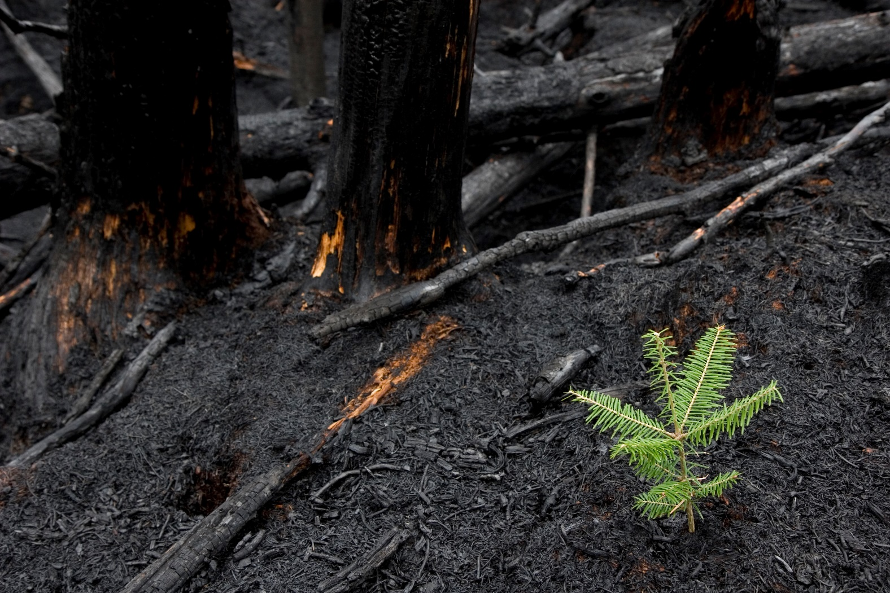

East Gippsland Uniting
Bushfire Recovery
RAPID ASSESSMENT and THEORY OF CHANGE

Executive Summary
June 2020

Executive Summary
Plan International Australia and Uniting Vic.Tas Bushfire Recovery Rapid Assessment and Theory of Change

Project background and rationale
In January 2020, Australia faced an unprecedented national crisis, as bushfires tore through bushland and rural communities across the country. In Victoria, the area of Gippsland in the east of the state was the most affected. The protracted nature of this crisis created circumstances that had never previously been experienced by communities or government response and relief agencies.
In Australia, and internationally, disasters disproportionately impact on children and youth. Children are unlikely to have cognitive capacities and emotional maturity to effectively manage challenges from disaster, and exposure to disasters increase their risk of serious and long-term consequences for social, psychological, emotional, cognitive and physical development. For young people, crisis situations can also accelerate or even skip the transition of adolescence into adulthood.
Uniting Vic.Tas (Uniting) has a long history of service provision within East Gippsland focused on children, young people and their families. A shared interest in the rights, participation and wellbeing of children and young people in bushfire recovery efforts brought Uniting and Plan International Australia together to partner on this project.
Plan International Australia strives to advance children’s rights and equality for girls all over the world. As an independent development and humanitarian organisation, PIA work alongside children, young people, supporters and partners to tackle the root causes of the challenges facing children, especially girls. PIA also support communities affected by natural disasters or emergencies.
By drawing on PIA’s capabilities, models and partners from international practice and combining this technical support with Uniting’s local knowledge and trusted relationships, we hope to contribute a unique perspective to support disaster recovery efforts in East Gippsland.

Aims of the project
This project aimed to:
- Undertake a Rapid Assessment and mapping of the current situation for children and young people across the developmental ages in bushfire-affected communities in East Gippsland.
- Develop a Theory of Change that provides the conceptual framework to plan and action our collective contribution to the immediate and longer-term recovery needs of children and young people in East Gippsland.
We hope that this project is beginning of ongoing conversation about the recovery needs of children and young people in East Gippsland.

Project methodology
The Rapid Assessment and Theory of Change were informed by Sphere Minimum Standards for Child Protection in Humanitarian Action and underpinned by Bronfenbrenner’s ecological systems theory.
Plan International and Uniting worked together to design 25 qualitative and quantitative interview questions. In total, interviews were conducted with 32 Key Informants across a range of Local Government, State Government and Community Service providers. Efforts were made to ensure interviewees had experience and knowledge on the different thematic areas and provided services across East Gippsland shire in locations such as Bairnsdale, Mallacoota, Cann River, Orbost and Buchan. Approximately 80 per cent of Key Informants identified as female and 20 per cent as male.
A major gap in this rapid assessment were the voices of children and young people. A decision was made not to interview children and young directly, as the short project timeframes may have compromised ethical data collection and representativeness. We recognise the critical need to hear directly from children and young people in the future to ensure a holistic approach.
The desktop review, data collection and Theory of Change workshops were conducted between 7 May 2020 and 24 June 2020.

Findings

Key challenges identified
The primary data collection highlighted the following key challenges:
- ‘Isolation from Peers’ and ‘Psychosocial Distress’ were the main sources of stress identified by Key Informants for children aged 5-11, and young people aged 12-18. The top two sources of stress identified for families of children and young people were ‘Psychological Distress’ and ‘Interactions with Formal Bodies’.
- Many Key Informants reported that direct opportunities for children and young people to be engaged in their recovery process were limited, but mostly non-existent.
- A lack of an inclusion lens was observed by many Key Informants at all governance levels of recovery.
- Key Informants reported unclear recovery coordination and governance mechanisms between:
  - State-based services and regional-based services
  - Government bodies and Non-Government Organisations/Community Service Organisations
  - Formalised recovery services and systems, and the community
  - Commonwealth funded programs and State funded programs.
- A disconnect between coordination of the services and systems that support child and youth rights centrally at a state level and at a regional level in bushfire affected areas was another key challenge perceived by many Key Informants.
- Clear communication to the community on coordination, governance, service access, community support and general trauma informed information was reported by Key Informants as limited and inconsistent.
- Key Informants stressed that the experience of the global COVID-19 pandemic was and will continue to interrupt communities from engaging in recovery processes that traditionally support their mental health and wellbeing.

Key opportunities identified
The primary data collection revealed the following opportunities to:
- Further strengthen connected coordination of the services and systems that support child and youth rights at a state-based and regional level.
- Leverage existing child and youth centred services and networks to embed a coordinated recovery approach.
- Better coordinate data gathering on the voices of children and young people in recovery.
- Provide more psychosocial support in community or group work, such as community recreational activities, to respond to isolation and psychosocial distress beyond one-on-one therapeutic interventions which are already well-resourced.
- Support the Community Recovery Committees (along with EGSC and BRV) to enhance the clear communication of the recovery mechanisms to the broader community, and to ensure a child and youth-centred approach.

Conclusions

Children and young people are actively involved in decision making at all stages of the emergency management cycle, from planning and preparedness to response and recovery, including activities in their own communities
Opportunity for child and youth-centred services and networks at a regional, state and Commonwealth level to work in coordination and collaboration to ensure that:
- The voice of all children and young people, are valued, and they are able to express themselves in culturally safe environment.
- All children and young people, especially those from diverse cultures and rural and remote areas, have the skills, connections and opportunities to participate and lead in decisions affecting their preparedness, response and recovery to emergencies.

Social connectedness increased (and psychosocial distress decreased) through community-based activities and group work
- Opportunity among services providers and networks in East Gippsland to scale up interventions that focus on community connectedness and that support families to develop a sense of safety and stability in the homes and community of children and young people.
- Opportunity, through the Psychosocial Sub-Committee, to expand their focus in this next stage of recovery, to include all the services that provide mental health and psychosocial support to children and young people across individual, group and community focussed interventions, and across all state, federal and privately funded backgrounds.

Communication
Opportunity for child and youth-centred services and networks to consider how they can support communication processes:
- Across the socio-ecological framework of the community
- Between the different tiers of governance
- To provide trauma informed key messaging on the recovery process to all relevant target groups, including children and young people, in a systematic and structured manner.

Inclusion
- Opportunity for child and youth centred services and networks to advocate an increased understanding and response to the diverse needs of these diverse groups.

Next steps
Our intention is to promote these findings widely and work collaboratively to help inform and contribute to the recovery efforts of children and young people in East Gippsland. We aim to distribute the final report and related resources widely through our networks, especially with the individuals who so generously contributed their insights as Key Informants.
We look forward to continuing to progress this work together to support collective recovery outcomes for East Gippsland communities and more widely across Victoria.

Uniting’s bushfire recovery theory of change
2.3 Service Access: Children, young people and families can access clear pathways to professional services in town centres, and rural and remote locations for support their mental health and well-being.
2.4 Inclusive: Communities are inclusive and provide a safe and secure space for all Children and Young People
1.3, 2.5, 3.6
Child and youth centred services and networks are consistently coordinated, in their support of child and youth rights, social capital and social inclusion

2.2 Families and peers provide mental health and wellbeing support to children and young people
3.5. Culturally diverse children and young people are connected within their community
IMPACT: CHILDREN AND YOUNG PEOPLE’S RECOVERY NEEDS ARE PRIORITISED IN EAST GIPPSLAND
- Rights: All children and young people have a voice at all stages of the emergency management cycle from planning and preparedness to response and recovery, including activities in their own communities.
2. Social Capital: All children and young people feel safe and secure as their mental health and well-being needs are met within their homes and communities.
3. Social Inclusion: All children and young people are connected to their community through shared identity with close family and friends, and associations/relationships with a range of people and institutions.
3. 2. Social opportunities provide a sense of connectivity to community for children and young people
3.3. Community actors, services and networks provide creative approaches to connecting children and young people to community
3.4. Families and peers: Children and young people have increased connection to their family and peers
1.2 Voice: The voice of all children and young people are valued, and they are able to express themselves in a culturally safe environment
1.1 Participation and leadership: All children and young people, especially those from diverse cultures and rural and remote areas, have the skills, connections and opportunities to participate and lead in decisions affecting their preparedness, response and recovery to emergencies
2.1 Psychosocial tools and resources: Children and young people have access, through a range of mediums, to psychosocial tools and resources to support their resilience and coping mechanisms
3.1. Children and young people have an increased circle of people, institutions and networks
Objectives
Outcomes
Promote the leadership of children and young people in recovery
Invest in the direct psychosocial resilience (provide definition) support of children and young people, and their families

Invest in and mobilise community support and connection activities
Collaborate and partner with child and youth centred services and networks

Influence policy makers to include the voice of children and young people in recovery
Strategies

The rapid assessment offers an overview of recovery needs and available support mechanisms in June 2020 but does not claim to offer a robust account of the bushfire recovery experiences of children and young people in East Gippsland.

